**Implementing Deep Learning for Atrial Fibrillation Diagnosis**

A Thesis Presented to the Faculty of Computer Engineering College of Engineering, Architecture and Technology

De La Salle University – Dasmariñas Dasmariñas City, Cavite

In Partial Fulfillment of the Requirements for the Degree of Bachelor of Science in Computer Engineering

Rostata, Carl Louise D. Anzures, Angel Ezekiel O.

Buenaventura, Justine Mae S.

[TABLE OF CONTENTS](https://docs.google.com/document/d/1lBtvr12H_A0Xr40cqQYjGW8Wc6H7_y4TW9dy98DCUq4/edit?fbclid=IwZXh0bgNhZW0CMTEAAR1hEpbeRn0EYSJoOKtgZMpXF9BuvjU-qrxVAktfAWwGbKD02oSoY6f1duY_aem_sJd75nLS54VZNzUgrpDoeQ#heading=h.4d34og8) i

LIST OF FIGURES ii

[**CHAPTER 1: INTRODUCTION**](https://docs.google.com/document/d/1lBtvr12H_A0Xr40cqQYjGW8Wc6H7_y4TW9dy98DCUq4/edit?fbclid=IwZXh0bgNhZW0CMTEAAR1hEpbeRn0EYSJoOKtgZMpXF9BuvjU-qrxVAktfAWwGbKD02oSoY6f1duY_aem_sJd75nLS54VZNzUgrpDoeQ#heading=h.30j0zll)

* 1. [Background of the Study 1](https://docs.google.com/document/d/1lBtvr12H_A0Xr40cqQYjGW8Wc6H7_y4TW9dy98DCUq4/edit?fbclid=IwZXh0bgNhZW0CMTEAAR1hEpbeRn0EYSJoOKtgZMpXF9BuvjU-qrxVAktfAWwGbKD02oSoY6f1duY_aem_sJd75nLS54VZNzUgrpDoeQ#heading=h.1fob9te)
  2. [Objectives of the Study 5](https://docs.google.com/document/d/1lBtvr12H_A0Xr40cqQYjGW8Wc6H7_y4TW9dy98DCUq4/edit?fbclid=IwZXh0bgNhZW0CMTEAAR1hEpbeRn0EYSJoOKtgZMpXF9BuvjU-qrxVAktfAWwGbKD02oSoY6f1duY_aem_sJd75nLS54VZNzUgrpDoeQ#heading=h.2et92p0)
  3. [Conceptual Framework 5](https://docs.google.com/document/d/1lBtvr12H_A0Xr40cqQYjGW8Wc6H7_y4TW9dy98DCUq4/edit?fbclid=IwZXh0bgNhZW0CMTEAAR1hEpbeRn0EYSJoOKtgZMpXF9BuvjU-qrxVAktfAWwGbKD02oSoY6f1duY_aem_sJd75nLS54VZNzUgrpDoeQ#heading=h.2s8eyo1)
  4. [Scope and Limitation](https://docs.google.com/document/d/1lBtvr12H_A0Xr40cqQYjGW8Wc6H7_y4TW9dy98DCUq4/edit?fbclid=IwZXh0bgNhZW0CMTEAAR1hEpbeRn0EYSJoOKtgZMpXF9BuvjU-qrxVAktfAWwGbKD02oSoY6f1duY_aem_sJd75nLS54VZNzUgrpDoeQ#heading=h.17dp8vu) 7
  5. [Significance of the study](https://docs.google.com/document/d/1lBtvr12H_A0Xr40cqQYjGW8Wc6H7_y4TW9dy98DCUq4/edit?fbclid=IwZXh0bgNhZW0CMTEAAR1hEpbeRn0EYSJoOKtgZMpXF9BuvjU-qrxVAktfAWwGbKD02oSoY6f1duY_aem_sJd75nLS54VZNzUgrpDoeQ#heading=h.tyjcwt) 9
  6. [Definition of Terms](https://docs.google.com/document/d/1lBtvr12H_A0Xr40cqQYjGW8Wc6H7_y4TW9dy98DCUq4/edit?fbclid=IwZXh0bgNhZW0CMTEAAR1hEpbeRn0EYSJoOKtgZMpXF9BuvjU-qrxVAktfAWwGbKD02oSoY6f1duY_aem_sJd75nLS54VZNzUgrpDoeQ#heading=h.3rdcrjn) 11

**CHAPTER 2: REVIEW** **OF RELATED LITERATURE**

* 1. Review of Related Literature 13

**CHAPTER 3: METHODOLOGY**

* 1. Methodological Framework 67
  2. Data Gathering Procedure 68
  3. Research Design 69
  4. Research Instruments 70
  5. Testing Methodology 72
  6. System Process Design 75
  7. System Components 79
  8. System Design 80

**CHAPTER 4:** **RESULTS AND DISCUSSION**

4.1 Web Application 87

4.2 Web App Functionality Testing 99

4.3 Comprehensive Security Design 101

4.4 Security Testing 103

4.5 Dataset Description/Overview 112

4.6 Performance Evaluation of Models 114

4.7 Analysis of Model Results 127

4.8 Comparative Analysis with Existing Approaches 166

4.9 Challenges and Limitations 167

4.10 Interpretation of Findings 172

4.11 Summary of Findings 174

**CHAPTER 5:** **CONCLUSIONS AND RECOMMENDATIONS**

5.1 Conclusion 176

5.2 Recommendation 178

References 182

**APPENDICES**

Appendix A – Budget Plan 188

Appendix B – Gantt Chart 188

Appendix C – Responses to the Panel Reviews 189

Appendix D – Transcript 194

**LIST OF FIGURES**

Figure 1.4.1 Conceptual Framework of the Study 6

Figure 3.1.1 Methodological Framework 68

Figure 3.5.1 Cross-Validation 73

Figure 3.5.2 ROC-AUC Curve 74

Figure 3.5.3 Confusion Matrix 74

Figure 3.6.1 System Block Diagram 75

Figure 3.6.2 System Flowchart 76

Figure 3.6.3 EfficientNet Architecture 78

Figure 3.8.1 Login Page 80

Figure 3.8.2 Dashboard Page 81

Figure 3.8.3 Capture Page 82

Figure 3.8.4 Results Page 83

Figure 3.8.5 Database Design 84

Figure 4.1.4.1 Register Page 89

Figure 4.1.4.2 Login Page and OTP Page 90

Figure 4.1.4.3 Dashboard Page 91

Figure 4.1.4.4 Capture Page 92

Figure 4.1.4.5 View Page 93

Figure 4.1.4.6 Archive Page 94

Figure 4.1.4.7 Profile Page 95

Figure 4.1.4.8 Reports Page 96

Figure 4.1.4.9 Reports Generated PDF File 96

Figure 4.1.4.10 Reports Generated Excel File 97

Figure 4.1.4.11 User Management Page 98

Figure 4.4.1 SSL/TLS Scanner Report 105

Figure 4.4.2 SQL Injection Scan Report 106

Figure 4.4.3 XSS Scanner Report 108

Figure 4.4.4 Web Recon results 109

Figure 4.4.5 Screenshot of deleted _token 111

Figure 4.4.6 Screenshot of denied .env access 111

Figure 4.4.7 Screenshot from phpMyAdmin encrypted user passwords 112

Figure 4.4.8 Screenshot from phpMyAdmin encrypted session 112

### 

### **CHAPTER 1**

### **INTRODUCTION**

#### **Background of the Study**

Atrial Fibrillation (AF) is the most common type of cardiac arrhythmia and a leading cardiac cause of stroke (Zeid Nesheiwat, 2023). Under normal conditions, the heart’s electrical system ensures that the heart beats regularly and remains coordinated but when abnormal electrical activity within the atria of the heart begins firing, this causes the heart rate to become irregular and fast. This rhythm irregularity makes the blood flow through the heart turbulent and increases the chance for the formation of thrombus (blood clot) which can ultimately discharge and cause a stroke. According to the American Heart Association (*Atrial Fibrillation*, n.d.), untreated AF puts you at a higher risk for stroke and heart failure. People with atrial fibrillation (AF) have three to five times greater risk for ischemic stroke and it can also lead to heart failure which is a condition in which your heart can’t circulate enough blood to meet your body’s needs. Atrial Fibrillation’s irregular, fast heart beat leads to ineffective pumping of the blood which – especially if left uncontrolled – may weaken the heart over time. Accurate and timely detection of this condition is critical for effective management and mitigating severe future complications such as stroke, heart failure, cardiomyopathy, and more.

One way to diagnose AF is through Electrocardiograms (ECG) that record your heart’s electrical activity (National Heart, Lung, and Blood Institute, 2022). ECG is an essential diagnostic tool in the field of medicine as it is used to diagnose a wide range of conditions including Atrial Fibrillation. However, challenges related to ECG variability can complicate the diagnostic process. ECG interpretation demands specialized expertise, and accurate AF detection can be challenging due to factors such as heart rate variability, noise interference, and the intermittent nature of the arrhythmia. Even experienced clinicians may encounter difficulties in distinguishing AF from other arrhythmias, especially in cases with atypical ECG patterns (Kapoor & Reddy, 2020). Human error, workload, and time constraints can further impact diagnostic accuracy (Lippi et al., 2020).

Deep learning, a subset of artificial intelligence (AI), has emerged as a promising tool for detecting atrial fibrillation with high accuracy. Deep learning algorithms, particularly convolutional neural networks (CNNs), have demonstrated superior performance in analyzing ECG data due to their ability to automatically extract relevant features from raw data without the need for manual feature engineering (Hannun et al., 2019). These models can handle large datasets and learn complex patterns associated with AF, improving diagnostic accuracy. Even with advancements in AF detection, accurately diagnosing the condition remains a challenge due to inconsistencies in ECG readings and the potential for human error. Since ECG interpretation requires specialized expertise, misdiagnoses or delays in detection can still occur. To improve accuracy and efficiency, there is a growing need for an AI-driven solution that can assist in identifying AF more reliably.

However, despite advancements in AF detection, several challenges persist, including the need for high-quality ECG datasets, the development of an optimal deep learning model, and its effective integration into a user-friendly diagnostic system. These challenges highlight the core issues this study aims to address. This study explores how deep learning can help bridge this gap by an automated method of detecting AF, ultimately enhancing patient care and supporting better clinical decision-making.

This research aims to use deep learning techniques to diagnose atrial fibrillation (AF) using 12-lead ECG images. AF is a serious condition that can lead to severe complications if not accurately and promptly diagnosed. One of the most significant complications of AF is stroke. The irregular heartbeat in AF causes blood to pool in the atria, which can lead to the formation of blood clots. These clots can travel to the brain, causing an ischemic stroke. Patients with AF are three to five times more likely to suffer a stroke compared to those without AF. Another major complication is heart failure. The inefficient and rapid heart rate associated with AF can weaken the heart muscle over time, reducing its ability to pump blood effectively. This can lead to heart failure, a condition where the heart is unable to meet the body’s circulatory demands. Additionally, AF can cause cardiomyopathy, a disease of the heart muscle that makes it harder for the heart to pump blood to the rest of the body. Other complications include chronic fatigue, cognitive impairment, and increased mortality.

ECG on the other hand, is an essential diagnostic tool, electrocardiograms (ECGs) are widely used to detect and monitor various cardiac conditions, including AF. However, interpreting and reading ECGs can be challenging especially for non-cardio medical practitioners and medical students.. ECG interpretation requires specialized knowledge and training. The heart’s electrical activity generates complex waveforms that need to be analyzed for identifying normal and abnormal rhythms. Factors such as heart rate variability, noise interference, and the intermittent nature of arrhythmias can complicate this analysis. Even experienced clinicians may encounter difficulties when interpreting ECGs. Atypical ECG patterns, which do not conform to textbook examples, can lead to misinterpretation. Additionally, the high variability in ECG presentations among different patients can further complicate the diagnostic process. Human error, influenced by factors such as fatigue, workload, and time constraints, can also impact the accuracy of ECG interpretation. Studies have shown that diagnostic errors are not uncommon, even among trained cardiologists, which can result in misdiagnosis or delayed diagnosis of AF and other arrhythmias (Kapoor & Reddy, 2020; Lippi et al., 2020). Given these challenges, there is a pressing need for more reliable and efficient diagnostic methods.

The core problem this research addresses is the need for a reliable and accurate diagnostic tool for atrial fibrillation (AF). By utilizing deep learning, this study seeks to develop a model that is capable of analyzing ECG image data in order to predict the presence of atrial fibrillation.

Specifically, the study aims to solve the following problems:

1. Data Collection and Preparation: How can we gather and preprocess a comprehensive and high-quality dataset from healthcare institutions or online sources to train the deep learning model effectively?

2. Model Development: What deep learning architecture is best suited for analyzing ECG image data to accurately identify patterns indicative of atrial fibrillation?

3. System Integration: How can we develop a user-friendly web application that deploys the deep learning model for atrial fibrillation detection, facilitating seamless data input, model inference, and result visualization?

4. Model Validation: How can we test and validate the accuracy and reliability of the developed model in a clinical setting, ensuring its practical applicability and effectiveness in predicting atrial fibrillation?

By addressing these problems, this study aims to contribute to the field of computational medicine, offering a novel approach to improving the diagnosis and management of atrial fibrillation.

#### **Objectives of the Study**

This thesis aims to utilize deep learning techniques for the analysis and interpretation of 12-lead electrocardiogram (ECG) data in diagnosing Atrial Fibrillation.

The study specifically aims to:

1) To collect a valid and comprehensive dataset from online datasets, clinics, or hospitals for developing the model.

2) To build a suitable machine learning model for analyzing 12-lead ECG digital image data using deep learning architecture.

3) To develop a web application that integrates web security features and a deployed final deep learning model for diagnosing Atrial Fibrillation, facilitating data input, and model inference.

4) To test and validate the accuracy of the model in clinical application with the help of a cardiologist, specifically in diagnosing Atrial Fibrillation.

#### **Conceptual Framework**

The thesis aims to utilize deep learning techniques for 12-lead ECG analysis and diagnosis of Atrial Fibrillation. This framework comprises the essential components for conducting the study. The diagram provided below illustrates the research paradigm of the proposed thesis:

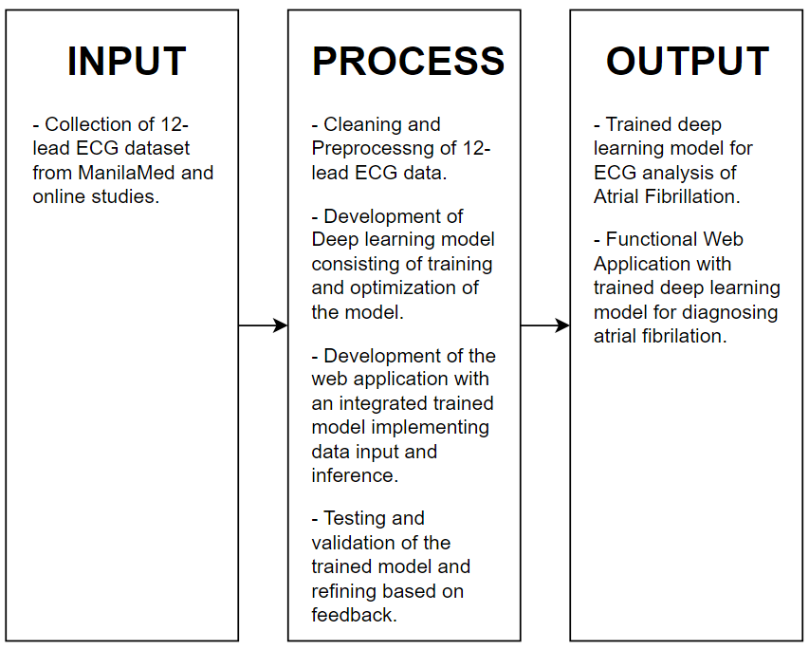

Collection of 12-lead ECG dataset from clinics and hospitals

*Figure 1.4.1 Conceptual Framework of the Study*

Following the IPO framework in Figure 1.4.1, comprehensive 12-lead ECG datasets will be collected from clinics or hospitals and various reputable online databases. The datasets will be thoroughly documented, only documenting 12-lead ECG data without any patients’ personal data.

The raw ECG data will be standardized to ensure uniformity and then converted into digital images suitable for deep learning analysis. A convolutional neural network (CNN) architecture will be selected based on literature and preliminary experiments, and the model will be trained with the preprocessed ECG images. Techniques such as hyperparameter tuning and data augmentation will be used to enhance model accuracy. A web application will be developed with the integrated trained model, allowing for real-time diagnosis.

Finally, the web application and deep learning model will undergo validation with a cardiologist to validate performance. The research will culminate in a trained deep learning model and a fully functional web application, providing a practical tool for non-cardio medical practitioners.

#### **Scope and Limitations**

This research aims to delve into the development and evaluation of a predictive deep learning model specifically tailored for analyzing 12-lead electrocardiogram (ECG) data to diagnose atrial fibrillation (AF). With the increasing significance of early detection and intervention in cardiovascular health, the study explored the potential of leveraging ECG data to construct a predictive model. By incorporating deep learning architectures, the research seeks to identify a suitable machine learning model capable of discerning patterns indicative of atrial fibrillation from the input data.

The scope of this study is limited to data collected from the private clinic of Dr. Gracita Topacio in Manila. All ECG images used for training and testing were validated by the cardiologist to ensure diagnostic accuracy, which strengthens the clinical relevance of the dataset. No publicly available or online datasets were used due to the lack of physician-verified labels, and to avoid the time-intensive process of manual validation by healthcare professionals.

The scope extends to the deployment of the developed model within a web application, thereby facilitating its accessibility and utilization in clinical settings. Techniques for data preprocessing during training of the deep learning model were explored and implemented to enhance the quality and relevance of input data, thereby optimizing the performance of the predictive model. An integral component of this research involves the comprehensive investigation and reporting of findings derived from the developed deep learning model. Through analysis and evaluation, the study aims to explore the accuracy and limitations of the model in diagnosing atrial fibrillation based on 12-lead ECG data.

The study acknowledges several limitations that influence the robustness and applicability of its findings. Firstly, the variability in data sources poses a potential challenge to the and generalization of the model. The researchers explicitly state their focus on employing deep learning models and techniques for diagnosing atrial fibrillation, which may necessitate the utilization of additional predictive methods not explored in this study. Additionally, the scope of the research is confined solely to atrial fibrillation, neglecting the exploration of other cardiac conditions that could potentially impact the model's diagnostic capabilities. Consequently, the study refrains from delving into the nuances of other heart-related diseases, which could limit the breadth of its conclusions.

Furthermore, the researchers emphasize their intention to solely investigate, and report findings derived from the machine learning model, thus excluding any comprehensive analysis of broader clinical implications or therapeutic interventions. These limitations underscore the need for cautious interpretation of the study's results and highlight potential avenues for future research to address these constraints and enhance the model's validity and utility in clinical practice.

**1.5 Significance of the Study**

Reading and interpreting ECG data can be challenging for non-cardiologists, including experienced medical professionals and health practitioners. The complexity of ECG signals often requires specialized training, and even then, some machines may not reliably interpret the data. This study's significance lies in its potential to simplify and enhance the diagnostic process through advanced deep learning techniques. By automating the interpretation of ECG data, this research aims to reduce the burden on non-specialists, improve diagnostic accuracy, and facilitate early detection of atrial fibrillation. Moreover, the deployment of this model in a web application makes it accessible and user-friendly, providing a practical tool for everyday clinical use. This could lead to more consistent and reliable diagnoses, ultimately improving patient outcomes and reducing the incidence of complications associated with delayed or missed diagnoses.

In essence, this study underscores the transformative power of deep learning in medical diagnostics. It paves the way for future innovations in the field, setting a precedent for how technology can be harnessed to tackle some of the most challenging health issues of our time. The benefits extend beyond immediate clinical applications, offering a framework that can be adapted for diagnosing other conditions, thus broadening the impact of this research.

The results of the conducted study will be beneficial to:

**Non-Cardiologist Experts in the Medical Field**

This research provides valuable insights into the application of deep learning for medical diagnostics, specifically in interpreting ECG data for diagnosing atrial fibrillation. Non-cardiologist experts, including those with extensive experience but without specialized cardiology training, can benefit from a reliable and automated diagnostic tool. This tool can assist in making accurate diagnoses, thereby improving patient outcomes and enhancing the quality of care provided.

**Health Practitioners**

Health practitioners, including nurses, often encounter challenges in accurately interpreting ECG data due to the complexity of the signals and the limitations of some diagnostic machines. This study aims to bridge this gap by offering a robust deep learning model that aids in the accurate detection of atrial fibrillation. By integrating this tool into clinical practice, health practitioners can make more informed decisions, leading to better patient management and timely interventions.

**Medical Students**

For medical students, this study offers a valuable learning opportunity to understand the integration of advanced technology in healthcare. By learning how deep learning techniques can be applied to diagnose atrial fibrillation from ECG data, students can enhance their educational experience and be better prepared for their future roles in a technology-driven medical field. This knowledge fosters innovative thinking and encourages the development of new diagnostic tools and technologies.

**Future Researchers**

The findings of this study provide a solid foundation for further exploration into the use of artificial intelligence in medical diagnostics. Future researchers can build upon this work, exploring new methodologies and applications of deep learning in diagnosing various conditions. This study serves as a reference point, facilitating advancements in medical diagnostics and broadening the impact of deep learning technologies in healthcare.

This study underscores the transformative potential of deep learning in medical diagnostics, particularly in simplifying and improving the accuracy of ECG interpretation. By addressing the limitations of existing methods and providing an advanced diagnostic tool, this research aims to enhance patient care and set a precedent for future innovations in the field.

**1.6 Definition of Terms**

**Atrial Fibrillation (AF)** - A common type of arrhythmia characterized by irregular and often rapid heart rate, which can lead to blood clots, stroke, heart failure, and other heart-related complications.

**Cardiologist** - A medical doctor specializing in diagnosing and treating heart conditions.

**Convolutional Neural Network (CNN)** - A type of deep learning algorithm particularly well-suited for analyzing visual data, such as images, by using convolutional layers to detect patterns.

**Data Augmentation** - Techniques used to increase the diversity of training data without actually collecting new data, often by altering existing data in various ways.

**Data Preprocessing** - The steps taken to clean, transform, and organize raw data into a format suitable for analysis and model training.

**Deep Learning** - A subset of machine learning involving neural networks with many layers that can learn from large amounts of data to make predictions or classifications.

**Electrocardiogram (ECG)** - A test that measures the electrical activity of the heart through electrodes attached to the skin, producing a record of heart rhythms.

**Hyperparameter Tuning** - The process of adjusting the parameters of a machine learning model to optimize its performance.

**Machine Learning Model** - A computational algorithm trained on data to recognize patterns and make predictions or decisions without being explicitly programmed for the task.

**Model Inference** - The process of using a trained machine learning model to make predictions on new, unseen data.

**Predictive Model** - A statistical or machine learning model that makes predictions about future outcomes based on historical data.

**Standardization** - The process of transforming data to have a uniform format and scale, often by adjusting for differences in measurement units or data distributions.

**Web Application** - A software program that runs on a web server and is accessed via a web browser, allowing users to interact with dynamic content and services over the internet.

**12-lead ECG** - A standard method of recording the electrical activity of the heart from 12 different perspectives, providing a comprehensive view of heart function.

### **CHAPTER 2**

### **REVIEW OF RELATED LITERATURE**

In this chapter, the researchers delve into the existing research and knowledge concerning deep learning models for analyzing heartbeat auscultation. This review aims to thoroughly examine previous studies, compare different approaches, pinpoint research gaps, and highlight the importance of our study in advancing this field. By analyzing past work, addressing any issues or limitations, and proposing new ideas, this review lays the groundwork for our research.

#### **Atrial fibrillation**

Atrial Fibrillation – especially in western countries has been a very common but serious cardiac arrhythmia (Bianca Brundel, 2022). Normally, the heart’s electrical system ensures that the heart beats regularly and in a coordinated manner. But when abnormal electrical impulses suddenly start firing in the atria, it overrides the heart’s natural pacemaker which causes irregular and rapid heart beat. As a result, atrial fibrillation occurs.

Atrial Fibrillation can be categorized based on disease persistence or etiology. When classified by persistence, Atrial Fibrillation is categorized into four classes: paroxysmal Atrial Fibrillation, which terminates spontaneously or with intervention within 7 days of onset; persistent Atrial Fibrillation, which persists for at least 7 days or requires cardioversion Atrial Fibrillationter this period; long-standing persistent Atrial Fibrillation, sustained for at least 12 months alongside a rhythm control strategy; and permanent Atrial Fibrillation, where attempts to restore or maintain sinus rhythm are discontinued. Atrial Fibrillation primarily affects older individuals (>70 years) and those with lifestyle-related conditions such as hypertension, diabetes mellitus, and obesity. Atrial Fibrillation can also be triggered by specific factors such as binge drinking, often referred to as “holiday heart syndrome”, as well as stress. AF can be further classified as "wear-and-tear" AF which is linked with aging and dietary habits typical of Western lifestyles, Congenital AF, associated with developmental heart defects from birth, and lastly, genetic AF, influenced by inherited genetic mutations. About 15% of Atrial Fibrillation cases exhibit familial clustering, highlighting a genetic predisposition to the condition.

AF can cause a variety of symptoms, including an irregular heart rate, palpitations (a sensation of a racing, uncomfortable, irregular heartbeat or a flip-flopping in the chest), shortness of breath, dizziness or lightheadedness, fatigue and general weakness, and in some cases, chest pain (angina). However, some individuals with AF may be asymptomatic, meaning they do not experience noticeable symptoms.

The diagnosis of AF involves several methods to detect and assess the irregular heart rhythm. The primary tool for diagnosing AF is an electrocardiogram (ECG or EKG), recording the electrical activity of the heart and identifying irregularities. Additional diagnostic tools include a Holter monitor, a portable ECG device worn for 24 to 48 hours to monitor the heart's activity over time; an event recorder, used for longer periods (weeks to months) to capture intermittent episodes of AF; and an echocardiogram, an ultrasound of the heart to visualize its structure and function, and to identify any underlying heart conditions that may contribute to AF. Blood tests are also used to check for conditions such as thyroid disease or electrolyte imbalances that may cause or exacerbate AF, and a stress test evaluates how the heart functions under physical exertion.

Managing AF typically involves a combination of lifestyle changes, medications, and medical procedures aimed at controlling the heart rate and rhythm, preventing blood clots, and addressing any underlying conditions contributing to AF. Catheter ablation, a procedure to isolate or destroy the heart tissue causing the abnormal signals, is also a common and effective treatment for many patients. Despite the challenges in selecting optimal treatment strategies due to an incomplete understanding of AF's etiology, research efforts focusing on the molecular and electrical mechanisms underlying AF pathogenesis offer promising avenues for developing novel therapies and improving patient outcomes.

#### **ECG Interpretation: Clinical Relevance, Challenges, and Advances**

The electrocardiogram (ECG) is an essential diagnostic tool in the field of medicine that provides a tracing of the heart’s electrical activity (Nikita Rafie, 2021). This is a non-invasive, fast, and simple test that is used to detect and diagnose a wide range of conditions. The ECG has a broad scope of clinical applications including the detection of acute and chronic myocardial injury, cardiac arrhythmias, structural heart diseases, and inflammatory processes like pericarditis. Its utility spans multiple medical specialties such as cardiology, emergency medicine, and internal medicine, and is used in various clinical settings, from emergency departments to primary care clinics and intensive care units.

Arrhythmia detection is another common use of the ECG. It remains a key tool for diagnosing conditions like atrial fibrillation and differentiating between supraventricular and ventricular arrhythmias. The ECG can also localize the origin of arrhythmic events, aiding in the management and treatment of conditions like Wolff–Parkinson–White syndrome.

The ECG is also valuable in detecting structural changes in the heart, such as atrial enlargement and ventricular hypertrophy, which can indicate underlying conditions like hypertension and predispose patients to further cardiovascular complications. For instance, left atrial enlargement may signal a risk for atrial fibrillation, while left ventricular hypertrophy can indicate increased cardiovascular risk from systemic hypertension. These changes can guide clinicians in optimizing treatment strategies for chronic conditions.

Overall, the ECG's simplicity, rapid execution, non-invasive nature, and cost-effectiveness contribute to its widespread use in clinical practice. However, accurate interpretation of ECG results is crucial, and this task has historically relied on skilled clinicians. The advent of computer-aided ECG interpretation has introduced challenges related to accuracy and clinician reliance on automated readings, underscoring the ongoing need for comprehensive ECG education and the potential benefits of AI-augmented ECG interpretation.

#### **How machine learning is impacting research in atrial fibrillation: implications for risk prediction and future management**

Artificial intelligence (AI) and machine learning (ML) have seen exponential growth in publications, driven by advances in deep neural networks (DeepNNs) and the availability of large, open-access databases (Olier et al., 2021). AI, coined by McCarthy in the late 1950s, denotes the simulation of human intelligence in machines. ML, a branch of AI, involves developing algorithms that use data to make predictions and improve accuracy without explicit programming.

Most of the ML research in AF has focused on detecting AF using electrocardiograms (ECGs). DeepNNs have been used to minimize or eliminate the need for feature extraction from ECGs before ML modeling. Despite this, no significant advantage has been observed in bypassing feature extraction. The performance of ML models in detecting AF varies, with some models potentially failing to detect AF in 1 in 10 to 1 in 100 cases.

ML has also been applied to other aspects of AF research, including risk prediction and management. AI/ML can enhance AF detection and risk prediction, especially for patients with comorbidities. The integration of AI/ML into mHealth technology, such as portable and wearable devices, enables real-time dynamic assessments and adapts to treatment changes and incident risk factors over time.

From a clinical perspective, AI/ML can expand the utility of AF detection and risk prediction. The use of AI/ML in smart mHealth technology facilitates real-time assessments, potentially improving clinical care for AF patients. The mAFA (mHealth technology to improve optimization of integrated care in patients with Atrial Fibrillation App programme) trial demonstrated that integrated care using mHealth technology significantly reduced adverse outcomes compared to usual care.

While ML has made significant strides in AF detection, there is potential for further research, especially in early AF detection and using other data modalities. Combining multiple data modalities could improve model performance and uncover new features or biomarkers. The ongoing development of dynamic AI/ML models for mHealth technology holds promise for improving holistic care and patient outcomes in AF management.

#### **Challenges in Learning ECG Interpretation Among Medical Students: A Small Group-Based Solution**

The study addresses the persistent difficulty medical students face in learning to interpret electrocardiograms (ECGs). Despite their importance in diagnosing various cardiac and non-cardiac conditions, ECGs are often perceived as "low yield" by students, meaning they are not heavily emphasized in board exams (*Challenges in Learning ECG Interpretation Among Medical Students: A Small Group-Based Solution - American College of Cardiology*, 2021). However, ECGs are a vital diagnostic tool used frequently in many medical specialties, providing insights into cardiac structure and function, detecting abnormalities, and reflecting physiological changes due to medications.

At the New York Institute of Technology College of Osteopathic Medicine (NYITCOM), the curriculum includes different tracks, such as the Doctor-Patient Continuum, which uses problem-based learning. In this track, students encounter approximately one ECG per week, integrating their knowledge with clinical cases. In contrast, students in the Lecture-Discussion-based curriculum receive ECG education through a few lectures without practical application. The study argues that repeated exposure to ECGs in various clinical contexts, known as spaced repetition, can improve interpretation skills and knowledge retention among students.

Spaced repetition is a well-documented educational theory that emphasizes the importance of repeated exposure to material over time for better retention. The Doctor-Patient Continuum curriculum's method of regularly presenting ECGs to students for interpretation is proposed as a model for improving confidence and competence in ECG interpretation. The study highlights the positive impact of repeated exposure on students' confidence, which is crucial for effective patient care.

To implement this approach, NYITCOM introduced a new educational model where students in the Lecture-Discussion-based program are presented with an ECG in each weekly small group learning session. This change, advocated by Todd J. Cohen, MD, FACC, chief of cardiology and director of Medical Device Innovation at NYITCOM, aims to integrate ECG interpretation into every patient case study, enhancing the students' learning experience.

The utility of ECGs in medicine is significant, and the study underscores the potential of spaced repetition learning models to rapidly improve medical students' confidence and competence in ECG interpretation. By incorporating ECG education into small group sessions throughout the preclinical curriculum, the study hopes to set a precedent for other medical schools to follow, ultimately enhancing the quality of ECG education and clinical practice.

This research emphasizes the need for continuous and integrated ECG training in medical education, proposing practical solutions to overcome the challenges students face in mastering this essential skill. By adopting spaced repetition and case-based learning, medical schools can better prepare students for the realities of clinical practice, ensuring they are confident and capable in interpreting ECGs.

#### **Atrial fibrillation detection using convolutional neural networks on 2-dimensional representation of ECG signal**

The study by Król-Józaga (2022) investigated the use of convolutional neural networks (CNNs) to detect atrial fibrillation (AFIB) from electrocardiogram (ECG) signals. By employing three distinct two-dimensional (2D) representations—spectrograms, scalograms, and attractor reconstructions (AR)—the study seeks to address the challenges of traditional AFIB detection methods. CNNs offer a promising alternative due to their ability to automatically extract features from images, reducing the need for manual preprocessing and complex feature extraction.

AFIB is a prevalent cardiac arrhythmia with significant health risks, including stroke and heart failure. Traditional detection methods often require manual feature extraction, such as identifying P-waves and analyzing RR interval variability, which can be time-consuming and error-prone. CNNs have shown efficiency in domains like image recognition, where they learn complex patterns directly from data. This study aimed to compare the effectiveness of three 2D representations of ECG signals using CNNs, introduce AR as a novel method for AFIB detection, and minimize preprocessing steps by using raw ECG signals.

The study used the MIT-BIH Atrial Fibrillation database, focusing on the first channel (ECG1) and categorizing segments into AFIB and non-AFIB classes. ECG signals are divided into 5-second segments to simplify analysis and reduce preprocessing. Three 2D representations are used: spectrograms, which capture frequency content over time; scalograms, which use wavelet transforms to provide a time-scale representation of the signal; and attractor reconstructions, which map ECG signals into a 3D phase space projected into a 2D density plot.

A CNN model with three convolutional layers, two dense layers, and a sigmoid activation function have been utilized for classification. The study employed 5-fold cross-validation and a 9:1 training-test split, using the F1 score as the primary metric for evaluation. The results show that scalograms achieve the best performance with a sensitivity of 94% and an F1 score of 94%, while spectrograms reach 95% sensitivity and a 93% F1 score. AR, though less effective, still yields satisfactory results with a sensitivity of 90% and an F1 score of 89%. Balancing the dataset through downsampling enhances detection performance, highlighting the impact of class imbalance on model efficacy.

Scalograms emerged as the most effective feature for AFIB detection, likely due to their ability to capture both time and frequency information, crucial for analyzing nonstationary ECG signals. Although AR was less effective, it presented a novel approach that warrants further exploration. The study aligned with the needs of the Internet of Medical Things (IoMT), where minimizing preprocessing is essential for real-time solutions. Addressing class imbalance is critical for designing robust models in clinical settings.

Król-Józaga's study has effectively demonstrated the potential of CNNs and 2D ECG representations for AFIB detection. Scalograms have provided superior performance, while AR shows promise for further exploration. Future research could explore optimizing CNN architectures, testing models on larger datasets, and developing hybrid models combining various feature extraction methods.

#### **Image based deep learning in 12-lead ECG diagnosis**

The electrocardiogram (ECG) is a crucial tool for diagnosing cardiovascular diseases, which are leading causes of death globally. Traditionally, deep learning models for ECG diagnosis have relied on analyzing raw signal data, but this approach can be limited in clinical settings where only printed or digital ECG images are available (Ao & He, 2023). This study has evaluated the effectiveness of image-based deep learning models in diagnosing conditions from 12-lead ECG images, offering a potential solution for areas lacking access to raw signal data.

Deep learning models based on the VGG architecture were trained and tested using several publicly available ECG datasets, including PTB-XL, CPSC 2018, and others. The primary aim was to determine how accurately these models could diagnose various cardiac conditions from ECG images. The study also tested the models on datasets that were not used during training to assess their generalizability and performance in different clinical contexts.

The data preprocessing involved converting ECG signal data into images using Python libraries, producing outputs similar to those seen in clinical practice. These images were then subjected to techniques like grayscale conversion and thresholding to enhance features for model training. Eight augmented versions of each ECG image were created to improve model robustness.

The study focused on training binary classification models to detect multiple conditions such as atrial fibrillation, myocardial infarction, and bundle branch blocks. Models were primarily trained using the PTB-XL dataset and evaluated on both holdout test data from PTB-XL and other unseen datasets. Results showed excellent performance, with models achieving high AUROC and AUPRC values across various diagnoses, indicating a strong ability to differentiate between classes.

The study also employed Grad-CAM, a technique for visualizing deep learning model decisions, providing insight into which ECG regions were crucial for specific diagnoses. For example, in atrial fibrillation cases, the model identified the absence of P-waves and irregular R-R intervals, aligning with traditional diagnostic markers.

Overall, the results have demonstrated the potential of image-based deep learning models for ECG diagnosis, achieving performance comparable to or better than signal-based methods. However, some variability in performance across different datasets highlighted the need for diverse training populations to ensure generalizability.

This research has suggested that image-based models could be particularly beneficial in settings where signal data is unavailable, such as remote or resource-limited areas. While promising, the study acknowledges limitations, including the variability across datasets and the need for further exploration of deep learning architectures to enhance model performance.

Image-based deep learning algorithms offer a promising avenue for ECG diagnosis, bridging the gap in areas with limited access to raw signal data. Future research should focus on improving model generalization and integrating these technologies into clinical workflows to fully realize their potential in aiding medical diagnosis.

#### **Performance of a Convolutional Neural Network and Explainability Technique for 12-Lead Electrocardiogram Interpretation**

The study has evaluated the application of Convolutional Neural Networks (CNNs) for analyzing 12-lead ECG data, contrasting its performance with that of a commercial ECG system and expert cardiologists. By exploring CNN efficacy across various diagnostic categories and utilizing the LIME (Local Interpretable Model-agnostic Explanations) technique, the study aims to address the black box nature often associated with CNNs (Hughes et al., 2021).

The results indicated a noteworthy advancement in diagnostic accuracy with CNNs. The CNN outperformed the widely used commercial ECG system, MUSE, for most diagnoses, underscoring a significant enhancement in diagnostic precision. Furthermore, CNN's performance was found to be comparable to that of expert cardiologists, measured by sensitivity, specificity, and F1 score. This suggests that CNNs not only match but may surpass human expertise in certain diagnostic scenarios, offering a compelling alternative or complement to existing methods.

A crucial aspect of the study is the use of LIME to address the inherent opacity of CNNs. By providing transparency into the specific ECG waveform segments that contribute to the algorithm’s decisions, LIME enhances clinician trust and facilitates the integration of automated systems into clinical workflows. This transparency is vital for ensuring that CNN-based diagnoses are understood and trusted by medical professionals.

The study has also highlighted the advantages and potential of CNNs in ECG analysis. CNNs benefit from the capability of incremental learning, meaning they can continually improve as more data becomes available. This offers the potential for ongoing enhancement in diagnostic capabilities. Additionally, CNNs hold the promise of predicting diagnoses that current systems cannot, such as decreased ejection fraction and hypertrophic cardiomyopathy, thus expanding the diagnostic utility of ECGs.

Integrating CNNs into existing ECG analysis systems could provide complementary diagnoses, thereby improving overall diagnostic accuracy. The approach of training CNNs on readily available digital ECG data, without the need for additional annotation costs, could facilitate the widespread adoption and refinement of CNN algorithms. This data-driven approach enables the utilization of the vast amount of ECG data already available in many institutions, which could lead to further improvements in CNN performance as more data is incorporated.

However, the study is not without limitations. The relatively small size of the consensus committee data set and the absence of external validation raise concerns about the generalizability of CNN's performance. This limitation suggests a need for further validation with larger and more diverse data sets to confirm the robustness of CNN-based ECG analysis. Additionally, errors in the parsing strategy used for class labels could affect the accuracy of the training and test data sets, potentially biasing the results.

To address these limitations, future research should focus on expanding the data sets to include a broader range of diagnoses and institutions, which could enhance the CNN's performance and generalizability. Refining parsing strategies and increasing training data precision could also address potential errors and improve the reliability of CNN-based diagnoses. External validation studies across different institutions and populations are crucial to confirm the CNN's performance and applicability in various clinical settings. Moreover, leveraging CNNs and explainability techniques to uncover novel ECG correlates and diagnostic opportunities could advance the field of cardiac diagnostics.

This study makes a strong case for integrating CNNs into ECG analysis, highlighting their potential to significantly enhance diagnostic accuracy and complement existing systems. While the results are promising, addressing limitations related to data size, validation, and parsing accuracy will be essential for realizing the full potential of CNN-based ECG analysis. Future research should aim to expand data sets, refine algorithms, and validate findings across diverse clinical contexts to further advance the field.

#### **Interpretable deep learning for automatic diagnosis of 12-lead electrocardiogram**

The study by Zhang, Yang, Yuan, and Zhang (2021) have investigated the application of deep neural networks for diagnosing cardiac arrhythmias using 12-lead ECG recordings. Leveraging the extensive CPSC2018 dataset and employing SHAP (SHapley Additive exPlanations) for interpretability, the paper provides a detailed examination of the model’s performance, interpretability, data preprocessing, network architecture, and training methodologies.

The model have demonstrated significant performance improvements on the CPSC2018 dataset, achieving state-of-the-art accuracy across multiple arrhythmias. Metrics such as Precision, Recall, F1 Score, AUC, and Accuracy underline the model’s effectiveness in distinguishing between different cardiac conditions. However, the reliance on a dataset primarily sourced from Chinese hospitals raises concerns about the model's generalizability to other populations. The dataset’s imbalance, particularly concerning rare arrhythmias, further complicates the evaluation of the model's performance across all diagnostic classes.

Regarding interpretability, the study utilizes SHAP values to provide insights into model predictions at both patient and population levels. This enhances clinician trust and validation by offering a clear understanding of feature contributions. Despite these advantages, the model's robustness against adversarial attacks is not assessed, and SHAP’s interpretability might still be influenced by erroneous predictions or misinterpreted features.

Preprocessing of ECG data includes standardizing input lengths and managing varying signal durations through padding or cropping. These steps ensure uniformity in the deep learning inputs but may introduce artifacts or remove relevant data, potentially impacting the model’s ability to capture nuanced arrhythmic features. Data augmentation techniques, such as scaling and shifting, are used to address data imbalance and improve model robustness. While these techniques help with generalizability and overfitting, they might obscure critical signal features depending on implementation and noise characteristics.

The network architecture, based on 1D CNNs with residual blocks, is well-suited for capturing complex temporal patterns in ECG signals. Residual connections mitigate vanishing gradient issues, making it possible to train deeper networks. However, the model’s complexity could lead to increased computational demands, and careful consideration of hyperparameters and architectural details is essential for optimal performance and efficiency.

Training and evaluation involved a 10-fold cross-validation approach, providing robust performance measures and mitigating overfitting. The detailed reporting of hyperparameters and training settings supports reproducibility and further refinement. Nonetheless, the study does not explore potential vulnerabilities, such as adversarial attacks or performance on out-of-distribution data, which are crucial for real-world application.

Population-level interpretation using SHAP values reveals the importance of different ECG leads for diagnosing various arrhythmias. This analysis can guide clinical practice by identifying informative leads. However, the analysis may overlook lead interactions or fail to fully capture ECG data’s complexity, and the importance ranking could be influenced by dataset biases.

The study has faced limitations, including potential geographic biases in the dataset, lack of examination into adversarial robustness, and the need for additional clinical validation of the model's explanations. Future research should address these issues by incorporating diverse datasets, testing adversarial robustness, and exploring optimal ECG lead combinations for improved diagnostic accuracy.

Zhang et al. (2021) have presented a robust approach to arrhythmia diagnosis using deep learning, with advancements in model performance and interpretability. Addressing dataset bias, model robustness, and clinical applicability will be crucial for advancing the practical deployment of this technology in healthcare settings.

#### **Automatic diagnosis of the 12-lead ECG using a deep neural network**

The study by Ribeiro et al. (2020) represented a significant advancement in the realm of automated ECG diagnosis through the application of deep learning techniques. The primary objective of their research was to develop a deep neural network (DNN) model to enhance the accuracy and efficiency of ECG interpretation, addressing the limitations of traditional manual methods which are often time-consuming and prone to human error.

The research was built upon an extensive dataset comprising 2,322,513 ECG records, which were meticulously divided into training, validation, and test sets. The authors employed both automatic and manual review processes to ensure high-quality annotations. For training and validation, the data were processed to create ground truth labels, with manual review conducted by medical students and cardiologists to ensure the reliability of these labels. The test set, meanwhile, underwent an independent annotation process involving two certified cardiologists. In instances of disagreement, a third senior specialist resolved the discrepancies, thereby securing a robust ground truth for evaluating the model's performance.

The DNN architecture utilized in this study was a convolutional neural network (CNN) adapted for one-dimensional ECG signals. A notable feature of the architecture was the incorporation of residual blocks, which include skip connections to facilitate efficient training by allowing the network to learn residual mappings. ECG signals were resampled and zero-padded to standardize input dimensions, and the network was trained using cross-entropy loss and the Adam optimizer, with dropout and batch normalization techniques applied to mitigate overfitting and stabilize the training process.

The study's methodology have included extensive hyperparameter tuning, experimenting with various configurations such as the number of residual blocks, kernel sizes, batch sizes, learning rates, optimization algorithms, and activation functions. Additionally, the researchers tested several architectural modifications and experimental approaches, including vectorcardiogram transformations and LSTM layers, to optimize the network's performance.

In terms of results, the authors employed several performance metrics to evaluate their model. Precision-recall curves were used to assess the model’s performance for each rhythm class, an important consideration given the imbalanced nature of ECG data. The F1 score, which balances precision and recall, was used to gauge overall performance, while bootstrapping techniques analyzed the distribution of these metrics to ensure robustness. Error analysis was also a crucial part of the evaluation, categorizing misclassifications into measurement errors, noise errors, and unexplained errors for the DNN, and into conceptual and attention-related errors for medical residents and students. This detailed analysis provided insights into where the model and human interpreters differed and highlighted areas for potential improvement.

The study’s strengths lie in its robust methodology and comprehensive evaluation. The rigorous approach to data annotation and model evaluation, supported by the use of multiple cardiologists and extensive hyperparameter tuning, underscores the quality and reliability of the developed model. The inclusion of various metrics and error classifications further enriches the assessment of the model’s performance and areas for enhancement.

However, there are notable limitations. The model's generalizability to other populations or ECG datasets remains uncertain, and further validation on diverse datasets would be beneficial. Additionally, the complexity of the model and its extensive hyperparameter tuning may pose challenges for practical implementation in clinical settings without substantial computational resources.

Looking forward, expanding the dataset to include a broader range of ECG data could improve the model's generalizability. Furthermore, exploring methods to integrate the model into clinical workflows and comparing its performance against human experts in real-world scenarios would be valuable for assessing its practical utility.

The study by Ribeiro et al. (2020) represented a notable advancement in the automatic diagnosis of ECGs through deep learning. The model’s rigorous development and evaluation process demonstrate its potential to enhance diagnostic accuracy and efficiency. However, continued research is needed to address its generalizability and practical implementation in clinical environments.

#### **2D Image-Based Atrial Fibrillation Classification**

The study titled *2D Image-Based Atrial Fibrillation Classification* by F. M. Dias et al. (2021) investigated the application of convolutional neural networks (CNN) for classifying atrial fibrillation (AF) using 2D ECG images, specifically concentrating on the DII lead. This innovative approach seeks to integrate seamlessly into existing hospital workflows by utilizing PACS (Picture Archiving and Communication System) and DICOM (Digital Imaging and Communications in Medicine) formats, which are commonly employed in clinical settings. The results of this study demonstrate high-performance metrics, suggesting that the proposed system could serve as an effective screening tool for AF.

The CNN-based system has achieved remarkable performance metrics, including 94.3% sensitivity, 98.9% specificity, 99.1% AUC, and 92.2% F1 score. These metrics indicate a robust model with low false negatives, crucial for screening applications where missing a positive case can have serious implications. The integration of 2D images stored in PACS means that the study's approach avoids the need for dedicated ECG analysis software, facilitating easier integration into clinical workflows. This can potentially streamline AF detection in various healthcare settings, including telemedicine.

The study has utilized a large dataset known as InCor-Db, consisting of 79,077 ECG exams from 64,766 patients, ensuring a diverse and representative sample. The preprocessing steps included converting images to grayscale, removing background grids, and resizing the region of interest (ROI), making the ECG signals more prominent for the CNN. The neural network architecture consisted of five blocks with layers designed for efficient feature extraction from the ECG images. The inclusion of demographic data such as age and gender in the fully connected layer suggests an attempt to enhance the model's predictive power by incorporating relevant patient information.

However, the study has acknowledged the need to expand the classification to include other cardiac conditions and to validate the model with external datasets. The current focus on a single entity, AF, is a limitation that the authors aim to address in future work. The study's strengths lie in its innovative use of 2D images. The shift from 1D ECG signal analysis to 2D image-based classification is a notable innovation, making the technology more accessible and easier to implement in existing systems. Achieving high sensitivity is particularly important in medical screening tools to minimize false negatives. The model’s high specificity also indicates a low rate of false positives, enhancing its reliability. Additionally, the ability to integrate with PACS without additional software requirements makes this approach highly scalable and practical for widespread adoption in hospitals.

Nevertheless, there are some weaknesses in the current approach. The model currently only detects AF, limiting its utility in broader clinical applications where multiple conditions need to be screened. Expanding the classification capability is essential for comprehensive cardiac care. The study’s reliance on a single dataset from one hospital may limit the generalizability of the findings. Validation with external datasets from different populations and settings is necessary to ensure broader applicability. Moreover, the accuracy of the model is inherently tied to the quality of the ECG images. Variations in image quality across different devices and settings could affect performance, necessitating robust preprocessing techniques.

Opportunities for improvement included broadening the classification scope, which involves future work focusing on training the model to detect a range of cardiac arrhythmias and other conditions, thereby enhancing its clinical utility. Testing the model on diverse datasets from various geographic and demographic backgrounds can improve its robustness and generalizability. Additionally, developing more advanced preprocessing algorithms to handle variations in image quality can further improve model performance and reliability.

The study has presented a promising approach to AF classification using 2D ECG images and CNNs, demonstrating high-performance metrics and practical integration capabilities. While the current focus on a single condition and the lack of external validation are limitations, the methodology offers significant potential for improving cardiac care through automated, image-based screening tools. Future research should aim to expand the classification scope and validate the model across diverse datasets to ensure broader clinical applicability.

#### **Ramanujan filter bank-domain deep CNN for detection of atrial fibrillation using 12-lead ECG**

The study explored a novel approach for detecting atrial fibrillation (AF) using 12-lead electrocardiogram (ECG) signals through the application of a Ramanujan filter bank (RFB) and deep convolutional neural network (CNN) architecture (Patwari et al., 2024). AF is characterized by irregular atrial activity that can lead to blood clots and an increased risk of myocardial infarction. It is commonly diagnosed using 12-lead ECG in clinical settings. While effective, this method requires manual examination and analysis by medical staff, making it time-consuming and labor-intensive. The study aims to address this challenge by developing an AI-based approach for optimal lead selection and automated AF detection, thereby improving diagnostic efficiency.

The researchers have proposed a deep CNN model within the RFB domain to enhance the detection of AF and improve classification accuracy. The Ramanujan filter bank is employed to evaluate the time-period representation (TPR) of ECG signals, capturing the periodicity in the QRS-complex and chaotic atrial f-waves observed during AF episodes. This TPR offers a robust feature set, enhancing the deep learning model’s ability to detect AF accurately.

The proposed deep CNN architecture operates within the RFB domain to automatically detect AF, consisting of multiple convolution and max-pooling layers followed by a flattened layer and output layer. The CNN processes TPR images of ECG signals and selects three optimal leads (I, II, and V5) for enhanced classification performance. The multichannel deep CNN is designed to utilize these TPR images, achieving superior classification results.

The study used a publicly available 12-lead ECG dataset from the Shaoxing database, including 10-second recordings from 10,646 subjects. Data preprocessing involves removing baseline wandering noise with a Butterworth filter and normalizing amplitudes to ensure consistent data quality. The data is split into training, validation, and testing sets using hold-out cross-validation and 5-fold cross-validation methodologies.

Key findings demonstrated the efficacy of the proposed RFB-based deep CNN approach. The single-channel deep CNN model achieved accuracy and F1-score values exceeding 90% for most ECG leads using hold-out cross-validation. Leads I, II, aVR, aVL, V2, V3, and V6 displayed accuracy, sensitivity, and specificity values greater than 90%. Leads I, II, and V5 were identified as the best-performing ECG leads, achieving a multichannel deep CNN accuracy of 98.14%. This performance surpasses that of other time-frequency-based methods like short-time Fourier transform, chirplet transform, and continuous wavelet transform. The RFB-based deep CNN approach also outperformed existing deep learning models, such as transformer and multilayer LSTM models, achieving significantly higher accuracy, sensitivity, and specificity values.

The study has effectively demonstrated the superiority of the RFB-based deep CNN approach for automated AF detection using 12-lead ECG signals. The RFB-based TPR representation, coupled with a multichannel deep CNN, provided superior classification accuracy compared to other time-frequency representations and deep learning models. The identification of optimal leads (I, II, and V5) significantly contributed to improved model performance, emphasizing the importance of lead selection in ECG analysis.

Despite its strengths, the study has faced limitations such as potential class imbalance in the dataset and the need for further validation of the approach's applicability to other cardiac ailments. The complexity of deep CNN models may also pose interpretability challenges for clinical practitioners. Future research could expand the methodology to classify paroxysmal and persistent AF episodes, explore its integration with wearable devices for real-time monitoring, and investigate transfer learning techniques to adapt the deep CNN model to related cardiovascular conditions. Overall, this study presents a promising advancement in the automated detection of AF, with potential implications for broader cardiovascular engineering applications.

#### **A new deep learning algorithm of 12-lead electrocardiogram for identifying atrial fibrillation during sinus rhythm**

The application of artificial intelligence (AI), particularly deep learning methods like convolutional neural networks (CNNs), in the analysis of electrocardiograms (ECGs) has advanced significantly. These AI models can analyze 12-lead ECGs to predict cardiovascular events, including atrial fibrillation (AF), offering a revolutionary approach to AF risk management (Yong-Soo baek, 2021).

Traditional predictive models, such as the CHARGE-AF clinical risk score, relied on patient demographics and clinical risk factors. In contrast, AI models enhance predictive accuracy by analyzing ECG data to identify subtle waveform patterns indicative of future AF events. This nuanced approach has been validated in research conducted at Massachusetts General Hospital (MGH) and externally in datasets like the UK Biobank.

These studies have involved training AI models on large datasets and testing them on independent cohorts, using metrics like the area under the receiver operating characteristic curve (AUROC) and calibration error to assess performance. MGH's study, for example, found that the AI model had a comparable AUROC to CHARGE-AF, with the combination of both models (CH-AI) achieving the highest predictive accuracy. This demonstrates the significant predictive value of AI-based ECG analysis, complementing traditional clinical risk scores.

For clinical adoption, AI models must be well-calibrated and generalizable across populations. Studies typically include internal and external validation cohorts, with recalibration for specific populations like the UK Biobank cohort. Calibration methods and statistical analyses, including hazard regression and net reclassification improvement (NRI), are crucial for ensuring consistent and reliable performance across diverse patient groups.

The integration of AI-based ECG analysis into clinical practice offers benefits such as efficient risk stratification and targeted monitoring of high-risk patients. AI models can enhance traditional risk scores, providing a comprehensive approach to AF prediction. However, understanding which specific ECG features influence AI predictions and assessing potential biases in AI models are essential. The development of publicly accessible, rigorously validated AI models is also crucial for widespread clinical implementation.

Advancements in AI-based analysis of 12-lead ECGs mark a significant leap in predicting atrial fibrillation. Studies show that AI models can match or exceed the predictive accuracy of traditional clinical risk scores, with combined approaches yielding the best results. As research continues to refine these models and address knowledge gaps, the clinical adoption of AI-based ECG analysis is expected to grow, enhancing early detection and management of atrial fibrillation and improving patient outcomes through more precise and timely interventions.

#### **Automatic Detection of Atrial Fibrillation Based on CNN-LSTM and Shortcut Connection**

Automatic AF detection has historically relied on methods that are heavy on feature extraction techniques which is labor-intensive and computationally expensive (Ping et al., 2020). Early approaches utilized basic signal processing and statistical methods to identify AF patterns, but these methods frequently faced limitations in accuracy and robustness due to the complexity and variability of ECG signals.

With the advent of deep learning, significant progress has been made in the automatic detection of AF. Convolutional neural networks (CNNs) emerged as powerful tools for feature extraction, owing to their ability to learn hierarchical patterns from raw data. CNNs have shown impressive results in image classification and have been adapted for ECG signal processing.

Recurrent neural networks (RNNs), including long short-term memory (LSTM) networks, address the challenge of modeling sequential dependencies in time-series data. LSTMs, in particular, are adept at capturing long-term dependencies and have been successfully applied to ECG signal analysis for AF detection.

Recent advancements have introduced the concept of shortcut connections (also known as residual connections) to enhance neural network performance. These connections help in mitigating issues like vanishing and exploding gradients, thereby improving training efficiency and model performance.

Remarkably, combining CNNs with LSTMs has proven to be a promising strategy for addressing the limitations of individual models. The integration allows for effective feature extraction through CNNs and robust temporal modeling through LSTMs. The proposed model, 8CSL, utilizes this hybrid approach with the addition of shortcut connections to further enhance performance. This model benefits from accelerated data processing and improved detection accuracy, as evidenced by its impressive F1 scores across various segment lengths.

While significant progress has been made, challenges such as processing efficiency and model generalization remain. Future research may focus on further optimizing model architectures, enhancing data processing techniques, and integrating additional features to improve detection accuracy and applicability in diverse clinical settings.

#### **Deep Learning-Based Approach for Atrial Fibrillation Detection**

Recent advancements in deep learning (DL) have brought about transformative changes in the analysis of electrocardiogram (ECG) signals, providing new avenues for AF detection. This research by Khriji et al. (2020) focuses on deep neural network (DNN) architectures and their performance in detecting AF.

Deep learning models, particularly convolutional neural networks (CNNs) and recurrent neural networks (RNNs), have shown great promise in the field of ECG signal classification. For instance, recent studies have demonstrated the effectiveness of deep neural networks (DNNs) in classifying ECG signals and detecting AF with high accuracy. These models have exceled in handling the complex and nuanced patterns present in ECG data, which are crucial for accurate diagnosis.

One notable approach involved the use of CNNs for ECG beat classification. Such models often consist of two main components: feature extraction and classification. The feature extraction component identifies significant patterns in the ECG signals, while the classification component assigns these patterns to specific categories, such as normal sinus rhythm or AF. These hybrid models have been effective in improving classification performance by combining advanced feature extraction techniques with robust classification algorithms.

Another significant advancement in this area is the development of deep CNN models specifically designed for ECG signal classification. These models leverage multiple layers to capture intricate details and patterns in the ECG data, resulting in improved detection capabilities for AF and other arrhythmias.

Recent research has also explored hybrid models that combine CNNs with RNNs. This combination allows the models to capture both spatial and temporal features of the ECG signals, enhancing their ability to detect AF in real-time. These models have demonstrated high performance in analyzing continuous ECG recordings, proving their effectiveness in practical applications.

In recent years, new architectures and approaches have been introduced to further enhance ECG classification accuracy. Some studies have focused on refining neural network architectures to achieve higher detection rates and better handling of noisy or incomplete ECG data. These innovations highlight the ongoing improvements in deep learning techniques for ECG signal analysis. One prominent example is the development of specialized neural networks, such as "ECGNet," which have achieved exceptionally high detection accuracy for AF. These models often employ advanced techniques and optimizations to handle the complexities of ECG data more effectively.

Moreover, advancements in computational resources, such as the use of graphic processing units (GPUs), have significantly accelerated the training and deployment of deep learning models for ECG classification. This has allowed for real-time analysis and improved clinical applicability of these models.

The research highlights the transformative impact of deep learning techniques on ECG signal classification and AF detection. The continued evolution of deep learning models, including CNNs, RNNs, and hybrid architectures, has led to significant improvements in diagnostic accuracy and efficiency. These advancements hold promise for enhancing early detection and management of AF, ultimately contributing to better patient outcomes.

#### **Empowering AI-Diagnosis: Deep Learning Abilities for Accurate Atrial Fibrillation Classification**

Traditionally, as Tutuko et al., (2023) explained, diagnosing AF involves visual inspection of ECG recordings by healthcare professionals, which can be both laborious and prone to error. Recent advancements in artificial intelligence (AI) and deep learning (DL) have offered promising solutions to enhance the accuracy and efficiency of AF diagnosis.

Artificial intelligence, particularly deep learning, has transformed the field of ECG classification. AI-enabled ECG systems utilize deep learning algorithms to automatically analyze and classify heart rhythms. Convolutional Neural Networks (CNNs) are widely employed for this purpose due to their capability to extract and learn features directly from ECG signals.

CNNs are effective in analyzing ECG signals because they can automatically learn and extract features from the data, thereby reducing the need for manual feature engineering. The architecture of CNNs typically includes convolutional layers, normalization layers, pooling layers, and fully connected layers. This setup allows CNNs to capture complex patterns in the ECG data, which is essential for distinguishing between normal sinus rhythm (NSR), AF, and other types of arrhythmias.

Recent studies have demonstrated significant improvements in the performance of CNN-based models for ECG classification. For instance, researchers have utilized various data sets and cross-validation strategies to enhance the robustness of their models. These studies have achieved impressive results in terms of accuracy, sensitivity, specificity, precision, and F1-score.

A comprehensive experimental approach involves testing the models on different data sets, such as balanced, imbalanced, and extremely imbalanced sets, to simulate real-world conditions. Additionally, comparisons of different ECG denoising algorithms, such as discrete wavelet transform (DWT) and denoising autoencoders (DAE), have been conducted to optimize signal preprocessing.

Several studies have made notable contributions to the field of AI-based AF classification:

· Nguyen et al. (2020) explored the combination of Support Vector Machines (SVM) and CNNs for ECG classification. They achieved an average F1 score of 84.19% using five-fold cross-validation on data from the PhysioNet and Computing in Cardiology Challenge 2017.

· Chen et al. (2021) combined CNN and Long Short-Term Memory (LSTM) networks for multi-class classification, including AF, NSR, and other arrhythmias. Their model achieved an accuracy of 96.62%, sensitivity of 95.40%, and specificity of 96.80%.

· Petmezas et al. (2021) also utilized CNN and LSTM for classifying various arrhythmias, including AF. Their approach, tested on the MIT-BIH AF database, achieved a sensitivity of 97.87% and a specificity of 99.29%.

· Serhal et al. (2022) investigated the use of continuous wavelet transform combined with two-dimensional CNNs. They reported accuracy rates of 95.7% to 98.8% across different leads in the ECG data.

· Ma et al. (2022) proposed a hybrid CNN-LSTM model and achieved an accuracy of 97.21%, sensitivity of 97.34%, and specificity of 97.08% for AF classification using the MIT-BIH AF database.

The integration of AI and deep learning in ECG classification has significantly advanced the ability to accurately diagnose AF. By leveraging sophisticated models like CNNs and hybrid CNN-LSTM architectures, researchers have demonstrated substantial improvements in classification performance. The application of these techniques, coupled with effective preprocessing and data management, holds the potential to enhance clinical decision-making and improve patient outcomes in the management of atrial fibrillation.

#### **Automated atrial fibrillation detection based on deep learning network**

Recent advancements in artificial intelligence (AI) and deep learning (DL) have shown promise in various fields, including image and voice recognition according to Iftene et al. (2022). This study has leveraged these advancements by proposing a method based on a stack sparse autoencoder neural network to enhance AF detection. The stack sparse autoencoder is a deep learning strategy known for its ability to learn high-level features from raw data, making it suitable for intelligent recognition and extraction of AF signals.

The proposed deep learning system utilized a stack sparse autoencoder, an unsupervised learning approach that forms feature hierarchies from raw ECG data. This approach is beneficial for extracting high-level abstractions that are difficult to specify explicitly. The system's architecture includes an encoder-decoder network, where the encoder reduces the data dimensions to capture essential features, and the decoder reconstructs the original input. A softmax classifier is added to the top of the network to facilitate the classification task.

The training process has involved greedy layer-wise training algorithms using massive unlabeled ECG data from a hospital, followed by optimization using the Back Propagation algorithm with labeled data from the MIT-BIH standard databases. The system was evaluated using another portion of the MIT-BIH databases to ensure robust performance.

The study has utilized four datasets: MIT-BIH AF, MIT-BIH NSR, MIT-BIH Long-Term, and a 24-hour ambulatory ECG dataset from a hospital. The MIT-BIH AF database contains 25 ECG recordings with 299 AF episodes, while the MIT-BIH NSR database includes 18 recordings without AF episodes. The MIT-BIH Long-Term database consists of 7 long-term ECG recordings, and the hospital dataset provides 3-lead 24-hour ECG data.

Pre-processing steps included signal filtering, normalization, R-wave detection, segmentation, and smoothing. The Mexican Hat wavelet and wavelet transform methods were used to enhance and detect R-waves accurately. The ECG signals were segmented into 10-second windows based on R-peak detection, facilitating feature extraction related to RR intervals (RRI) and P-wave information.

The model was pre-trained using unlabeled hospital data and one-third of the MIT-BIH data, fine-tuned with another third, and evaluated with the remaining data. The deep learning architecture demonstrated superior performance with deeper network layers, although training time increased with more layers. The optimal setup involved a two-layer network, yielding an accuracy of 98.309%.

After pre-training, the detection accuracy was 75.159%, which significantly improved to 98.309% after fine-tuning. This highlights the importance of fine-tuning in unsupervised learning with labeled data to enhance model performance.

The study by Chan Yuan (2016) has successfully demonstrated the application of deep learning, specifically stack sparse autoencoders, in AF detection. The proposed method achieves high accuracy and robustness by leveraging massive unlabeled ECG data for pre-training and fine-tuning with labeled data. This approach not only outperforms traditional AF detection algorithms but also introduces a new possibility for utilizing extensive clinical ECG data for real-time AF monitoring. The integration of deep learning techniques in AF detection holds significant potential for improving clinical decision-making and patient outcomes in managing atrial fibrillation.

#### **AFibNet: an implementation of atrial fibrillation detection with convolutional neural network**

Atrial fibrillation (AF) is a prevalent cardiac arrhythmia that poses significant health risks, including stroke and heart failure. Traditional methods of detecting AF involve manual interpretation of electrocardiogram (ECG) data by healthcare professionals, which can be time-consuming and prone to human error. Recent advances in deep learning (DL), particularly convolutional neural networks (CNNs), have shown promise in automating AF detection with high accuracy.

The study by Tutuko et al. (2021) has addressed the challenge of generalizing DL models for AF detection across different ECG devices and datasets. Previous research often relied on models trained with single-frequency sampling from specific devices, limiting their applicability to other datasets. The AFibNet study emphasizes the need for a DL approach that can handle variations in signal lengths and sampling frequencies, crucial for accurately determining heart rate variability (HRV) and predicting AF.

AFibNet has employed a one-dimensional convolutional neural network (1D-CNN) for AF detection. The study utilized a dataset of 11,842 subjects, with the model trained and validated on 8,232 records from three datasets and tested on 3,610 records from eight datasets. This approach allows the model to generalize well across different datasets and devices without the need for specific pre-processing of signal lengths and sampling frequencies.

The AFibNet model demonstrated high accuracy, sensitivity, and specificity, achieving 99.80% in these metrics when compared to diagnoses made by human practitioners. When tested on unseen data, the model achieved 98.94% accuracy, 98.97% sensitivity, and 98.97% specificity at a sample period of 0.02 seconds using the DL Cloud System. These results indicate the model's effectiveness and reliability in detecting AF.

To further validate the AFibNet model, the study expanded the dataset to include 18 arrhythmia conditions classified as Non-AF. This increased the dataset size from 11,842 to 26,349 instances, categorized into three classes: Normal sinus rhythm, AF, and Non-AF. The model maintained high performance with 96.36% accuracy, 93.65% sensitivity, and 96.92% specificity, demonstrating its robustness in distinguishing between AF and other arrhythmias.

AFibNet is implemented using a cloud-based DL system, which supports extensive computational requirements and real-time analysis of ECG data. This cloud-based approach enhances the model's scalability and practical deployment in healthcare settings, facilitating timely and accurate AF detection.

The study "AFibNet: an implementation of atrial fibrillation detection with convolutional neural network" has illustrated the potential of deep learning, particularly CNNs, in accurately detecting atrial fibrillation from raw ECG data. The model's high accuracy and ability to generalize across diverse datasets underscore its promise for clinical application. The cloud-based implementation further supports its practical utility, paving the way for advanced diagnostic tools in cardiology. This research highlights the significant impact of deep learning in improving AF diagnosis and patient outcomes.

#### **A Deep Learning Approach for Atrial Fibrillation Classification Using Multi-Feature Time Series Data from ECG and PPG**

This study by Aldughayfiq et al. (2023) has presented a novel approach to AF classification by integrating ECG and Photoplethysmogram (PPG) signals using a hybrid deep learning model. The primary objective is to improve the accuracy of AF detection through a sophisticated deep learning architecture that combines 1D Convolutional Neural Networks (CNN) and Bidirectional Long Short-Term Memory (BiLSTM) networks.

The research utilized the MIMIC PERform dataset, which is derived from the MIMIC III Waveform Database. This dataset includes recordings from 200 patients, evenly divided between those with normal sinus rhythm (NSR) and those with atrial fibrillation (AF). Each patient's data consists of both ECG and PPG signals, providing a comprehensive view of the heart's electrical and hemodynamic activity. The dataset's balanced distribution of AF and non-AF cases ensures robust model training and evaluation.

The proposed model has leveraged a hybrid architecture that combines the strengths of 1D CNNs and BiLSTM networks. The 1D CNN is adept at capturing local patterns in sequential data by applying convolutional filters along the temporal axis of the input signals. This allows the model to learn and extract relevant features from the ECG and PPG signals automatically. On the other hand, the BiLSTM network enhances the model's ability to capture long-distance dependencies in the data by processing sequences in both forward and backward directions. This bidirectional processing is crucial for understanding complex temporal patterns in the heart's activity.

The hybrid model's architecture included multiple convolutional layers followed by BiLSTM layers, allowing it to capture both low-level and high-level features from the time-series data. This comprehensive feature extraction process is essential for distinguishing between AF and NSR with high accuracy. The model was trained over 25 epochs, showing a continuous improvement in training and validation accuracy and a decrease in loss.

Upon evaluation, the hybrid model achieved an impressive accuracy of 95% on the test data, with a total loss of 0.1955. Sensitivity (recall) for AF was 1.0, indicating perfect detection of AF cases, while sensitivity for non-AF was 0.7. Specificity was also high, with a value of 1.0 for non-AF cases and 0.7 for AF cases. The area under the Receiver Operating Characteristic (ROC) curve was 0.99, reflecting excellent discriminative ability between AF and non-AF cases.

What sets this research apart is its integration of both ECG and PPG signals using a hybrid deep learning approach. While previous studies have predominantly focused on using ECG alone for AF classification, this research demonstrates that combining ECG and PPG data enhances classification accuracy. The hybrid 1D CNN and BiLSTM model captures complementary information from both signal types, improving the overall performance of AF detection. This innovative approach not only improves diagnostic accuracy but also highlights the potential of integrating multiple physiological signals for more reliable and effective AF diagnosis.

In conclusion, this study showcased the effectiveness of a hybrid deep learning model in classifying atrial fibrillation using multi-featured time series data from ECG and PPG signals. The model's high accuracy and robust performance offer significant advancements over traditional methods and contribute to better clinical decision-making and patient outcomes in managing atrial fibrillation.

#### **ECG-Based Deep Learning and Clinical Risk Factors to Predict Atrial Fibrillation**

Artificial intelligence (AI)–enabled analysis of 12-lead ECGs may enhance the prediction of atrial fibrillation (AF) risk. This study by Khurshid et al. (2022) has explored whether AI-based ECG analysis can significantly improve predictive accuracy compared to traditional clinical risk factors for AF.

A convolutional neural network (ECG-AI) was developed to predict 5-year incident AF risk using 12-lead ECGs from patients at Massachusetts General Hospital (MGH). Three models were compared: ECG-AI alone, the CHARGE-AF clinical risk score, and a combined model (CH-AI) incorporating both ECG-AI and CHARGE-AF. Model performance was evaluated through discrimination (area under the receiver operating characteristic curve, AUROC) and calibration in internal and external test sets (Brigham and Women’s Hospital [BWH] and UK Biobank). Models were recalibrated to estimate 2-year AF risk for the UK Biobank. Saliency mapping was used to identify influential ECG features for ECG-AI predictions and to examine correlations between ECG-AI and CHARGE-AF predictors.

The results has shown that the training set included 45,770 individuals (mean age 55±17 years, 53% women, 2,171 AF events), and test sets included 83,162 individuals (mean age 59±13 years, 56% women, 2,424 AF events). AUROC values were similar for CHARGE-AF (MGH: 0.802; BWH: 0.752; UK Biobank: 0.732) and ECG-AI (MGH: 0.823; BWH: 0.747; UK Biobank: 0.705). The combined CH-AI model had the highest AUROC (MGH: 0.838; BWH: 0.777; UK Biobank: 0.746). Calibration errors were low for both ECG-AI (MGH: 0.0212; BWH: 0.0129; UK Biobank: 0.0035) and CH-AI (MGH: 0.012; BWH: 0.0108; UK Biobank: 0.0001). Saliency mapping showed that the P-wave had the greatest impact on ECG-AI predictions. Correlations between ECG-AI and CHARGE-AF linear predictors were moderate (Pearson r ranging from 0.41 to 0.66).

This research has concluded that AI-based analysis of 12-lead ECGs is comparable to clinical risk factor models for predicting incident AF. The combination of AI-based and clinical risk models provides the highest predictive accuracy. ECG-AI offers an efficient method for estimating future AF risk.

#### **12 Lead ECG Vs 6 Lead ECG Vs Single Lead ECG**

The article has examined the crucial role of the 12-lead ECG in cardiac diagnostics, contrasting it with 6-lead and single-lead ECGs (Tricog Health, 2024). Cardiovascular diseases (CVDs) are the leading global cause of death, making accurate and timely diagnosis vital. With over 17 million deaths annually due to CVDs, early detection and management can significantly improve outcomes. Electrocardiograms (ECGs) are fundamental in assessing the heart's electrical activity, detecting abnormalities, and diagnosing heart diseases.

The 12-lead ECG, employing ten electrodes to create twelve leads, provides a comprehensive view of the heart's electrical signals. This type of ECG excels in diagnostic accuracy, offering high sensitivity and specificity for detecting coronary artery disease and other cardiac conditions. It captures a detailed regional analysis, identifying abnormalities across different heart areas, such as the anterior, lateral, and inferior walls. This capability is critical for diagnosing myocardial infarction and ischemia. The 12-lead ECG also allows for a thorough examination of P waves, QRS complexes, and T waves, which is essential for diagnosing arrhythmias, hypertrophy, and other cardiac issues.

In contrast, the 6-lead ECG has used six electrodes to generate six leads, providing a more basic assessment of heart function. While useful in specific situations, such as monitoring pacemakers or assessing cardiac function during exercise, it lacks the comprehensive diagnostic capabilities of the 12-lead ECG. The 6-lead ECG has lower sensitivity and specificity, making it less effective for detailed cardiac diagnostics.

The single-lead ECG, involving one electrode, is mainly used for short-term monitoring of heart rate and rhythm. It offers limited accuracy and sensitivity, rendering it unsuitable for diagnosing most cardiac conditions. Although it is inexpensive and easy to use, its role is more confined to monitoring rather than providing comprehensive diagnostic insights.

The 12-lead ECG is endorsed as the standard diagnostic tool for its detailed and accurate assessment of heart health. Its use in emergency situations allows for rapid and precise information, essential for making timely treatment decisions. Additionally, it plays a critical role in long-term monitoring, helping track disease progression and evaluate treatment effectiveness. The standardization of the 12-lead ECG, supported by medical societies and clinical guidelines, ensures its reliability and consistent application across various healthcare settings. The evidence-based practice further solidifies its status as the gold standard in cardiac diagnostics.

Despite its advantages, the 12-lead ECG is more expensive and requires specialized training, which can be a limitation. However, these factors are justified by the detailed diagnostic information it provides. The article highlights that while the 6-lead and single-lead ECGs have their uses, particularly in specific scenarios or for monitoring, the 12-lead ECG’s comprehensive evaluation and diagnostic accuracy make it the superior choice for assessing heart health.

The 12-lead ECG remains the gold standard for diagnosing and monitoring cardiac conditions. Its ability to offer a complete picture of the heart's electrical activity and its effectiveness in both emergency and long-term monitoring scenarios ensure its continued prominence in clinical practice. Despite higher costs and complexity, the benefits of the 12-lead ECG far outweigh its limitations, making it an indispensable tool in cardiac care.

#### **Comparison of discrimination and calibration performance of ECG-based machine learning models for prediction of new-onset atrial fibrillation**

In recent years, the utilization of machine learning (ML) methods for predicting new-onset atrial fibrillation (AF) from electrocardiogram (ECG) signals has gained significant traction. This study aimed to evaluate the performance of two distinct ML approaches—convolutional neural networks (CNN) and eXtreme Gradient Boosting (XGB)—in predicting new-onset AF, comparing them in terms of discrimination, calibration, and their dependence on sample size and class imbalance corrections (Baj et al., 2023).

The study has trained three models: a CNN that analyzes raw ECG signals, an XGB model that operates on extracted features from ECG signals, and a penalized logistic regression (LR) model used as a benchmark. Discrimination was measured using the area under the receiver operating characteristic curve (AUC), while calibration was assessed using the integrated calibration index (ICI). The research explored the impact of sample size on model performance and the effects of random under-sampling to address class imbalance.

The findings revealed that CNN's performance in terms of discrimination was significantly influenced by the sample size, with optimal results emerging only with larger datasets (around 10,000 observations). The CNN model outperformed both XGB and LR when trained on larger samples, achieving an AUC of 0.80 with 150,000 observations compared to 0.74 for XGB and 0.68 for LR. In contrast, XGB and LR showed relatively stable performance with varying sample sizes. Calibration, assessed through ICI, indicated that sample size had a minimal impact on model calibration for all approaches.

The study also investigated the effects of balancing the training set through random undersampling. It was found that balancing did not improve discrimination for any of the models and instead led to worse calibration. For the CNN model, the ICI increased from 0.014 to 0.17 when balancing was applied, indicating poorer calibration. The XGB and LR models experienced similar deteriorations in calibration with increasing levels of undersampling.

Overall, the results has suggested that the choice of ML approach for ECG-based prediction of new-onset AF should be influenced by the available sample size, with deep learning methods like CNN proving more effective with larger datasets. The study also highlights that imbalance correction techniques, such as random undersampling, may degrade model calibration and should be used with caution in clinical prediction contexts where accurate probability estimates are crucial. This research underscores the importance of considering both the size of the training dataset and the implications of class imbalance corrections when developing predictive models for clinical applications.

#### **Overview on prediction, detection, and classification of atrial fibrillation using wavelets and AI on ECG**

The study has delved into the critical area of atrial fibrillation (AF), the most prevalent supraventricular arrhythmia, which significantly increases the risk of stroke and heart attack (Serhal et al., 2022). Given the often asymptomatic and brief nature of AF episodes, early and automatic prediction, detection, and classification are essential for effective treatment. This review consolidates research from the past decade on these aspects, particularly focusing on wavelet transforms (WT) and artificial intelligence (AI) applied to ECG data.

The study has highlighted the importance of AI in enhancing the prediction and classification of AF. By analyzing electrical heart activity through ECGs, AI models can detect AF at an early stage, potentially preventing severe health issues. The review covers 45 articles, with a significant portion (36) dedicated to the use of WT for AF prediction, detection, and classification. Among these, 15 studies employ deep learning (DL), while 21 use conventional machine learning (ML). The review also compares the performance of Fourier transforms (FT) and wavelet transforms (WT), noting that WT offers advantages in capturing both frequency and time domain information, making it a valuable tool for analyzing ECG signals.

The review identified two main approaches to feature extraction from ECG signals: the FT, which converts signals from the time to frequency domain, and the WT, which provides a dual-domain analysis. The latter has been found to be particularly effective in various applications, including AF detection. The paper further explores the datasets used, preprocessing techniques, and feature extraction methods employed in recent studies, concluding that WT-based models often outperform FT-based models in predicting and classifying AF.

The review is organized into sections that discuss AF, the selection strategy for relevant papers, and recent advancements in detection and classification techniques. It concludes that AI and WT are promising tools for improving the accuracy and efficiency of AF diagnosis, offering significant potential for future research in this field. The findings underscore the importance of integrating advanced AI models with WT to enhance AF prediction, detection, and classification, ultimately contributing to better patient outcomes and more effective treatment strategies.

#### **Can Deep Learning Models Differentiate Atrial Fibrillation from Atrial Flutter?**

Atrial Fibrillation (AFib) and Atrial Flutter (AFlut) are two common types of atrial arrhythmias that pose significant health risks and require accurate differentiation for effective clinical management (Ribeiro et al., 2023). Traditional methods of diagnosing these conditions involve manual interpretation of electrocardiogram (ECG) records, which can be prone to error and variability. The advent of deep learning (DL) techniques, particularly convolutional neural networks (CNNs), has shown promise in automating the detection and differentiation of these arrhythmias.

The study has investigated the application of DL models to differentiate AFib from AFlut using standard 12-lead ECG records from six of the largest PhysioNet CinC Challenge 2021 databases, along with a private database. Two primary DL approaches were considered: one-dimensional (1D) and two-dimensional (2D) CNN architectures. The performance of these models was assessed to determine their capability in accurately classifying the two arrhythmias.

Among the 1D CNN architectures evaluated, LiteVGG-11 emerged as the best performer. The model achieved an accuracy of 77.91 ± 1.73%, an area under the receiver operating characteristic curve (AUROC) of 87.17 ± 1.29%, an F1 score of 76.59 ± 1.90%, a specificity of 71.69 ± 4.73%, and a sensitivity of 86.53 ± 5.33%. These results indicate that 1D CNNs are effective in distinguishing AFib from AFlut with reasonable accuracy and reliability.

For the 2D CNN architectures, EfficientNet-B2 demonstrated the best performance, with an accuracy of 75.20 ± 3.38%, an AUROC of 85.50 ± 1.14%, an F1 score of 71.59 ± 3.66%, a specificity of 74.76 ± 13.85%, and a sensitivity of 75.74 ± 13.85%. Despite being effective, the performance of 2D CNN models was generally lower than that of 1D CNN models, highlighting the challenges in using image-based approaches for this specific classification task.

The study highlighted significant variability in model performance based on the datasets used. Models trained and tested on the PhysioNet CinC Challenge 2021 databases alone showed considerably lower performance, with metrics close to chance level. In contrast, models based solely on the private InCor-DB dataset successfully differentiated AFib from AFlut. This discrepancy underscores the importance of dataset quality and composition in training robust DL models for arrhythmia classification.

The findings of this study have several practical implications. Firstly, the success of 1D CNN models in differentiating AFib from AFlut suggests that one-dimensional signal processing may be more suitable for this task compared to image-based approaches. Secondly, the variability in model performance across different datasets emphasizes the need for careful dataset selection and evaluation before combining AFib and AFlut into a single class for analysis. The study also cautions against the use of certain datasets, such as the Ningbo dataset from CinC 2021, due to labeling inconsistencies that can affect model predictions.

The study "Can Deep Learning Models Differentiate Atrial Fibrillation from Atrial Flutter?" has provided valuable insights into the application of deep learning techniques for arrhythmia classification. It demonstrates that 1D CNN models can effectively differentiate between AFib and AFlut, highlighting their potential for clinical application. However, the study also emphasizes the challenges posed by dataset variability and the need for rigorous evaluation of datasets before deploying DL models in clinical practice. These findings contribute to the growing body of evidence supporting the use of deep learning in cardiology and offer guidance for future research and development in this field.

#### **A deep neural network for 12-lead electrocardiogram interpretation outperforms a conventional algorithm, and its physician overread, in the diagnosis of atrial fibrillation**

The study has evaluated the performance of a deep neural network (DNN) algorithm, Cardiologs®, against a conventional algorithm, Veritas®, and physician overreads in interpreting 12-lead ECGs for diagnosing atrial fibrillation (AF) (Smith et al., 2019). This research is crucial due to the high mortality associated with AF, which is a major contributor to stroke.

The study has analyzed 24,123 consecutive 12-lead ECGs recorded over six months. These ECGs were interpreted by three methods: the Veritas® algorithm, Veritas® with physician overread, and Cardiologs®. Of these, 500 ECGs with an AF diagnosis were randomly selected to compare algorithm interpretations against expert reviews. Additionally, sensitivity was assessed in a separate database of 1,473 ECGs.

Results indicated that Cardiologs® achieved an accuracy of 91.2%, significantly higher than Veritas®'s 80.2% (p < 0.0001) and comparable to Veritas® + physician (90.0%, p = 0.12). Notably, when Veritas® was incorrect, the accuracy of Veritas® + physician dropped to 62%, whereas Cardiologs® maintained a high accuracy of 90% (p < 0.0001). Sensitivity for AF detection was 92% for Cardiologs® compared to 87% for Veritas® (p = 0.46), and specificity was 99.5% vs. 98.7% (p = 0.03), respectively.

The study underscored the significant advantage of Cardiologs®' DNN in interpreting 12-lead ECGs, providing higher accuracy, specificity, and positive predictive value compared to conventional algorithms and their physician overreads. Cardiologs® uses a convolutional neural network (CNN) that processes raw ECG data to output probabilities for 76 different labels, allowing it to detect multiple abnormalities simultaneously. This method contrasts with traditional algorithms, which often rely on simplified rules or single-abnormality focus.

The findings has illustrated the limitations of conventional algorithms and their reliance on physician overreads, which can be influenced by prior erroneous automated interpretations. Cardiologs®' DNN, by contrast, offers improved performance by leveraging extensive training data and advanced learning techniques, ultimately enhancing the accuracy and reliability of AF diagnosis.

This study has highlighted the growing role of advanced AI technologies in improving cardiovascular diagnostics and emphasizes the potential for DNN algorithms to provide more accurate and reliable interpretations of complex ECG data compared to traditional methods.

#### **Machine Learning Model Deployment as a Web App using Streamlit**

Makhijani (2024) has detailed the process of deploying machine learning (ML) models as a web application using Streamlit, a specialized open-source framework designed for easy and efficient web-based deployment of data science models.

The content began by discussing the setup of Streamlit, which is as simple as installing a Python module. Once installed, Streamlit allows users to create interactive web applications by writing Python scripts. These scripts define the web page layout, input fields for the model's features, and a prediction button that triggers the model to produce results based on user input.

One of Streamlit's key features is its support for hot-deployment. This allows developers to make changes to their application code and see the updates reflected in real-time on the web app without requiring a restart. This feature is particularly useful during the iterative process of model refinement and testing.

After building the web application, the content explained how to deploy the model on a web server. Streamlit provides its own hosting platform, Streamlit Cloud, where users can deploy their applications directly from a linked GitHub repository. The deployment process involves configuring the app settings on the Streamlit website, connecting the repository, and initiating the deployment. If any issues arise during deployment, developers can access the application logs for troubleshooting.

Makhijani, (2024) further illustrated the deployment process with a practical example. It discusses deploying an income prediction ML model, demonstrating how the model's prediction capabilities can be made accessible through a simple web interface. Users interact with the app by entering relevant data into the input fields, and the model returns a prediction based on the input.

Streamlit is described as a lightweight yet powerful tool that bridges the gap between complex data science models and end-user accessibility. It allows data scientists to rapidly deploy and share their models with others, making it an excellent choice for creating interactive, web-based data science applications.

#### **Easily deploy machine learning models from the comfort of your Notebook**

Ali (2023) has provided an in-depth look at how Modelbit.com simplifies the process of deploying machine learning (ML) models directly from Jupyter notebooks, transforming them into production-ready REST APIs with minimal effort. Model deployment, a crucial step in the machine learning pipeline, typically requires expertise in software engineering, DevOps, and cloud computing. However, Modelbit addresses these challenges by allowing data scientists to deploy models quickly and efficiently without needing extensive technical knowledge.

The model deployment is important, complex and a time-consuming process. Modelbit streamlines this process by enabling one-line deployments from Jupyter notebooks, eliminating the need for special frameworks, code rewrites, or deep software engineering skills.

Deploying an ML model involves more than just transferring it from a development environment to production. The deployment process must ensure that the model can handle new data, scale to support multiple users, and maintain fairness and transparency. Modelbit simplifies these challenges by providing a seamless transition from model development to deployment.

One of the primary challenges in model deployment is ensuring that the environment in which the model was trained is consistent with the production environment. Differences in libraries, dependencies, or even minor version changes can impact model performance. Modelbit mitigates this issue by automatically creating fully customizable Python environments that mirror the development setup. This ensures consistency across different stages of the model's lifecycle, preventing the common "it works on my machine" problem.

Traditionally, deploying an ML model as a REST API involves several steps, including persisting the model file, creating necessary configuration files like Dockerfile and requirements.txt, building a Docker container, and deploying the API on a cloud service. Modelbit simplifies this process by allowing the creation of a fully functional REST API with just one line of code, reducing deployment time to mere minutes.

Continuous Integration/Continuous Delivery (CI/CD) practices automate the building, testing, and deployment of software. However, implementing CI/CD in machine learning is complex due to the dependency on both the code and the data. Modelbit provides a comprehensive CI/CD stack that includes features like unit tests, a model registry, and Git integration, making it easier to manage ML pipelines.

Reliable API performance is critical for deployed ML models, especially when serving predictions to multiple applications. Modelbit includes built-in monitoring tools to track the availability and latency of API endpoints, ensuring consistent performance and quick response times.

The website has provided a practical example of using Modelbit to deploy a loan underwriting machine learning pipeline. The example walks through the process of building a simple sklearn pipeline for loan default prediction, followed by deploying it as a REST API using Modelbit. The process is simplified to the point where the deployment is achieved with a single line of code. The example demonstrates the power of Modelbit in turning a trained model into an accessible API endpoint, allowing for easy integration into real-world applications. Users can interact with the deployed model using simple HTTP requests, and Modelbit handles the complexities of deployment, scaling, and monitoring.

In an era where the seamless transition from model development to deployment is increasingly critical, Modelbit stands out as a valuable tool for data scientists. It bridges the gap between notebook-based experimentation and production deployment, making it possible to deploy robust ML models without the need for extensive software engineering expertise. Modelbit's intuitive platform ensures that data scientists can focus on refining their models, confident that deployment will be quick, reliable, and efficient. As the AI field continues to evolve, tools like Modelbit will play a key role in making machine learning more accessible and impactful.

#### **Web Based Cardiac Arrhythmia Classification System Using ECG Data Analysis and Machine Learning**

The study on the Web-Based Cardiac Arrhythmia Classification System Using ECG Data Analysis and Machine Learning by Thalor et al. (2023) has addressed the critical challenge of heart disease, which remains the leading cause of death globally. Traditional methods of detecting and diagnosing cardiac arrhythmias are often laborious and time-consuming, typically requiring expert analysis of extensive ECG data. To address this issue, the study proposes a web-based system that leverages machine learning algorithms to streamline the detection process. Specifically, the system utilizes Support Vector Machine (SVM) and Convolutional Neural Network (CNN) algorithms to classify heart disease based on ECG data.

The comparative analysis of these algorithms has revealed that CNNs outperform SVMs, achieving an average score of 92% in precision, recall, and F-measure, compared to 87% for SVMs. This superior performance suggests that CNNs offer a more accurate approach for arrhythmia detection. The key feature of the proposed web-based application is its ability to provide cardiologists with the option to select and compare different machine learning algorithms, enhancing diagnostic flexibility and accuracy.

The implementation of this web-based system offered significant advantages in clinical practice by supporting automated preliminary screening of cardiac arrhythmia patients. This capability not only expedites the diagnostic process but also aids in the early detection and management of heart disease, which is crucial for improving patient outcomes and potentially saving lives. Future improvements could involve integrating hybrid approaches or ensembles of CNNs to further enhance system performance, leveraging the parallelization capabilities inherent in CNNs. Overall, this study highlights a significant advancement in cardiac care through the application of machine learning to ECG data analysis.

#### **Web-Based Software Tool for Electrocardiogram Annotation**

The study has addressed the challenges associated with the manual annotation of large multilead ECG databases, particularly in terms of meaningful visualization, user-friendly annotation tools, and simultaneous access for multiple experts via extended Internet connectivity (Stoyanov, 2022). The research presents a development platform and capabilities of an internet-based software tool designed for the manual annotation and delineation of heartbeats in 12-lead ECG databases. The annotation software consists of two main components: a server-based application and a web-based front-end application.

The server-based application has been written in Python using the Django framework with an SQLite database manager. It includes procedures for managing ECG records, receiving and saving ECG signals, storing manually annotated data, and generating average beats. The web-based front-end application is created in the Node Package Manager environment under the React JavaScript framework. It features a graphical user interface (GUI) for visualizing 12-lead ECG signals and managing user input/output commands. The annotation module within the front-end application provides tools to mark and correct the positions and types of QRS complexes. The average beat module allows users to switch between leads, provides graphical markers for annotating fiducial points and time-intervals in the averaged heartbeat waveform, and sets the average beat type. Additionally, the rhythm type module displays the rhythm type and allows users to change it.

The software has been designed to be open for further development, making it potentially useful for the annotation of large ECG databases without limitations on the number of ECG leads or the number of annotations per ECG recording. This approach aligns with the current trends of accumulating large ECG databases from multiple sources, which serve as a foundational platform for developing machine learning and deep learning algorithms for ECG signal processing and arrhythmia classification.

By providing a user-friendly, internet-based tool for ECG annotation, this study contributes to the broader efforts of enhancing ECG analysis through improved data management and annotation capabilities. The integration of server-based and web-based applications facilitates real-time collaboration among multiple experts, thereby improving the accuracy and efficiency of ECG annotation. This tool not only supports the manual annotation process but also paves the way for future advancements in automated ECG analysis, which is crucial for the development of machine learning models in cardiology.

#### **Review of Deep Learning-Based Atrial Fibrillation Detection Studies**

Deep learning, according to Murat et al. (2021) has significantly advanced the detection of atrial fibrillation (AF) from electrocardiograms (ECGs), leveraging sophisticated neural network architectures to enhance diagnostic accuracy. These advancements primarily involve the use of convolutional neural networks (CNNs) and recurrent neural networks (RNNs), including Long Short-Term Memory (LSTM) networks, to analyze complex ECG signals. (Murat et al., 2021) explains:

CNNs became a key tool in the automatic detection of AF due to their effectiveness in extracting hierarchical features from ECG data. By learning patterns directly from raw ECG signals, CNNs reduce the need for manual feature extraction and have shown improved performance in identifying AF compared to traditional algorithms. These models are particularly adept at detecting complex waveform anomalies that are characteristic of AF.

RNNs, and more specifically LSTM networks, are designed to handle sequential data, making them well-suited for analyzing time-series ECG data. LSTMs can capture long-term dependencies and temporal patterns within ECG signals, which are crucial for distinguishing between normal sinus rhythm and AF. Their ability to remember information over extended sequences enhances the accuracy of AF detection.

Combining CNNs with LSTMs into hybrid models represents a significant advancement in AF detection. CNNs excel at feature extraction, while LSTMs are proficient at modeling sequential dependencies. Integrating these approaches allows for comprehensive analysis of ECG signals, improving the model’s performance. Hybrid models, often incorporating additional techniques such as shortcut connections, have shown promise in enhancing both training efficiency and detection accuracy.

Despite the progress, several challenges remain in deep learning-based AF detection. These include ensuring model interpretability, generalizing across diverse patient populations, and optimizing computational efficiency. Addressing these challenges is crucial for the broader clinical adoption of AI-based solutions. Future research should focus on refining model architectures, incorporating additional patient data, and validating models in diverse clinical settings to improve predictive accuracy and reliability.

Deep learning technologies have made substantial strides in the detection of atrial fibrillation, offering significant improvements in accuracy and efficiency over traditional methods. The use of CNNs, LSTMs, and hybrid models has demonstrated promising results, suggesting a bright future for AI-enhanced AF detection. Continued research and development are essential to overcoming existing challenges and maximizing the potential of these technologies in clinical practice.

#### **Emerging Technologies for Identifying Atrial Fibrillation**

The study has addressed the growing impact and challenges associated with mobile and digital health technologies in the detection of atrial fibrillation (AF) (Ding et al., 2020). AF is a major global health concern due to its association with severe complications such as stroke, heart failure, chronic kidney disease, and reduced quality of life. Effective and timely diagnosis is crucial, given that strokes linked to AF are highly preventable with appropriate anticoagulation therapy. However, the complexity of diagnosing AF is compounded by its often paroxysmal nature and minimal symptoms, leading to a significant number of undiagnosed cases, particularly in the United States.

Current clinical guidelines on AF screening have exhibited variability. While the US Preventive Services Task Force and other guidelines offer limited recommendations, European and Australian guidelines support opportunistic screening, particularly for individuals over the age of 65, using both pulse-taking and single-lead electrocardiographs. This disparity highlights the ongoing debate about the benefits and risks of mass screening for AF.

Recent advancements in mobile and digital technologies, such as the AliveCor Kardia, Apple Watch Series 4, Google Study Watch, and FibriCheck app, have been FDA-cleared for AF detection and offer significant promise. These devices, which analyze pulse or electrocardiographic data, have the potential to transform AF screening by making accurate detection more accessible. However, integrating data from these technologies into existing healthcare systems and electronic health records remains a significant challenge. The development of industry standards and platforms is critical for facilitating this integration.

Despite these technological advancements, several critical questions remain unresolved. Research is needed to determine whether novel technologies are effective for older adults at risk for AF, whether wearable pulse analysis algorithms are accurate enough for community use, and whether AF detected by these devices has the same risk profile as conventionally diagnosed AF. Furthermore, the ideal management strategy for AF detected through mobile or digital devices is still unclear.

Long-term adherence to mobile and digital technologies, particularly among older adults, is not well understood, and more studies are needed to identify optimal deployment and support strategies. While innovative trials suggest that smart devices can be successful in various settings, the integration of such systems into everyday clinical practice is still uncommon.

There are also concerns about potential harms, such as false positives, and the challenges associated with incorporating device-generated data into clinical workflows. The unclear clinical significance of device-detected AF and the rudimentary nature of population-based arrhythmia care in the United States present additional barriers. To address these issues, collaborative efforts among healthcare providers, researchers, engineers, professional societies, and other stakeholders are essential. Future research should focus on randomized trials with clinically relevant outcomes, such as healthcare utilization, stroke, and bleeding, to provide definitive answers that can inform clinical practice and improve patient care.

### **CHAPTER 3**

### **METHODOLOGY**

This chapter details the methodology applied throughout the research. Acting as a structured guide, it directed the progression of the study by outlining each step taken to meet the research objectives with clarity and coherence. It opens with a discussion of the methodological framework, then proceeds to explain the procedures followed in data collection, the research design, and the development of the system. In addition, it describes the technological setup that enabled the deployment of a deep learning model for electrocardiogram (ECG) analysis. By following a logical and systematic approach, this chapter conveys how the study examined the practicality of employing deep learning methods to differentiate between atrial fibrillation and normal sinus rhythm.

**3.1 Methodological Framework**

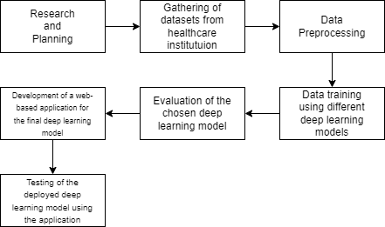

*Figure 3.1.1 Methodological Framework*

**3.2 Data Gathering Procedure**

The data collection process in this study focused on gathering and preparing 12-lead electrocardiogram (ECG) signals, which formed the basis for training and validating the deep learning model intended for atrial fibrillation (AF) detection. The researchers followed a practical and carefully structured process to make sure the data used was both reliable and of high quality. Collaborations with hospitals and clinics allowed the research team to include actual clinical ECG data, making the dataset more representative of real-life conditions. Using real-world data gave the model a stronger foundation to learn from actual ECG examples.

Before collecting any data, the researchers first took steps to get the necessary permissions from both the hospitals involved. Ethical practices were followed closely, especially when it came to keeping patient information private. Any ECG data taken from clinics or hospitals was stripped of personal identifiers to make sure that individuals couldn't be recognized in any way. All data obtained from clinics were fully anonymized to prevent the disclosure of any personal identifiers. The clinical ECG recordings typically reflected routine diagnostic use.

For this study, the ECG images were collected directly from printed clinical results provided by Dr. Topacio’s clinic. These images became the starting point for the model and were pre processed before being used in training. The main purpose of preprocessing was to make the ECG images clearer, reduce visual distractions such as shadows or background noise, and ensure that all the samples followed a uniform format. These adjustments played an important role in preparing the images for analysis through a convolutional neural network (CNN). Although the images were enhanced for clarity and consistency, they still preserved the core layout of a standard 12-lead ECG. This allowed the model to recognize and learn the visual cues commonly associated with atrial fibrillation.

**3.3 Research Design**

This study employed a quantitative research design to investigate the potential of deep learning, specifically convolutional neural networks for classifying Atrial Fibrillation (AF) and Normal Sinus Rhythm (SR) using 12-lead ECG images. The approach was chosen for its ability to analyze structured data, apply statistical techniques, and produce reproducible, measurable outcomes essential in developing a predictive diagnostic tool.

The study focused on image-based data rather than raw ECG signals. A dataset composed of ECG images sourced exclusively from the clinic of Dr. Gracita Topacio in Manila was used. All samples were verified by a licensed cardiologist, ensuring clinical relevance and diagnostic accuracy. While the dataset was relatively small, it was augmented offline to simulate real-world diversity and visual variability.

Using the EfficientNet-B0, a type of convolutional neural network (CNN), the model was trained to identify AF from Normal Sinus rhythm directly from image inputs. CNNs are well-suited for visual pattern recognition and allow the study to bypass manual feature engineering, instead learning representations of the ECG signals automatically. Throughout the training process, the study utilized metrics such as accuracy, F1-score, and ROC-AUC to objectively evaluate model performance.

To improve generalization, the model underwent iterative refinement. The preprocessing pipeline included grayscale conversion, sharpening, padding, contrast enhancement, denoising, and resizing steps that aimed to improve image clarity and ensure uniformity across inputs.

Finally, the validated model was integrated into a user-facing web application, enabling real-time diagnosis through ECG image uploads. This deployment served as a testbed for observing how the model performs under practical conditions, including variation in lighting, angle, and image quality.

The quantitative design supported the development of a scalable, data-driven tool for detecting AF. It allowed the study to remain focused on measurable outcomes, ensured statistical rigor, and laid the groundwork for broader clinical use of image-based deep learning in cardiovascular diagnostics.

**3.4 Research Instruments**

Several key instruments were utilized in the development and evaluation of the deep learning model designed to detect Atrial Fibrillation (AF) from 12-lead electrocardiogram (ECG) images. Central to this study were the ECG images themselves, which were captured from printed outputs of real patient exams at the clinic of Dr. Gracita Topacio in Manila. These images included confirmed cases of both normal sinus rhythm and atrial fibrillation, all of which were validated by a licensed cardiologist to ensure the reliability and clinical relevance of the data. Images were taken using a mobile phone camera under natural clinic conditions, introducing real-world variations such as lighting inconsistencies, shadowing, and variable framing. This method served both as a practical data collection tool and a way to test the robustness of the model against realistic capture scenarios.

To process these images and extract meaningful features, a deep learning model based on the EfficientNet-B0 architecture was employed. This architecture, developed by Google, balances depth, width, and resolution through a technique called compound scaling. It is well known for achieving high accuracy with fewer parameters, making it ideal for image-based tasks like ECG classification. EfficientNet-B0 uses Mobile Inverted Bottleneck Convolution (MBConv) blocks, along with squeeze-and-excitation (SE) modules that help the network focus on the most relevant parts of an image. Activation was handled using Swish, which improves learning dynamics. The model's relatively lightweight nature allowed it to be deployed on a web platform without requiring excessive computational resources.

Image preprocessing was a critical step in ensuring the quality and consistency of inputs. This pipeline included several techniques: Gaussian-based sharpening to enhance waveform clarity, CLAHE for localized contrast enhancement, non-local means denoising to reduce visual noise, and morphological erosion to suppress unnecessary background clutter. Padding was used to standardize image dimensions without distortion, followed by resizing to 224×224 pixels, the required input size for the model. These steps improved the model's ability to focus on actual ECG waveforms rather than being distracted by grid lines or noise introduced during image capture.

To support real-time accessibility, the model was deployed through a custom-built web application. This platform was developed using Laravel for the backend, running on a LEMP stack hosted on DigitalOcean. The web app served as the frontend interface for users to upload ECG images and receive instant feedback on the model’s prediction, allowing for quick and practical diagnostic use. It also acted as a platform for validation, as test ECGs captured from mobile phones were run through the system to assess its real-world reliability.

Overall, the instruments ranging from ECG images and mobile devices to convolutional neural networks and a fully integrated web application worked in concert to build, train, and deploy a functional diagnostic tool. Each component was selected and optimized to reflect clinical workflows, technological feasibility, and the overarching goal of making AF detection more accessible and efficient.

**3.5 Testing Methodology**

The researchers applied structured testing methodologies to evaluate whether the deep learning model functioned as intended. These tests focused on assessing the model’s accuracy in predicting and analyzing Atrial Fibrillation (AF) and Normal Sinus Rhythm (SR) based on input from 12-lead ECG images. This section details the testing procedures used throughout the development phase.

**Cross-validation**

To ensure the model could handle ECG images it had never seen before, the researchers used a technique called cross-validation. The dataset was divided into several parts, or "folds." The model was trained on most of the folds and tested on the one left out. This process was repeated until each part had been used for testing. It helped the researchers check if the model was just memorizing patterns from the training data or truly learning to recognize atrial fibrillation. By doing this, they gained a better sense of the model’s real-world reliability without relying on a single train-test split.

*d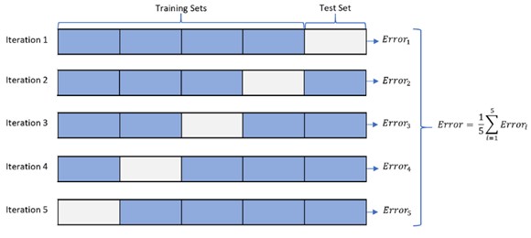*

*Figure 3.5.1 Cross-Validation*

**Performance Metrics Evaluation**

The researchers evaluated the model using standard performance metrics, including accuracy, sensitivity, specificity, F1-score, ROC-AUC, and the confusion matrix. These measures provided a balanced view of the model’s predictive strengths and its areas for improvement.

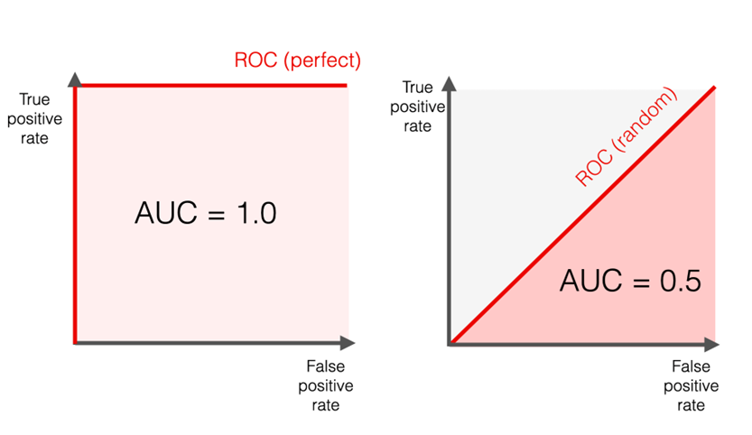

*Figure 3.5.2 ROC-AUC Curve*

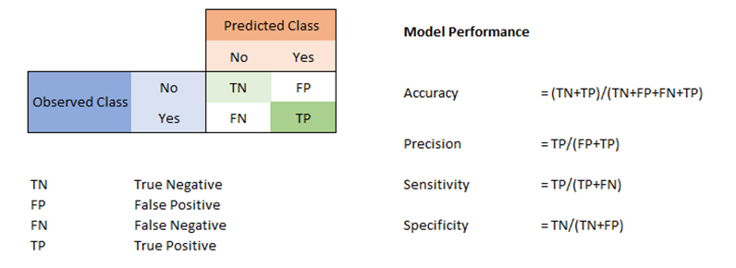

*Figure 3.5.3 Confusion Matrix*

**Clinical Validation**

To ensure clinical relevance, the researchers collaborated with licensed cardiologists for expert validation of the model's outputs. This clinical validation process assessed whether the predictions made by the model aligned with real-world diagnoses and standards of care.

**Out-of-sample testing**

The model was evaluated using out-of-sample ECG image data not included in any training or validation phases. This approach tested the model's ability to generalize and revealed its robustness under conditions that mimic real-world deployment.

**3.6 System Process and Design**

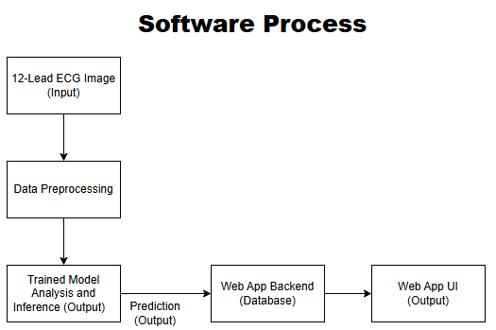

*Figure 3.6.1 System Block Diagram*

Figure 3.6.1 illustrates the block diagram of the system, comprising four primary software components: the preprocessing module, database, deep learning model, and web application. Upon receiving a 12-lead ECG image from the user, the preprocessing module initiates the data pipeline by standardizing the input. This includes operations such as resizing, normalizing, and formatting the image to meet the input requirements of the trained deep learning model.

Once preprocessing is complete, the processed ECG image is then passed to the trained EfficientNet-B0 model, which performs classification to detect potential indicators of atrial fibrillation or normal sinus rhythm.

The resulting prediction is forwarded to the backend, where it is relayed to the user interface. The frontend component of the web application then displays the diagnostic outcome to the user in a clear and interpretable format, completing the end-to-end flow of the system.

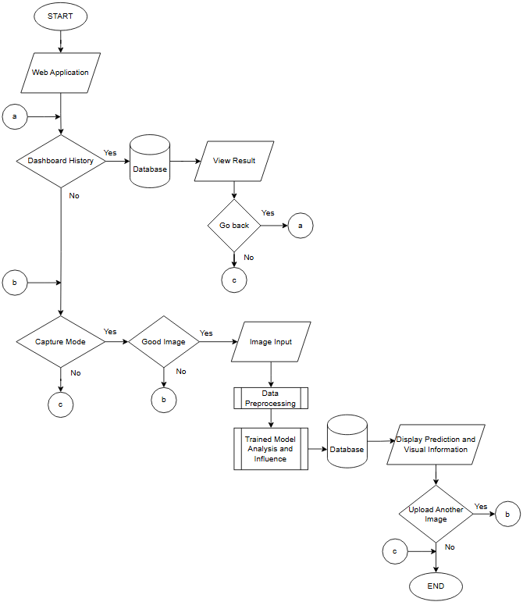

*Figure 3.6.2 System Flowchart*

**Architecture**

**EfficientNet**

EfficientNet is a type of convolutional neural network introduced by Google in 2019. What makes it different from other models is the way it scales. Instead of just making the model deeper or wider on its own, EfficientNet increases depth, width, and input resolution all at the same time using a fixed formula. This method, called compound scaling, helps the model perform better without making it unnecessarily large or slow. In the case of this study, this was helpful because the study needed something accurate for classifying ECG images, but still efficient enough to be deployed on the web without heavy hardware requirements.



where:

* d depth,
* w network width,
* r input resolution,
* a, β, y coefficients,
* Θ compound scaling factor.

This approach makes sure that the model grows in a balanced way—getting deeper, wider, and handling larger images all at once. Compared to older architectures that typically scale just one part, like depth or width, EfficientNet’s method tends to be more efficient and effective, especially when working with limited resources.

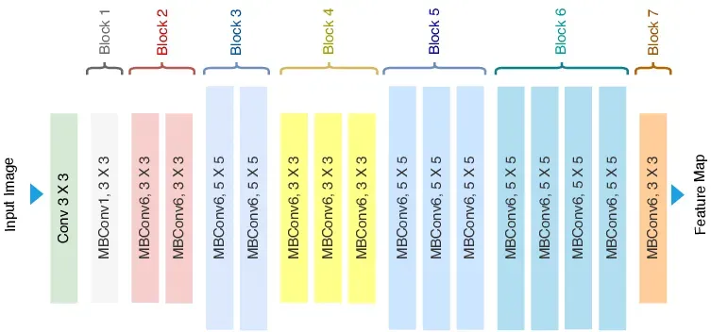

*Figure 3.6.3:* *EfficientNet Architecture*

EfficientNet builds on MobileNetV2 and introduces several improvements that help it perform well without needing a lot of computing power. One of its main features is a special kind of layer called MBConv, which helps the model focus on important details in the image while keeping things efficient. It also uses something called SE blocks, which basically help the model decide which parts of the input are more useful and should be given more attention.

Unlike most models that just increase depth or size, EfficientNet scales everything together — depth, width, and resolution — in a more balanced way. This makes it more efficient overall. The model also uses Swish, an activation function that helps it learn more smoothly than ReLU. Batch Normalization and Dropout are included too, which help with training and reduce the chance of overfitting.

EfficientNet comes in versions like B0 to B7. Smaller ones like B0 are good for mobile or light tasks, while the larger ones are better suited for more demanding jobs.

**3.7 System Components**

**Hardware Components**

* Mobile Phone – A handheld device equipped with a built-in camera was used to capture images of ECG printouts. This portable device also enabled connectivity to the internet for accessing the web-based application, making it a practical tool for testing and collecting data in various settings.

**Software Components**

* Jupyter Notebook – utilized for implementing and training deep learning models using Python.
* Google Colab – A cloud-based platform provided by Google that allowed the researchers to write and execute Python code in a Jupyter Notebook environment. It was primarily used for training, testing, and fine-tuning the deep learning model due to its built-in GPU support and ease of access for collaborative research.
* Visual Studio Code - Integrated development environment developed by Microsoft which features debugging, syntax highlighting, intelligent code completion, snippets, code refactoring, and embedded version control with Git.
* Laravel – PHP framework used for building scalable and secure web applications.
* LEMP Stack – Server setup consisting of Linux, Nginx, MySQL, and PHP for hosting web applications.
* Git - Open source version control system used by programmers to manage their code.

**3.8 System Design**

**User Interface**

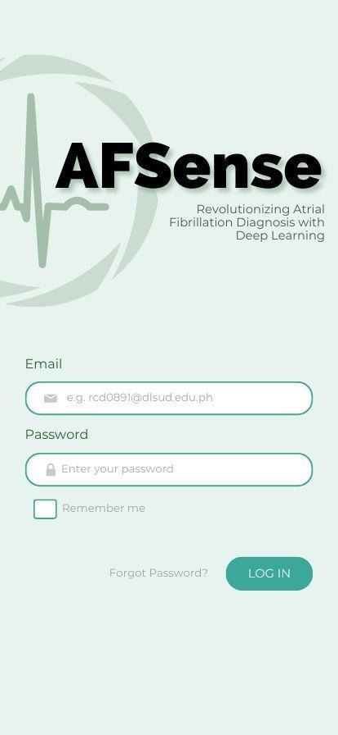

*Figure 3.8.1 Login Page*

Figure 3.8.1 showed the login page for the AFsense web application. It featured a clean and minimal design, utilizing soothing green tones for an eye-friendly experience. Users could log in using their registered accounts.

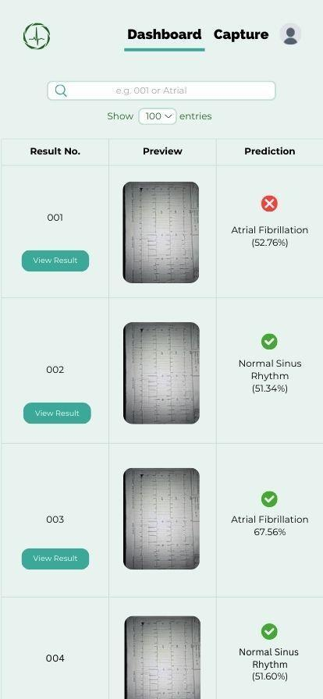

*Figure 3.8.2 Dashboard Page*

Figure 3.8.2 presents the dashboard of the AFsense web application. where users could access a list of their previously submitted ECG analyses. The users can click the view result to expand the result, and a check or X was displayed to indicate if the inference was correct or wrong. A menu icon in the upper right corner provided navigation to account information and logout settings. The overall layout was designed for clarity and ease of use, enabling efficient review and management of past results.

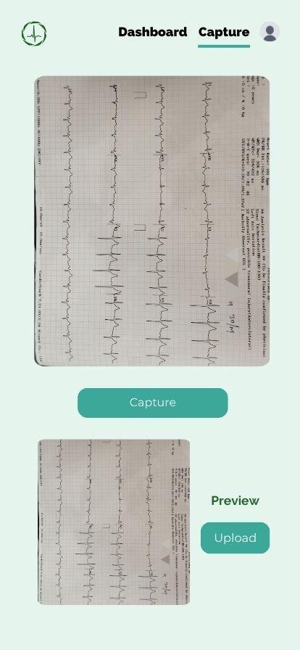

*Figure 3.8.3 Capture Page*

Figure 3.8.3 illustrates the capture page of the AFsense web application. The upper part of the page has the live camera viewfinder, once the user clicks the capture button, the preview of the captured image will be shown below. Once the user confirms that the captured image is good, the user may click the upload button to send the image to the backend with preprocessing and inference. The layout was designed to be user-friendly, allowing straightforward interaction with the application’s core functions.

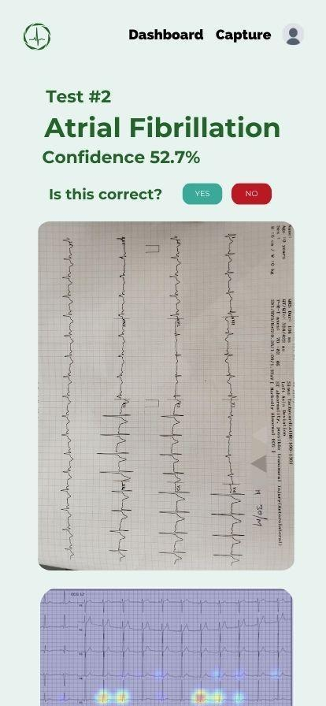

*Figure 3.8.4 Results Page*

Figure 3.8.4 displays the results page interface of the AFsense web application. This page shows the inference of the model, confidence score, validation prompt for the user if the inference is correct, and the original input image.

**Database Design**

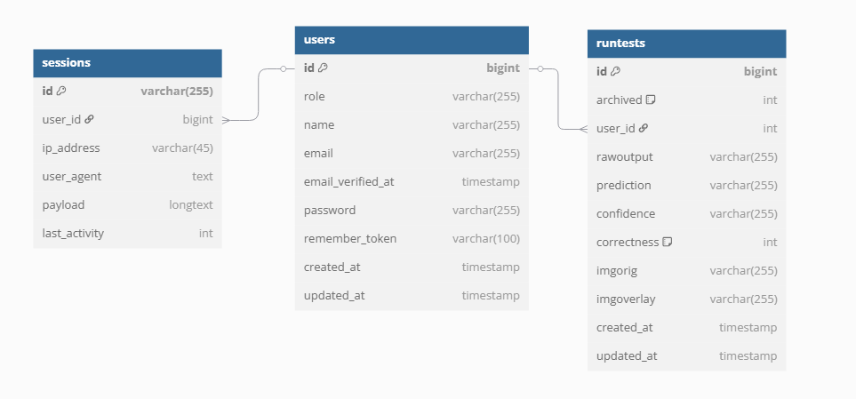

*Figure 3.8.5 Database Design*

Figure 3.8.5 illustrates the structure of the system's core database, which is composed of four interconnected tables: users, sessions, and runtests. This relational structure enables secure user management, session tracking, and diagnostic recordkeeping.

The users table serves as the central registry for all individuals using the system. It contains essential fields such as:

* Id: A unique identifier for each user (primary key).
* role: Specifies the user's role in the system (admin and user).
* name: The full name of the user.
* email: The login credential and point of contact, required to be unique.
* email_verified_at: Timestamp indicating when the user's email was verified.
* password: The securely hashed user password.
* remember_token: Used to support the “Remember Me” login feature.
* created_at and updated_at: Track when the user record was created or last modified.

This table is directly connected to both the runtests and sessions tables via the user_id foreign key, establishing relationships that help track system activity and diagnostic history per user.

The runtests table logs all AI-based diagnostic operations initiated by users. It includes:

* id: The unique identifier for each test.
* archived: Indicates whether the test result is active or archived.
* user_id: A foreign key linking the test back to the corresponding user.
* rawoutput: The unprocessed output string returned by the deep learning model.
* prediction: The diagnostic result (e.g., “AF” or “Sinus”).
* confidence: The model’s confidence score for its prediction.
* correctness: Field used for validation feedback or scoring accuracy.
* imgorig: The file path of the original ECG image uploaded.
* imgoverlay: The path to a visual Grad-CAM overlay that highlights regions the model focused on.
* created_at and updated_at: Timestamps indicating when the test was recorded and last updated.

This relationship allows the system to accurately associate every model-generated diagnosis with the specific user who submitted the ECG data.

The sessions table is responsible for managing and storing active login sessions within the system. Its key fields include:

* id: A unique session identifier.
* user_id: Links the session to a specific user.
* ip_address: Shows where the user logged in from.
* user_agent: Identifies the browser or device used.
* payload: Serialized session data used internally by Laravel.
* last_activity: Integer timestamp recording the most recent activity during the session.

This table enhances security and provides transparency regarding login behaviors and access history.

**CHAPTER 4**

**RESULTS AND DISCUSSION**

This chapter outlines the outcomes of building, training, and evaluating a deep learning model developed to detect atrial fibrillation (AF) from 12-lead ECG images. It includes a discussion of the model’s performance, the validation process, and how the system was implemented in practice. These results are interpreted considering the research objectives stated in Chapter 1 and are also compared with prior studies reviewed in Chapter 2. Lastly, the chapter explores the practical value of the findings, while acknowledging the system’s strengths and limitations in terms of clinical application.

**4.1 Web Application**

To support the real-time diagnosis capabilities of the deep learning model, a dedicated web application was developed and deployed using structured and scalable architecture. This system enables users to upload ECG images, view classification results, and interact with their data in a meaningful way. The following section outlines both the backend deployment process, and the frontend functionalities provided to users and administrators.

**4.1.1. Server Setup and Environment Configuration**

The web application was deployed using a virtual private server hosted on DigitalOcean. An Ubuntu-based droplet was configured as the base environment. Within this server, a dedicated directory (/var/www/script) was prepared to handle execution of Python-based inference scripts. These scripts were verified through command-line testing to ensure stability.

**4.1.2. LEMP Stack Installation**

A LEMP (Linux, Nginx, MySQL, PHP) stack was installed to support the Laravel framework. The setup included:

* Nginx as the web server
* PHP and PHPMyAdmin for server-side logic and database access
* MySQL as the database engine

Git was configured to manage source control and deployment, allowing updates to be pushed easily from the local development environment to the production server.

**4.1.3. Laravel Setup and Interface Development**

Laravel was used to handle both backend operations and frontend interface development. The initial setup involved:

* Designing the user interface with clean navigation
* Implementing login, registration, and camera-based image capture
* Enabling ECG image uploads and local file storage
* Creating the database structure via Laravel migrations
* Preparing a basic result display for future integration with backend scripts

At this stage, Laravel’s frontend operated independently, while script integration was planned for the next development phase.

**4.1.4. User Features and Interface**

The system offers multiple pages tailored to standard users:

* **Register Page**

New users can create an account by providing a valid email address, a secure password, and a confirmation of that password. The password is validated using specific security criteria—it must be at least 12 characters long and include at least one uppercase letter, one lowercase letter, and one number. This ensures that user credentials are protected by strong password standards.

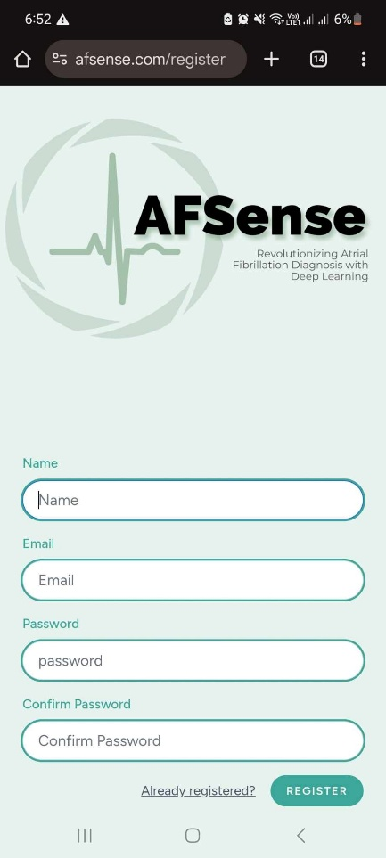

*Figure 4.1.4.1 Register Page*

* **Login Page**

To access the system, users input their registered email and password. Upon submitting valid credentials, the system initiates a two-step verification process. A One-Time Password (OTP) is generated and sent to the user’s email. The user must input the correct OTP to complete the login. Once verified, they are redirected to the dashboard.

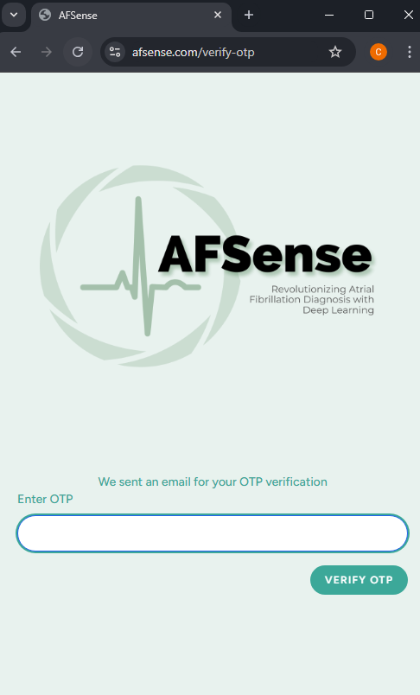

*Figure 4.1.4.2 Login Page and OTP Page*

* **Dashboard Page**

Displays a list of past ECG uploads, each with a preview image, predicted result, and a “View Result” button. A search bar allows quick filtering, while a dropdown lets users customize how many entries are displayed per page (e.g., 10, 25, 50).

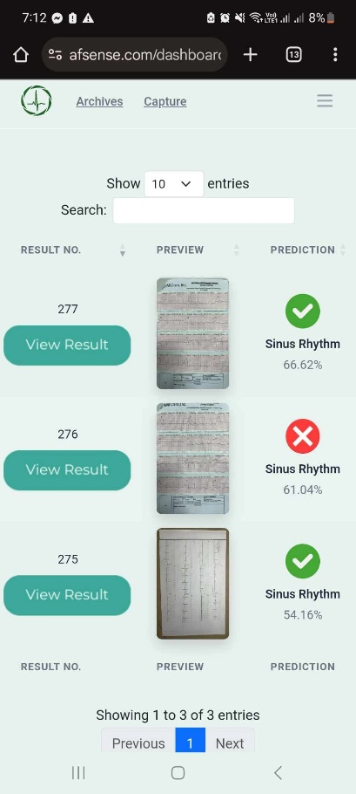

*Figure 4.1.4.3 Dashboard Page*

* **Capture Page**

Allows users to take a photo of their ECG using their device’s camera. A preview of the image is shown immediately, with options to recapture or proceed to upload. Once uploaded, users are redirected to the View page.

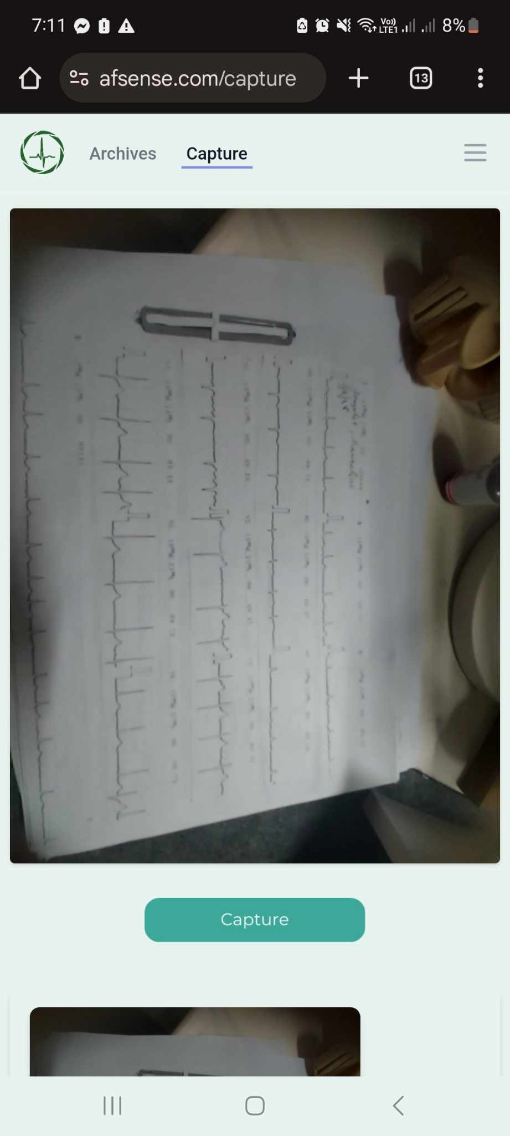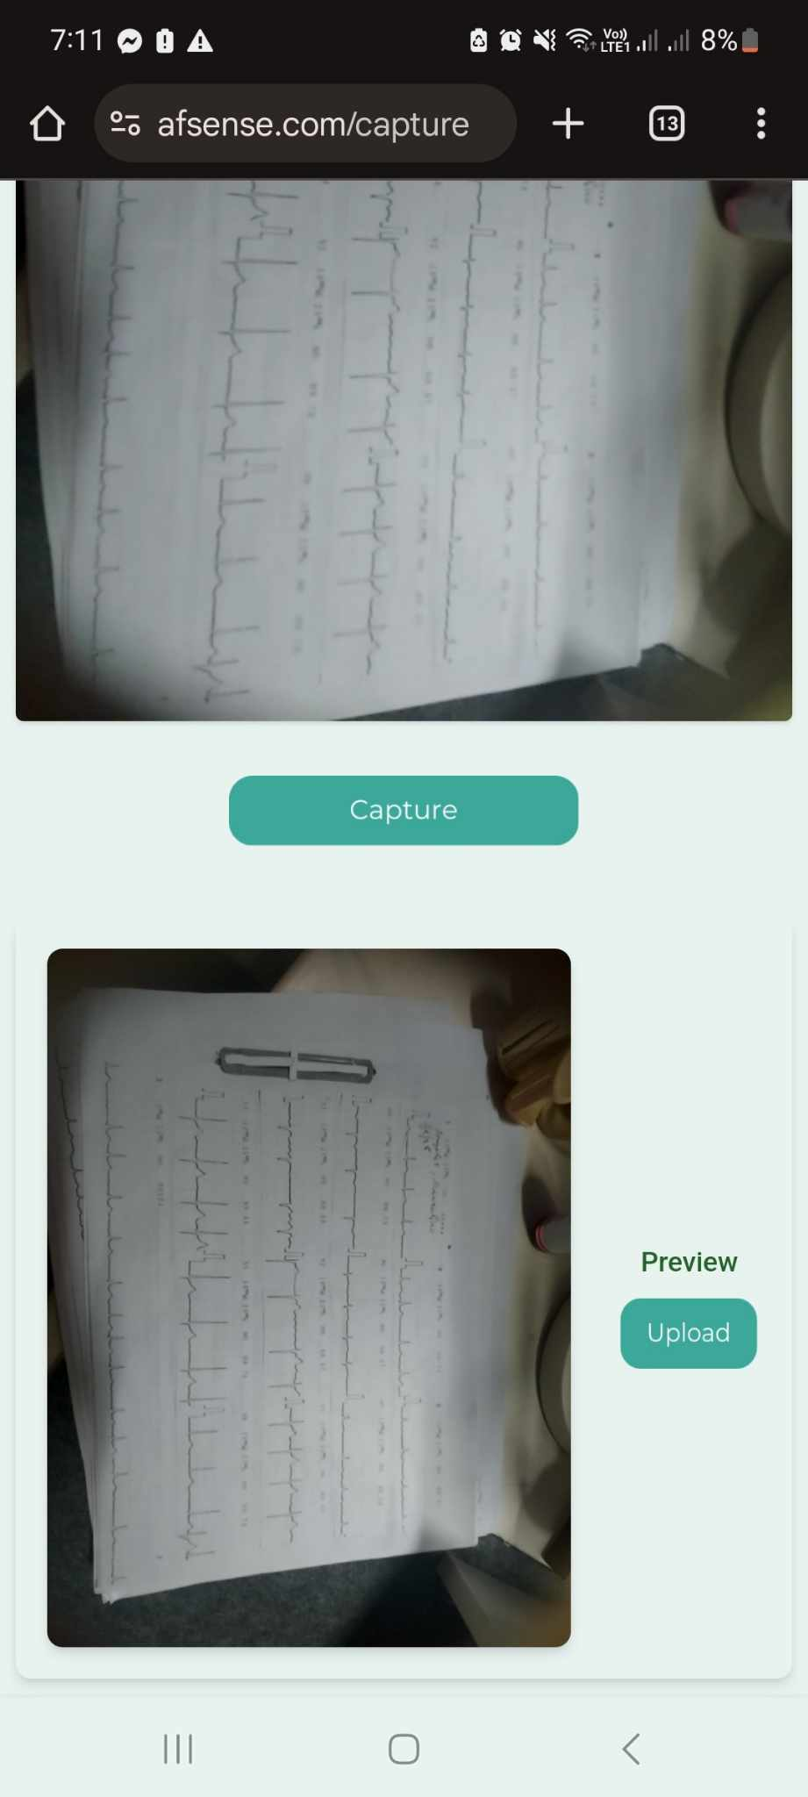

*Figure 4.1.4.4 Capture Page*

* **View Page**

Displays the uploaded ECG image, the model’s prediction, and a confirmation prompt: “Is this correct?” Users can click "Yes" or "No" to verify the prediction. A heatmap is displayed below the image, showing what the model focused on. An archive button is available for storing the record.

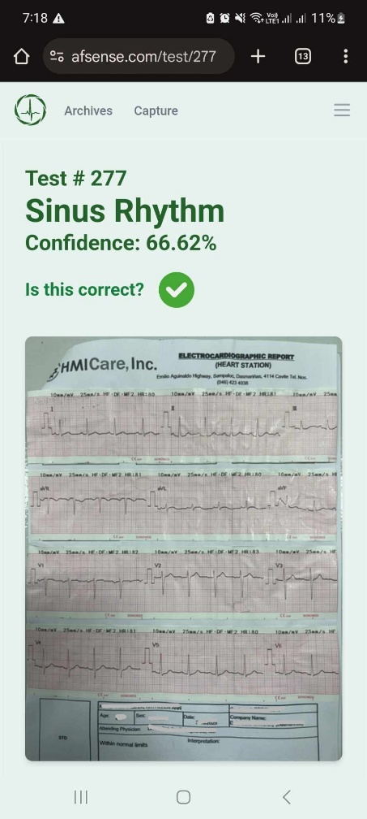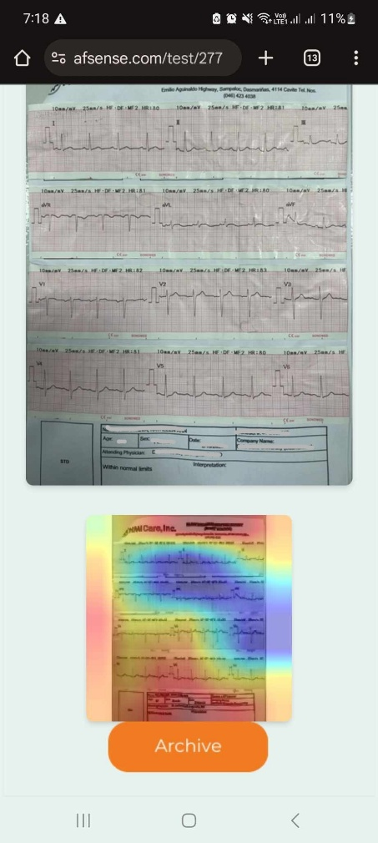

*Figure 4.1.4.5 View Page*

* **Archive Page**

This page contains all ECG entries that users have chosen to archive. The layout is like the dashboard, with each archived entry displaying a preview image and prediction result. Search functionality and a customizable "show entries" dropdown are also available. This page helps users organize and revisit past data without cluttering their main dashboard.

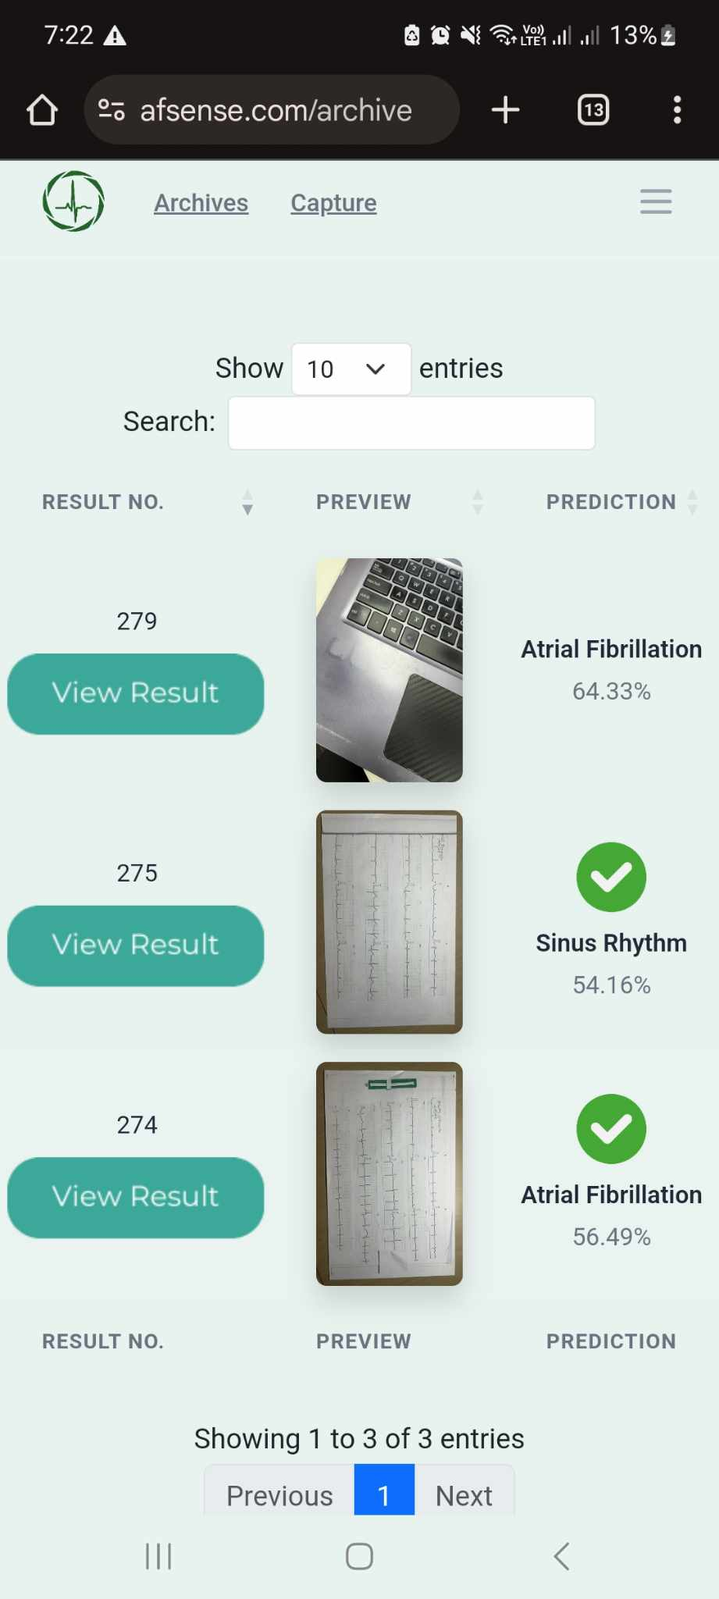

*Figure 4.1.4.6 Archive Page*

* **Profile Page**

Users can view their name and email, change their password, or delete their account. A profile dropdown in the navigation bar includes links to the profile and a logout option.

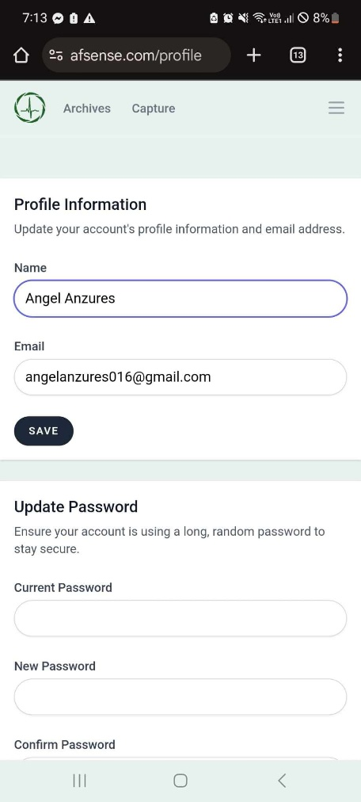

*Figure 4.1.4.7 Profile Page*

**4.1.5. Admin Features**

Users with administrative roles are given access to additional management tools:

* **Reports Page**

Provides a log of all diagnostic entries, showing user ID, name, email, prediction results, confidence scores, and creation date. Filters for date range and search functionality allow refined viewing. Reports can be exported in PDF or Excel format.

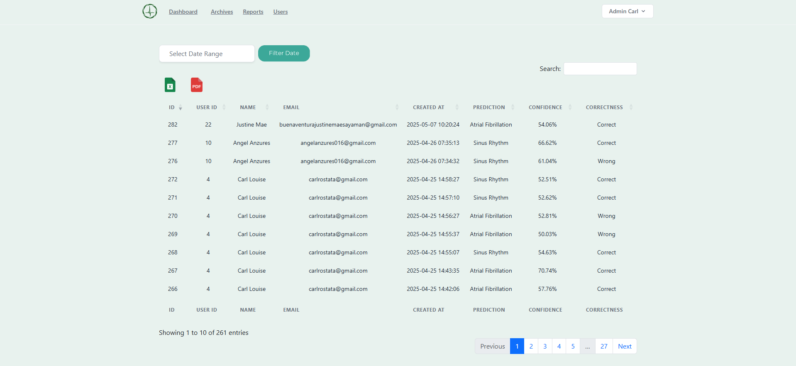

*Figure 4.1.4.8 Reports Page*

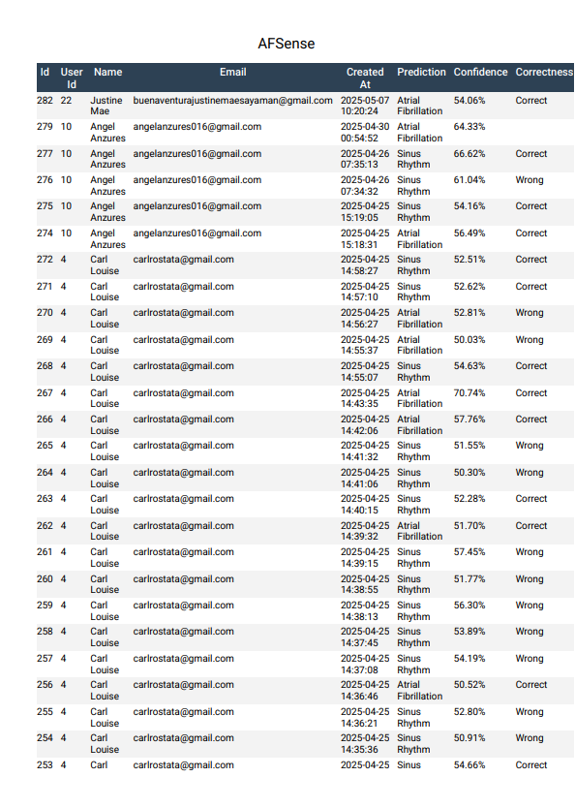

*Figure 4.1.4.9 Reports Generated PDF File*

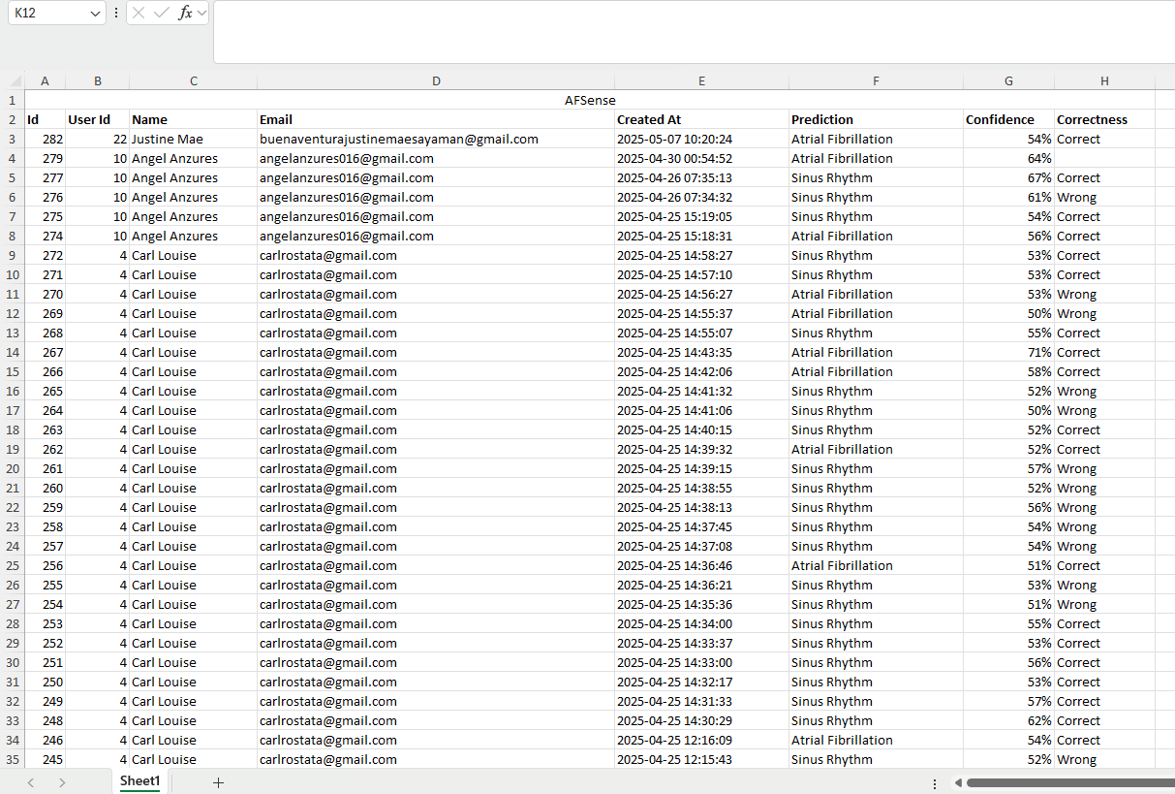

*Figure 4.1.4.10 Reports Generated Excel File*

* **User Management Page**

Lists all registered users with their ID, name, role, and email. Admins can promote users to admin status, demote admins to user level, or delete accounts. Changes are confirmed via a dropdown and "Apply" button.

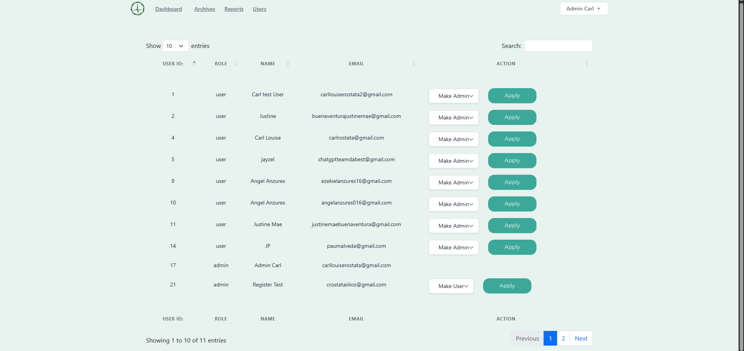

*Figure 4.1.4.11 User Management Page*

Admins also have extended access to delete ECG records entirely, while standard users can only archive their entries.

**4.1.6. Laravel-Git Integration and Deployment Workflow**

Laravel code was pushed to the server using Git. After deployment, the following commands were executed on the server:

* composer install and npm run build to install dependencies and compile assets
* php artisan migrate to initialize the database structure

This deployment approach ensured consistent behavior between the development and production environments.

**4.1.7. Script Integration and Inference Handling**

To enable prediction functionality, Laravel was configured to:

* Execute Python scripts via exec command-line calls
* Pass the uploaded ECG image path as an argument
* Capture the model’s prediction and confidence score
* Display the results and heatmap on the View page

All integration tests and adjustments were performed directly on the server to ensure compatibility with the live environment.

**4.2.** **Web App Functionality Testing**

To make sure the web application works smoothly and is easy to use, we asked Dr. Gracita Topacio, a licensed cardiologist, to test it using actual ECG images. Although she doesn’t consider herself tech-savvy, she was open-minded and eager to try out the system. Her feedback was incredibly helpful, especially from a medical point of view.

She went through all the main features, from creating an account to checking the model’s predictions, and rated each one based on her experience.

Here’s what she said:

| **Feature** | **Description** | **Rating** | **Remarks from Dr. Gracita Topacio** |
| --- | --- | --- | --- |
| **Register Page** | Signing up with a secure password | 10 | “Easy to use. I like that the password needs to be strong.” |
| **Login Page with OTP** | Logging in with a code sent to email | 8 | “The extra step is great for security. Maybe just add a short note explaining what is happening.” |
| **Dashboard** | List of uploaded ECGs with filters | 10 | “Full of details. I could find everything quickly.” |
| **Capture Page** | Taking an ECG photo using the device camera | 9 | “It’s fast and simple—no confusion at all.” |
| **Upload & Redirect** | Uploading image and moving to the next page automatically | 10 | “Straight to the point, not hard to use.” |
| **Prediction Display** | Shows the model’s output and confidence | 7 | “Clear result, but I don’t know how to interpret confidence score.” |
| **Feedback Buttons (Yes/No)** | Confirming if the prediction is correct | 10 | “This part makes me feel involved. It’s nice that I can give my own input.” |
| **Heatmap (Grad-CAM)** | Visual focus of the model shown below the ECG image | 10 | “This really stood out to me. It helped me understand where the AI was focusing. That’s very useful for insight” |
| **Archive Feature** | Option to store certain ECGs for archive | 8 | “It’s working well. Maybe it would be nice if we could add short labels to each archive for faster recall.” |
| **Archive Page** | Viewing previously archived ECGs | 8 | “This is helpful. I can go back to old results without cluttering the main list.” |
| **Profile Page** | View personal info, change password, delete account | 8 | “All the options are here. It’s good that I can update my info whenever I needed” |
| **Reports Page (Admin)** | Downloadable logs of all tests in PDF/Excel | 10 | “Very helpful! I can see this being used in a clinic or hospital to track patients.” |

**Overall Impression**

Dr. Topacio shared that she enjoyed using the web app. Despite not being very technical, she said it felt comfortable and intuitive. The features, especially the heatmap and the ability to give feedback, made her feel that the system was built with doctors in mind. She also noted that everything looked clean and professional, and she could see this being used in real clinics for actual patient data.

**4.3. Comprehensive Security Design**

To ensure confidentiality, integrity, and security of user data within AFSense web application, a security architecture was implemented. The system was developed using Laravel, a robust PHP framework that provides a suite of security features suitable for handling sensitive information in a web-based environment.

One core element of the design is Cross-Site Request Forgery (CSRF) protection. Laravel automatically generates a unique token for each user session, which is required for all form submissions. This token is embedded in the form using the @csrf directive and is validated on the server side to prevent forged requests from unauthorized sources.

To protect against SQL injection attacks, the system utilizes Laravel’s Eloquent ORM and Query Builder. These components use prepared statements and parameter binding by default, which ensures that user inputs are not directly executed in database queries. This prevents attackers from manipulating SQL statements to access or alter protected data.

Cross-Site Scripting (XSS) prevention is handled through Laravel’s Blade templating engine. Blade automatically escapes output, which ensures that any user-generated content is displayed as plain text rather than executable code. This mitigates the risk of malicious scripts being injected into the web interface.

Secure communication is enforced through HTTPS across all pages of the platform. SSL/TLS certificates issued by Let’s Encrypt were integrated into the server configuration, ensuring that all data transmitted between users and the server is encrypted. The platform supports modern protocols, including TLS 1.2 and 1.3, and uses strong cipher suites to protect against interception and tampering.

To safeguard sensitive configuration details, access to environment configuration files such as .env is restricted at the server level. These files contain database credentials, encryption keys, and API tokens, and are not accessible through the browser or external requests.

The system also applies encryption at rest for critical data such as diagnostic results and user credentials. Laravel’s Crypt facade is used to encrypt sensitive values before storing them in the database, while user passwords are hashed using the Hash facade, which applies the Bcrypt and Argon2 hashing algorithm. This ensures that even if the database is compromised, the data remains unreadable and secure.

Together, these security measures form a comprehensive strategy to protect the ECG diagnosis platform from common vulnerabilities. By leveraging Laravel's built-in security mechanisms and applying secure development practices, the system maintains a high standard of data protection suitable for healthcare applications.

**4.4. Security Testing**

To verify the effectiveness of the implemented security measures in the ECG diagnosis platform, a series of automated and manual tests were conducted. These tests were selected based on the features outlined in the system’s security design and aim to validate the platform’s resilience against common web-based vulnerabilities. The table below presents a summary of each test, the method used, the observed result, and the final findings.

|  |  |  |  |  |
| --- | --- | --- | --- | --- |
| **#** | **Security Feature** | **Test Method** | **Result** | **Summary of Findings** |
| 1 | HTTPS & TLS Encryption | SSL/TLS Scanner (Pentest-Tools) | TLS 1.2/1.3 supported, strong ciphers, valid cert | Secure communication is enforced |
| 2 | CSRF Protection | Manual DevTools + form tampering | 419 Page Expired returned when _token was removed | CSRF tokens enforced by Laravel middleware |
| 3 | SQL Injection Protection | SQLi Scanner (Pentest-Tools) | No injectable parameters found | System is protected against SQL injection |
| 4 | XSS Protection | XSS Scanner (Pentest-Tools) | No exploitable XSS found; one harmless reflection | Blade escaping protects user input |
| 5 | Server Exposure & Recon | Web Recon  (Pentest-Tools) | No sensitive files found; only server version exposed | No critical leaks; server info is minimal |
| 6 | .env File Exposure | Manual direct URL access | /env and /.env returned 404 | Environment configuration is not publicly accessible |
| 7 | Encrypted Storage of Diagnostic Data | phpMyAdmin inspection | User password and session values appear encrypted/hashed | Data at rest is protected via Laravel encryption |

The scanner found no SSL/TLS vulnerabilities on port 443. The server supports secure protocols (TLS 1.2 and 1.3) and is not vulnerable to Heartbleed, ROBOT, POODLE, or other known attacks. This confirms encrypted communication and robust TLS configuration.

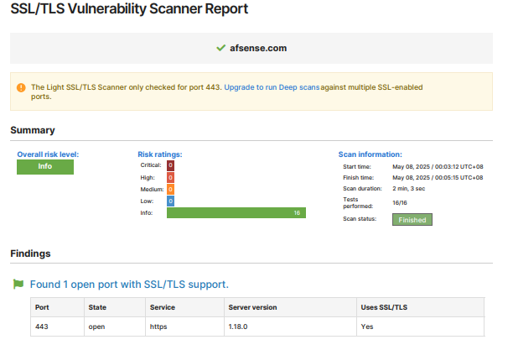

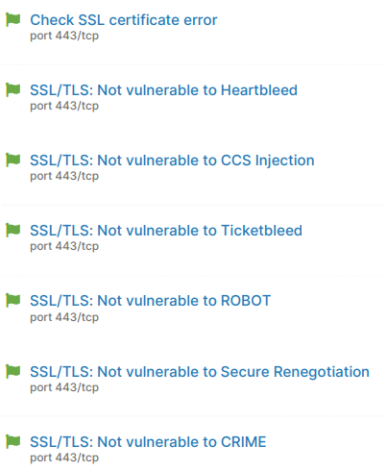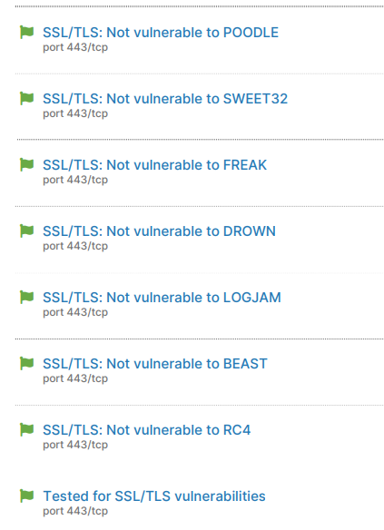

*Figure 4.4.1: SSL/TLS Scanner Report showing valid certificate and TLS 1.3 support*

The SQL Injection scanner performed multiple payload tests on forms and endpoints. No SQL injection vulnerabilities were found. Laravel's use of Eloquent ORM and validation likely prevented direct injection attempts.

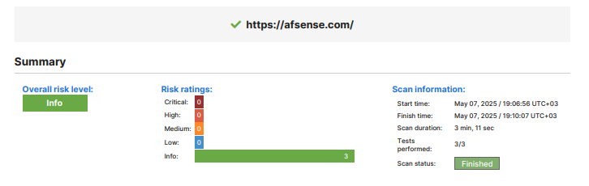

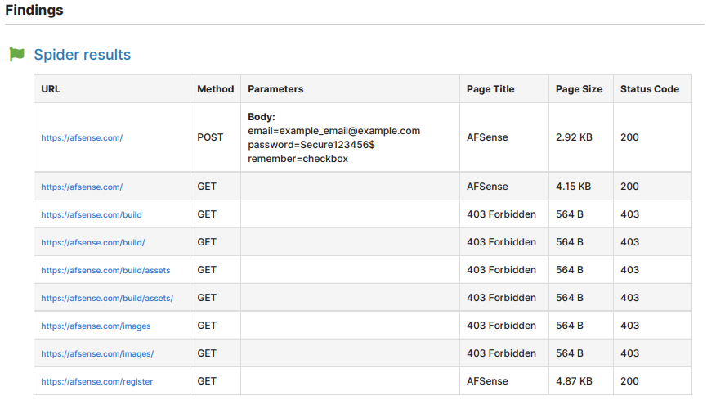



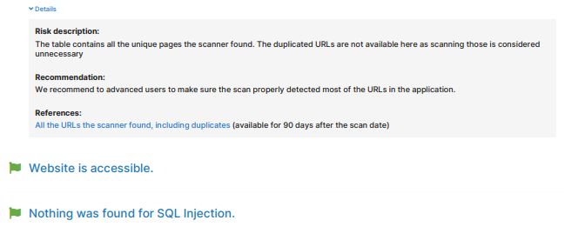

*Figure 4.4.2. SQL Injection Scan Report with no injection found*

One input (email field) was reflected in the server response but did not execute as a script. This confirms no exploitable XSS vulnerabilities. The reflection was noted as informational, not a confirmed risk.

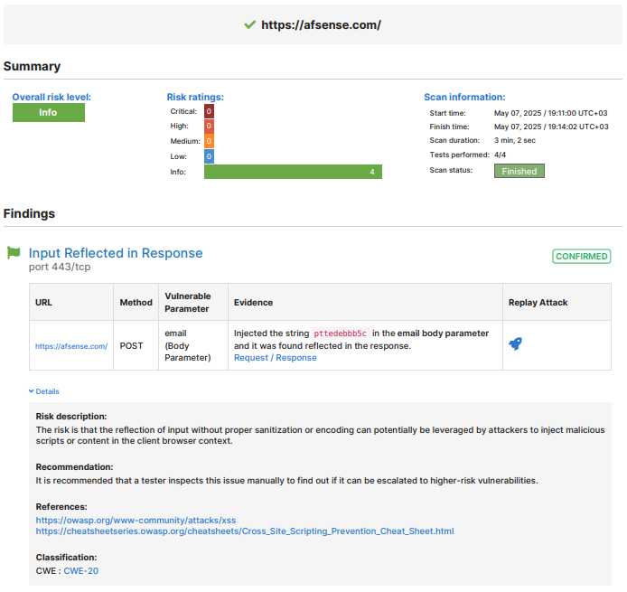

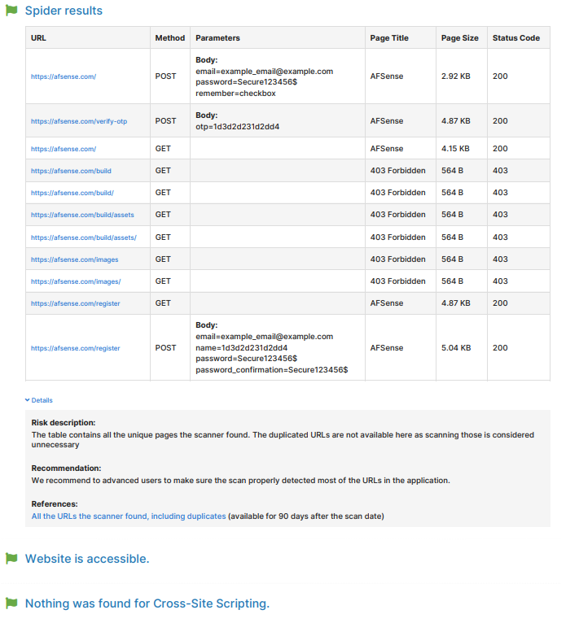

*Figure 4.4.3. XSS Scanner Report showing no vulnerabilities*

The scan detected the use of NGINX and Ubuntu through server headers. While this minor information exposure poses low risk, no sensitive files or misconfigurations were found.



*Figure 4.4.4. Web Recon results showing limited exposure*

In a manual test, the hidden CSRF token was removed from the form using browser DevTools (Inspect element). Upon submission, Laravel returned a 419 Page Expired response. This confirms CSRF protection is enforced by the framework.

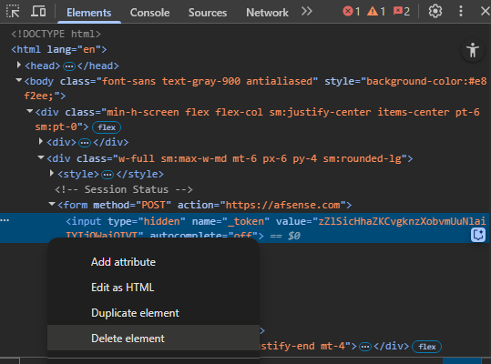

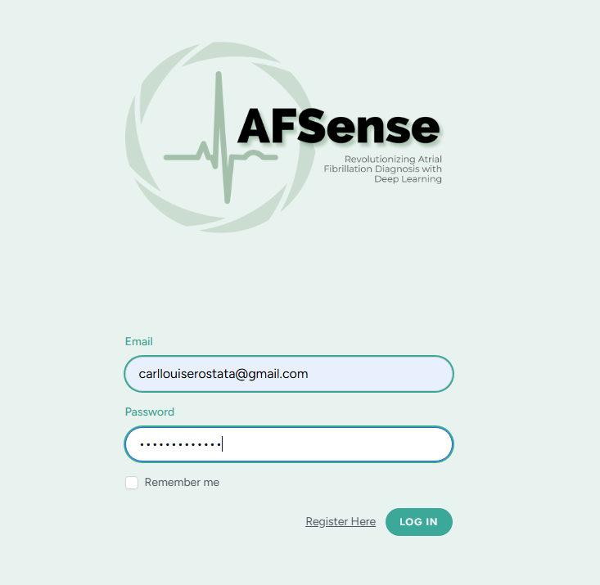



*Figure 4.4.5. Screenshot of deleted _token from form and resulting 419 Page Expired error*

A manual attempt to access /.env returned a 404 error. This proves that the Laravel environment file is correctly protected from public access, following secure deployment guidelines.



*Figure 4.4.6. Screenshot of denied .env access (404)*

A review in phpMyAdmin showed that session information and user passwords are stored in encrypted or hashed format, indicating proper data protection at rest. This confirms that Laravel’s Crypt::encrypt and Hash::make are functioning well.

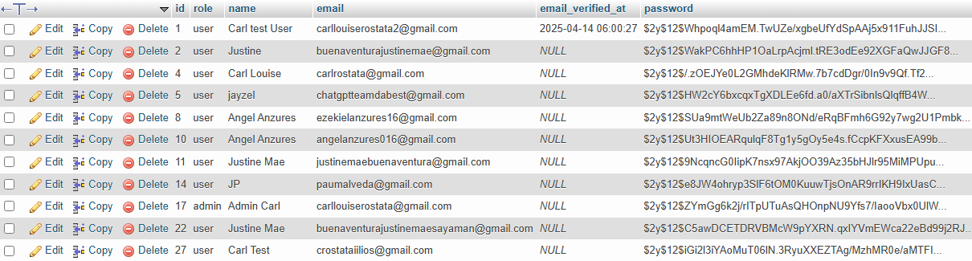

*Figure 4.4.7. Screenshot from phpMyAdmin showing encrypted user passwords*

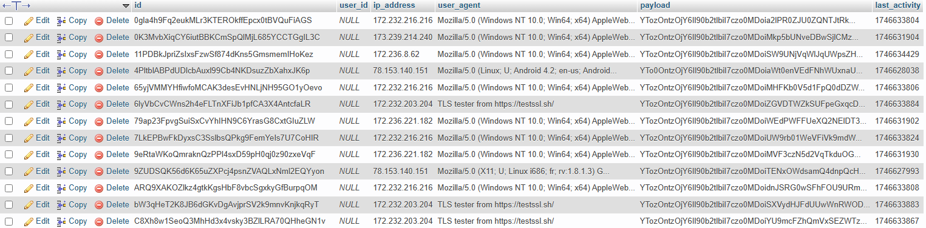

*Figure 4.4.8. Screenshot from phpMyAdmin showing encrypted session information*

**4.5 Dataset Description/Overview**

The dataset used in this study consisted of 12-lead electrocardiogram (ECG) images categorized into two classes: Atrial Fibrillation (AF) and Normal Sinus Rhythm (SR). These ECG images were sourced from ECG printouts collected from healthcare facilities, particularly from Dr. Topacio’s clinic in Manila.

#### Dataset 1 – Baseline Synthetic Dataset

* Composed of 73 original ECG images per class, with 365 augmented images per class, totaling 876 samples (438 AF, 438 SR).
* No preprocessing was applied to the images.
* Images were padded into squares to maintain signal proportions and avoid waveform distortion.
* All images were resized to 224×224 pixels to match the model input requirement.

#### Dataset 2 – Real-World ECG Images (Raw)

* Contained 121 original ECG images per class, augmented to a total of 1936 samples.
* These were sourced from real-world ECG printouts captured via phone camera or scan, representing realistic clinical variability.
* Images were manually cropped to isolate the ECG waveform area.
* No denoising or preprocessing was applied, resulting in many noisy samples (e.g., rotated angles, inconsistent lighting, grid overlays, non-uniform paper backgrounds, and visible camera artifacts).

#### Dataset 3 – Preprocessed and Augmented Real-World ECG Images

* Contained 121 original ECG images per class, augmented to a total of 1930 samples.
* Built upon Dataset 2 using the same original ECG images, but underwent a detailed preprocessing pipeline:
  + Grayscale conversion
  + Noise reduction via fastNlMeansDenoising
  + Morphological erosion
  + Padding to square dimensions
  + Image sharpening
  + Resizing to 224×224
* Extensive data augmentation was applied to increase variability and simulate real-world conditions:
  + Random rotation, brightness and shadow adjustments, scaling, and horizontal flips

**4.6 Performance Evaluation of Models**

To determine the most effective deep learning architecture for classifying ECG images into Atrial Fibrillation (AF) and Normal Sinus Rhythm (SR), five pre-trained models were evaluated: ResNet18, VGG16, MobileNetV2, EfficientNet-B0, and InceptionV3. Each model was fine-tuned for binary classification and tested on preprocessed and augmented ECG datasets.

The evaluation metrics included:

* Accuracy
* F1-score
* ROC-AUC (Area Under the ROC Curve)
* Sensitivity (Recall)
* Specificity

#### **Observations and Model Insights**

* **EfficientNet-B0**

Offers the best overall balance between performance and efficiency. It consistently identified both normal sinus and AF cases with high reliability and showed strong generalization, even when trained on a relatively small dataset. Its ability to scale features effectively, while remaining computationally efficient, makes it highly suitable for clinical applications where both accuracy and practicality matter.

Why it may not be good:  
 Although efficient, it still requires a reasonable amount of training time. When applied to more diverse or unstructured datasets, it may need additional fine-tuning to maintain its performance.

Dataset requirement:  
 Performs well on small to medium datasets when supported by good preprocessing and augmentation. For broader use, a more diverse dataset would further strengthen generalization

* **InceptionV3**

It showed excellent precision and consistent performance throughout training. It was particularly effective at avoiding false positives, making it valuable in contexts where accurate identification of normal cases is just as important as detecting abnormalities. Its multi-scale architecture enabled it to extract complex features from ECG images effectively.

Why it may not be good:  
The model is resource-intensive and slower to train. It was also slightly less aggressive in identifying AF cases, which might not be ideal when high sensitivity is the main goal.

Dataset requirement:  
 Best suited for medium to large datasets. It benefits greatly from well-labeled, clean data and class balance to fully utilize its capacity

* **MobileNetV2**

Is optimized for speed and low memory usage, making it ideal for deployment on mobile or embedded devices. It learned quickly in early training stages and showed promise in low-resource environments.

Why it may not be good:  
 The model’s stability decreased over time. It was prone to fluctuations in performance and overfitting when trained longer, limiting its reliability for consistent diagnostics.

Dataset requirement:  
 Requires at least a moderately sized dataset with well-designed augmentation to maintain accuracy and prevent overfitting.

* **ResNet18 and VGG16**

Underperformed significantly compared to the other models. ResNet18 showed unstable results across epochs and was highly sensitive to noise and augmentation, indicating poor generalization. While it trained quickly, its inconsistency and tendency to overfit made it unreliable for clinical use.

VGG16, on the other hand, failed to distinguish between normal and abnormal cases, often predicting everything as AF. Despite its depth and established reputation, it heavily overfit the training data and lacked the flexibility to adapt to small, balanced datasets.

Dataset requirement: Both models require larger, more diverse datasets to perform effectively. In low-data environments, they are highly prone to overfitting and misclassification, limiting their suitability for real-world diagnostic tasks.

#### Overfitting Analysis

* EfficientNet-B0 showed minimal overfitting throughout training. The gap between training and validation performance remained small, and both loss and accuracy curves stayed aligned. This indicates that the model learned meaningful features from the data rather than memorizing it. Its strong generalization is a key reason it performed best overall.
* InceptionV3 had slightly more overfitting than EfficientNet-B0 but still within acceptable levels. There was a minor divergence between training and validation metrics toward the later epochs, but the model maintained stable performance. It managed to generalize well, although with a bit more sensitivity to training noise and complexity.
* MobileNetV2 exhibited noticeable overfitting, especially in the last few epochs. The training accuracy continued to improve while validation accuracy began to drop. This indicates that the model started memorizing training data rather than learning general patterns. It suggests that MobileNetV2 may require stronger regularization or early stopping in future use.
* InceptionV3 and MobileNetV2 showed increasing divergence between training and validation curves in later epochs, suggesting the models began memorizing training data.
* ResNet18 & VGG16 both suffered from significant overfitting.
  + ResNet18 showed erratic training behavior, with sharp fluctuations in validation performance, likely due to its sensitivity to augmentation artifacts and small dataset size. It learned too quickly and generalized poorly.
  + VGG16 overfit heavily—training accuracy was high, but validation performance collapsed. It failed to balance learning and simply memorized patterns, leading to extremely poor generalization.

#### Final Model Selection

1. Primary Model: EfficientNet-B0
   * Best generalization capability
   * Highest sensitivity and ROC-AUC
   * Minimal overfitting
2. Secondary Model: InceptionV3
   * Comparable accuracy and F1-score
   * Higher specificity
   * Slight overfitting in later epochs

**4.6.1 Evaluation Metrics**

To comprehensively evaluate the performance of the deep learning models, several metrics were employed, each offering unique insights into the model’s ability to classify Atrial Fibrillation (AF) and Normal Sinus Rhythm from ECG images. The selection of these metrics was guided by the clinical significance of AF detection and the need for high diagnostic reliability.

True Positive (TP). This refers to instances where the model correctly identifies an ECG recording as atrial fibrillation (AF) when the condition is indeed present.

False Positive (FP). These are cases in which the model incorrectly classifies an ECG exhibiting normal sinus rhythm as atrial fibrillation.

True Negative (TN). This denotes instances where the model accurately predicts an ECG as normal sinus rhythm when the patient truly exhibits a normal sinus rhythm.

False Negative (FN). These occur when the model fails to detect atrial fibrillation, instead classifying the ECG as normal sinus rhythm despite the actual presence of AF.

#### **Accuracy**

Accuracy measures the proportion of correct predictions (both AF and Normal Sinus) among the total number of cases. While it is a common metric in classification tasks, it can be misleading in imbalanced datasets, where one class (e.g., Normal Sinus Rhythm) may dominate. However, due to balanced class representation in the augmented dataset, accuracy remained a meaningful metric for overall model performance.

*Accuracy= TP+TN​/TP+TN+FP+FN*

#### **Sensitivity**

Recall refers to the proportion of actual positive cases (AF) that were correctly identified. In the context of AF detection, recall is especially important, as missing a true AF case can result in serious complications such as stroke or heart failure. Therefore, high sensitivity is prioritized to ensure that AF cases are rarely missed.

*Recall=TP​/TP+FN*

**Specificity**

Specificity (True Negative Rate) reflects the model’s ability to correctly identify normal (Normal Sinus) cases. High specificity ensures that patients without AF are not wrongly flagged, which helps reduce unnecessary clinical attention or treatment.

*Specificity=TN​/TN+FP*

#### **F1-Score**

The F1-score is the harmonic mean of precision and recall. It provides a balanced measure of the model’s accuracy, particularly when the cost of false positives and false negatives are both significant. It is an essential metric in this study due to handling class imbalance and its alignment with clinical risk sensitivity.

*F1-score= 2TP​/2TP+FP+FN*

#### **ROC-AUC (Receiver Operating Characteristic – Area Under the Curve)**

The ROC-AUC score provides a measure of the model's ability to distinguish between classes across all decision thresholds. A higher AUC indicates better model discrimination between AF and SR. It is especially valuable when comparing the performance of multiple models.

*FPR=FP​/FP+TN*

**4.6.2 Model Performance Comparison**

Visual Comparison of Model Metrics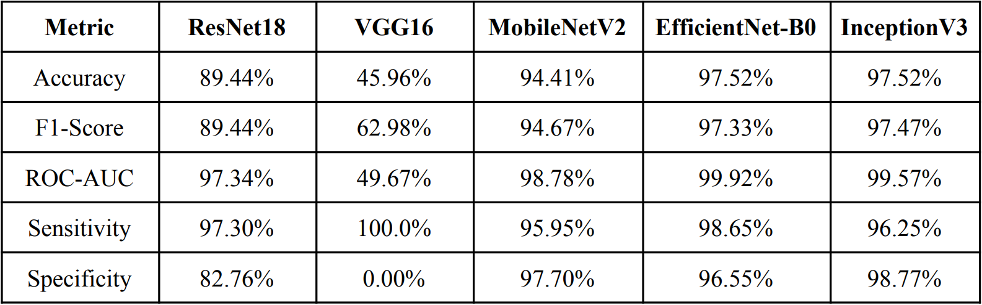

*Figure 1* shows a visual comparison of each model across five performance metrics. EfficientNet-B0 and InceptionV3 clearly outperform the others in most categories. VGG16, on the other hand, struggled significantly achieving high sensitivity but 0% specificity, meaning it failed to correctly identify any non-AF cases.

In addition to its superior metric performance, EfficientNet-B0 was selected primarily because it demonstrated the most stability during training and consistently learned from the dataset without significant fluctuations. Its architecture also proved to be well-suited for the relatively small and augmented dataset, making it an ideal choice for data-constrained environments like this study. While the performance metrics across all models appear promising, it is important to note that these results are part of an initial evaluation phase. The metrics may reflect a degree of overfitting due to the dataset’s size and the limited number of training epochs. At this stage, the goal was not to finalize model deployment but to identify which architecture is best suited for further development and fine-tuning.

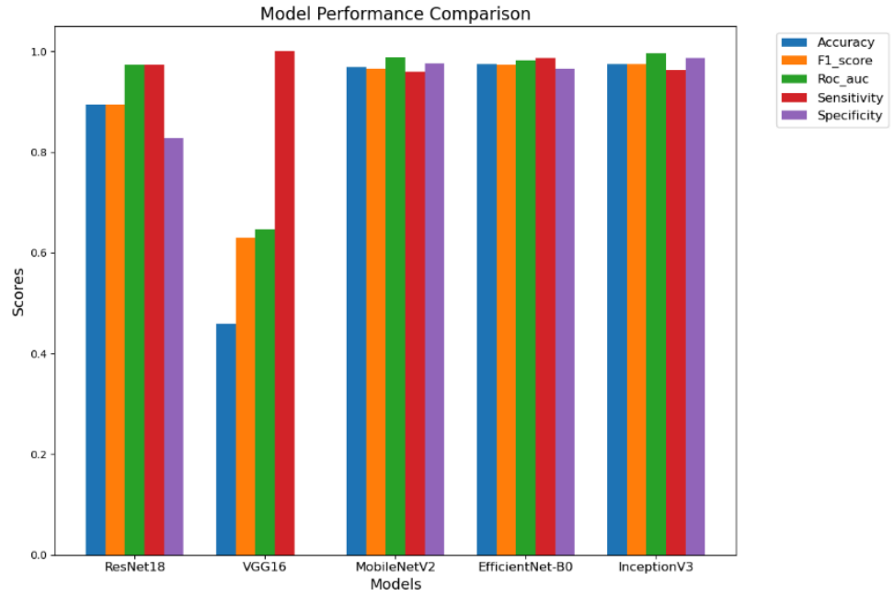

*Figure 2* illustrates a comparative view of all five models across five key evaluation metrics: Accuracy, F1-score, ROC-AUC, Sensitivity, and Specificity.

Graphs of Performance Metric Results per Epoch:

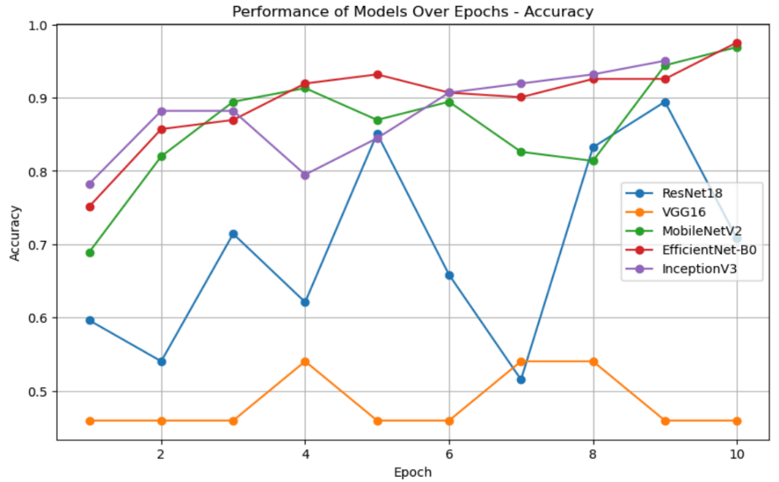

*Figure 3* shows how the accuracy of each model evolved over 10 training epochs. This trend visualization offers critical insight into each model’s learning behavior and potential overfitting issues.

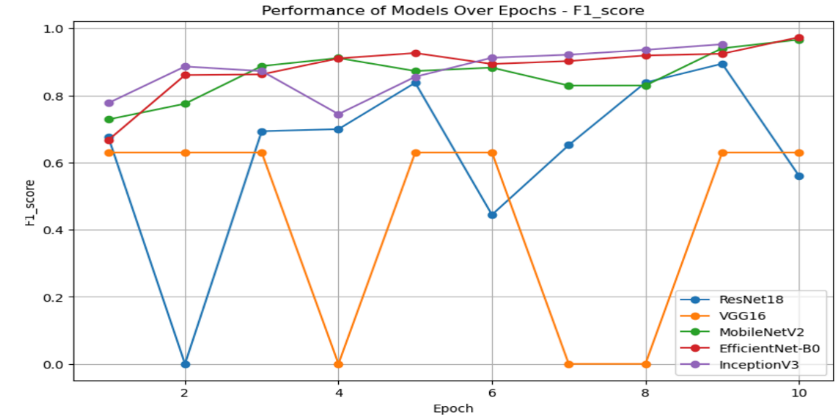

*Figure 4* presents the evolution of the F1-score—a key metric combining both precision and recall—for all models across 10 epochs.

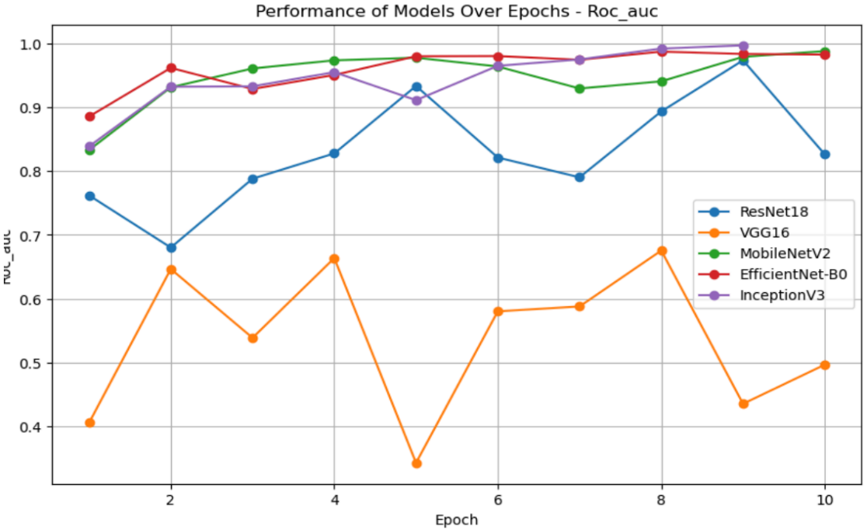

*Figure 5* illustrates the Receiver Operating Characteristic - Area Under Curve (ROC-AUC) score of each model over 10 epochs. This metric reflects the model's ability to correctly separate positive (AF) and negative (SR) classes at varying decision thresholds.

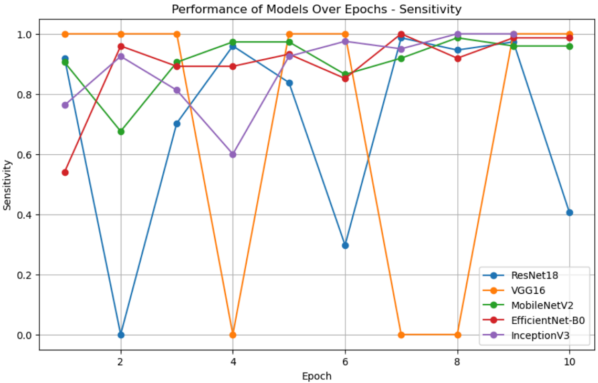

*Figure 6* illustrates how each model performed in terms of sensitivity (also known as recall) over 10 training epochs. Sensitivity measures the model’s ability to correctly detect positive AF cases, making it a vital metric in clinical diagnostics to avoid missing critical arrhythmias.

Train and Test Losses:

EfficientNet-B0 shows a close alignment between training and validation losses, indicating minimal overfitting and strong generalization.

In contrast, InceptionV3 and MobileNetV2 reveal increasing divergence between training and validation losses in the later epochs, suggesting potential overfitting as the models began to rely more heavily on training data patterns.

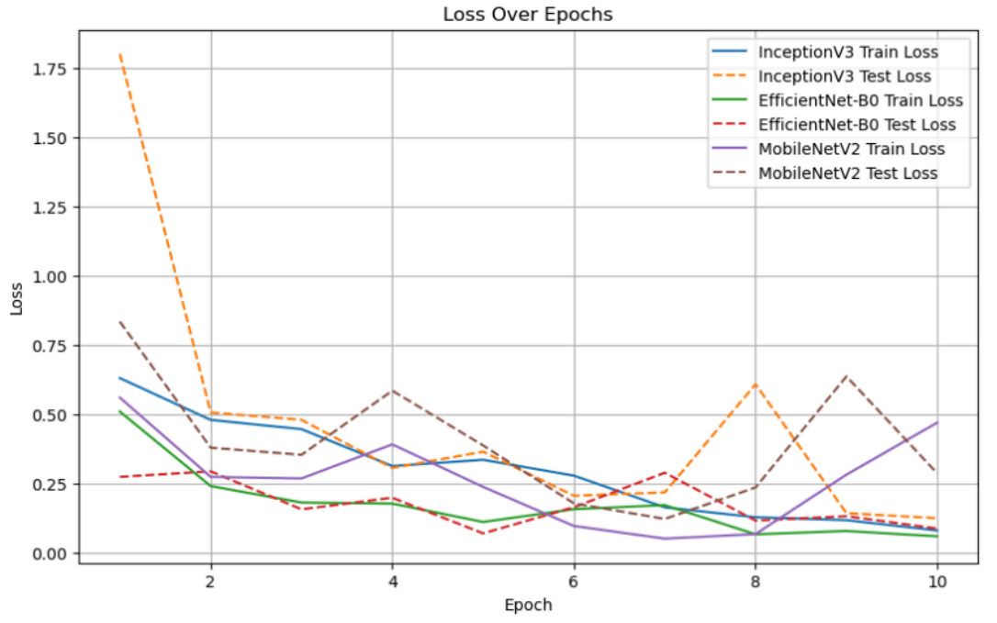

*Figure 7* shows the training and test (validation) loss curves of the top three models: EfficientNet-B0, InceptionV3, and MobileNetV2. These curves are crucial in evaluating each model’s learning stability and tendency to overfit.

The comprehensive analysis across all evaluation metrics and training behaviors consistently highlights EfficientNet-B0 as the most reliable and high-performing model for atrial fibrillation detection from ECG images. As demonstrated in the bar chart (Figure 2) and metric table, EfficientNet-B0 achieved top scores in accuracy (97.52%), F1-score (97.33%), ROC-AUC (99.92%), and sensitivity (98.65%), while maintaining excellent specificity (96.55%).

The performance-over-epoch plots (Figures 3 to 6) further revealed that EfficientNet-B0 sustained stable and steadily improving accuracy, F1-score, ROC-AUC, and sensitivity, with minimal variance—unlike models such as ResNet18 and VGG16, which exhibited erratic learning patterns and poor generalization.

Finally, the loss curve comparison (Figure 7) showed that EfficientNet-B0 maintained closely aligned training and validation loss, a strong indicator of proper generalization and effective resistance to overfitting. In contrast, MobileNetV2 and InceptionV3 displayed minor instability in validation loss across certain epochs, though still performed competitively.

In summary, EfficientNet-B0 outperformed all other models in both quantitative metrics and training behavior consistency, making it the most suitable model for real-world deployment in atrial fibrillation detection systems. InceptionV3 remains a strong secondary model, while ResNet18, VGG16, and MobileNetV2 were less reliable and were therefore ruled out.

**4.7 Analysis of Model Results**

This section presents a detailed examination of the model’s training outcomes, validation performance, and real-world testing. It outlines how the deep learning model was developed, the metrics used to evaluate its performance, and how well it generalized to unseen data. Beyond numerical results, this chapter also explores the model’s behavior during actual use, providing insights into its reliability, accuracy, and practical limitations when deployed in real-world scenarios.

**4.4.1 Initial K-Fold Model**

After selecting EfficientNet-B0 as the core architecture based on its promising performance in initial trials, a 5-fold cross-validation strategy was employed to identify the most optimal data split configuration. The objective of this phase was not only to benchmark fold-specific performance but also to determine a reliable baseline model for further retraining and refinement.

Each fold was trained using the following consistent configuration:

* EfficientNet-B0 initialized with ImageNet V1 pretrained weights
* Adam optimizer with a learning rate of 1e-4
* Batch size of 32
* 10 training epochs
* Augmentations applied: horizontal flip, rotation, affine transformations, and color jittering

Among the five folds, Fold 3 emerged as the most stable and highest-performing configuration, striking a balance between sensitivity and specificity. It was subsequently selected as the baseline checkpoint for future retraining. The performance metrics for Fold 3 were as follows:

Fold 3 Results (Unprocessed Data)

* Accuracy: 0.8926 ± 0.0642
* F1 Score: 0.8996 ± 0.0618
* ROC-AUC: 0.9602 ± 0.0529

However, when the same Fold 3 model was tested on the final preprocessed dataset, the performance decreased:

Fold 3 on Preprocessed Data

* Accuracy: 0.68
* F1 Score (Normal Sinus): 0.70
* F1 Score (AF): 0.66

A notable observation was the model’s difficulty in correctly classifying Normal Sinus Rhythm, with many normal ECGs being misclassified as Atrial Fibrillation. Despite this modest performance, Fold 3 was retained as the foundation due to its relative consistency compared to the other folds (with Fold 2 ranked second). The model checkpoint best_efficientnet_b0_fold3.pth was then used for the retraining process aimed at improving generalization.

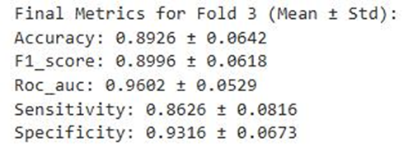*\*

*Fold 3 performance in training*

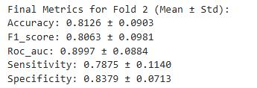

*Fold 2 performance for references*

*Fold 3 performance in preprocessed dataset*

#### **4.7.2 Retraining on Unprocessed Noisy Data (AUGMENTED_2R)**

The first retraining phase focused on testing the model’s capacity to generalize to real-world, unclean ECGs. The dataset used comprised **121 original ECGs** and **847 augmented samples**, with various visual issues such as paper artifacts, inconsistent lighting, and rotational distortions.

Key configuration changes:

* Continued training from the Fold 3 baseline
* Frozen layers: Blocks 0–3 (to retain low-level ImageNet features)
* Unfrozen layers: Blocks 4–7 (for ECG-specific fine-tuning)
* Loss function: CrossEntropyLoss
* Optimizer: Adam (learning rate = 1e-5)

Results on unprocessed data:

* Accuracy: 0.94
* F1 Score (Normal Sinus): 0.8889
* F1 Score (AF): 0.8787

**Observation:**

Performance significantly improved over the baseline, demonstrating the model's ability to learn even from noisy data. However, it continued to struggle with orientation, image borders, and gridlines. Additionally, there was a **s**light bias toward AF classification, indicating the model's tendency to overpredict AF regardless of class balance. This could be attributed to the limitations of CrossEntropyLoss in capturing subtle features unique to Normal Sinus rhythms.

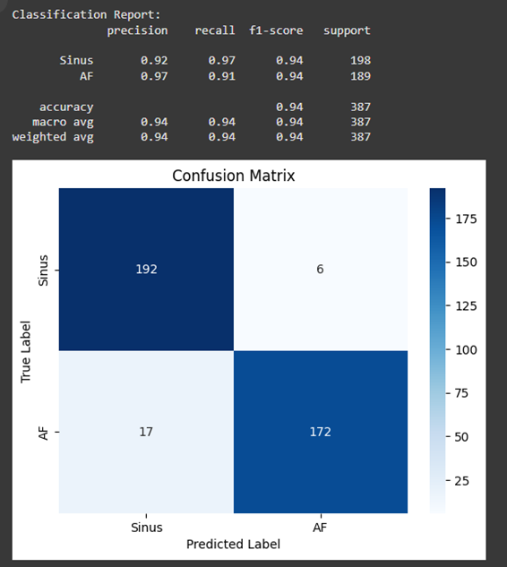

*Retrained Fold 3 performance in unprocessed dataset*

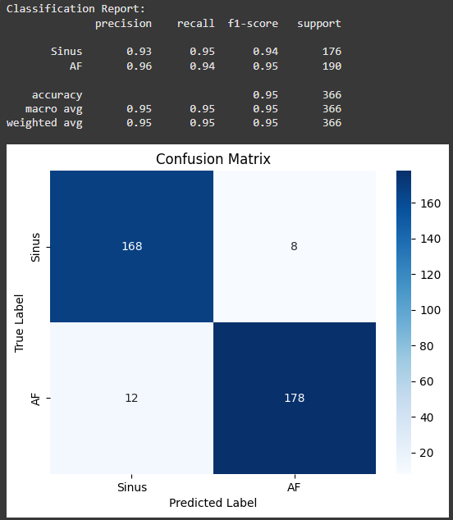

*Retrained Fold 3 performance in preprocessed dataset*

* + The model struggled to classify Normal Sinus correctly and showed a bias toward AF. CrossEntropyLoss might have led to poor classification performance in Normal Sinus rhythm. The model exhibited a tendency to overpredict AF even when class distributions were relatively balanced, suggesting an issue beyond just label imbalance, possibly due to suboptimal feature learning or loss sensitivity.
  + The unclean dataset distorted signal regions, removing crucial ECG information. Cleaning and preprocessing were necessary to restore ECG signal clarity. As seen in the image below, some lines are removed from the image.

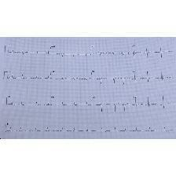

*Unprocessed image*

**4.7.3 Preprocessing Pipeline for Dataset 3**

Before training the final version of the model, the ECG images in Dataset 3 underwent several preprocessing steps to improve clarity and ensure that the signals were more easily understood by the deep learning model. These steps were designed to reduce noise, improve contrast, and make each image consistent in shape and quality, especially since the dataset included a variety of scanned or photo-captured ECGs.

**Sharpening the Image** To help the model focus better on important parts of the ECG waveform, a sharpening technique was used. This made the signal lines—such as the P-wave and QRS complex—stand out more clearly by emphasizing their edges. It helped reduce the blurriness that sometimes occurs in scanned or photographed ECGs.

**Enhancing Contrast with CLAHE** Contrast Limited Adaptive Histogram Equalization (CLAHE) was used to brighten up the signal in areas that were too dark or flat. This was especially helpful in improving the visibility of subtle waveforms, allowing the model to pick up on small variations that may be significant when detecting AF.

**Padding for Square Dimensions** Since ECG printouts come in all shapes and sizes, white padding was added to each image to make them square. This made sure that when the images were resized for the model, none of the ECG details—especially those close to the edge, were lost or distorted.

**Denoising the Image** Some ECGs were affected by digital noise or low-quality camera captures. A denoising filter was applied to remove speckles and unwanted artifacts, which helped the model focus on the actual waveform instead of random visual noise in the background.

**Erosion to Clean Up White Space** A technique called morphological erosion was applied to clean up extra white areas around the signal. This helped reduce background distractions like gridlines or paper texture, making the ECG trace itself stand out more clearly.

**Resizing the Image** All ECGs were resized to 224×224 pixels—the input size required by the EfficientNet-B0 model. Resizing made sure that all training images were uniform, which is important for consistent learning and prediction.

**Converting Image Type** Finally, the image values were clipped to a standard pixel range (0–255) and saved in the correct format for image processing. This step made sure all images were compatible with the tools used in training and that no pixel information was lost in the conversion.

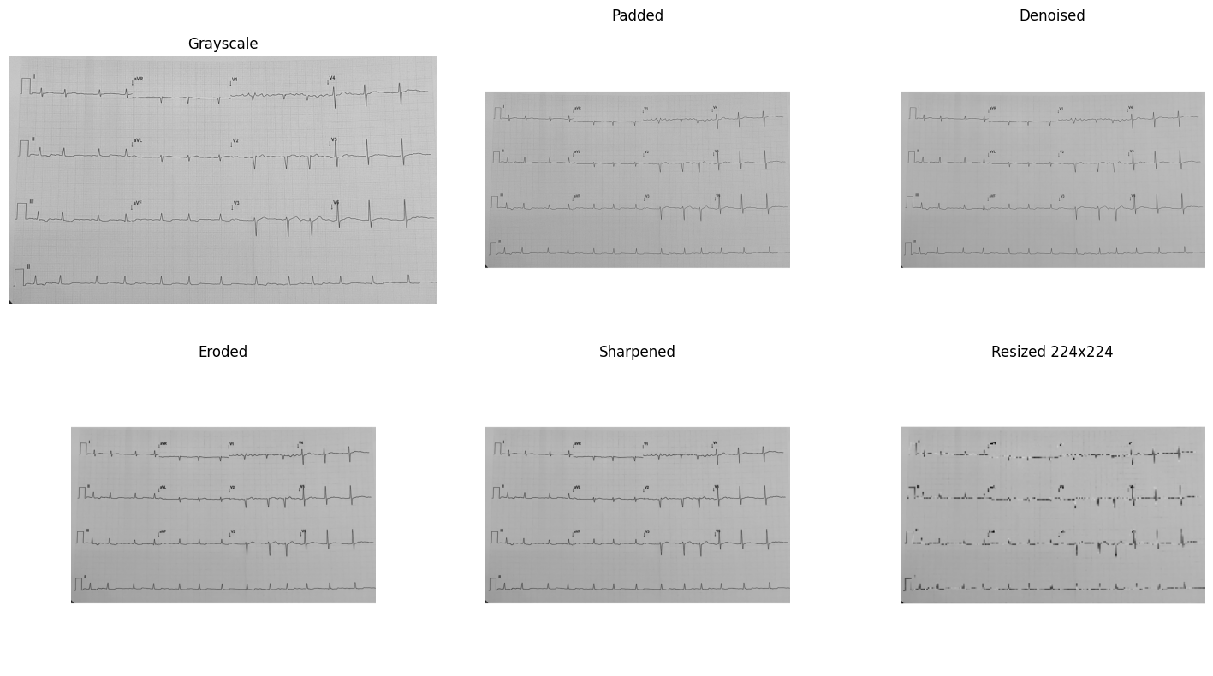

*Significant ECG waveforms were preserved after resizing*

#### **4.7.4 Retraining on Cleaned, Preprocessed Data (Dataset 3)**

To address the misclassification and bias issues, the model was further retrained using a cleaned and standardized dataset. The preprocessing pipeline included:

* Grayscale conversion
* Denoising
* Morphological erosion
* Image sharpening
* Square padding
* Resizing to 224×224

In this phase, all model layers were unfrozen, enabling the network to fully adapt to ECG-specific features rather than relying on pretrained low-level filters.  
**Results:**

* Accuracy: 0.95
* F1 Score (Normal Sinus): 0.8960
* F1 Score (AF): 0.8908

**Observation:**

* Generalization improved notably. The model became more robust in handling edge cases, including low-contrast images, rotated ECGs, and off-centered plots. The preprocessing steps helped the model focus on signal characteristics rather than irrelevant visual features such as grid backgrounds or margins.

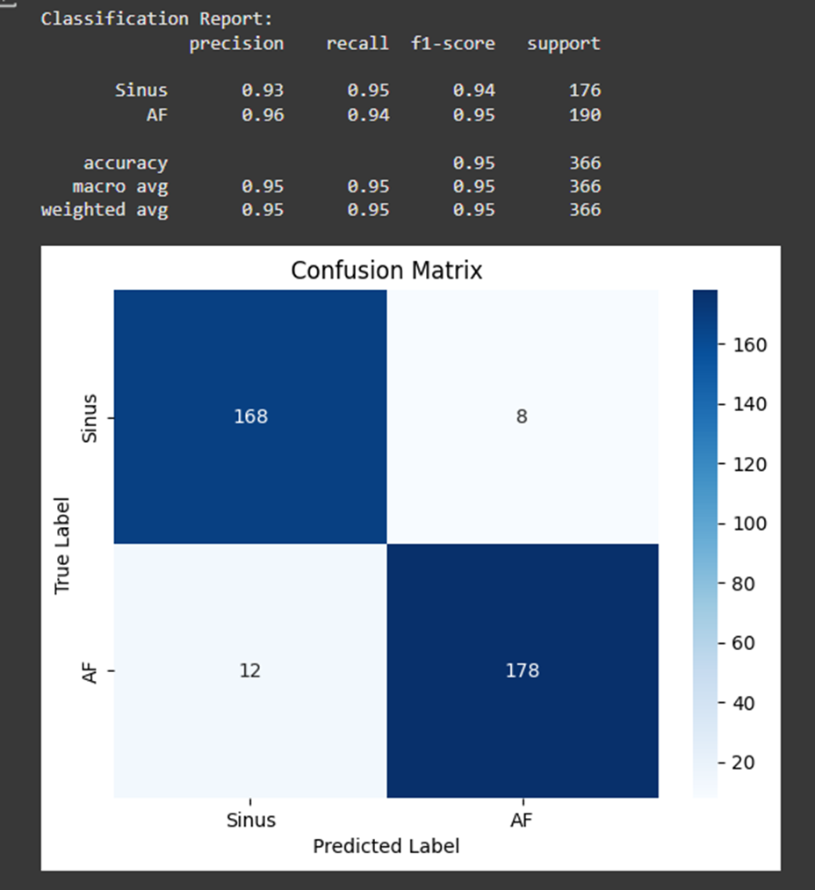

Switching to Focal Loss corrected AF underperformance. but, still lacking in performance since the confidence score as seen in the testing from sample images below:

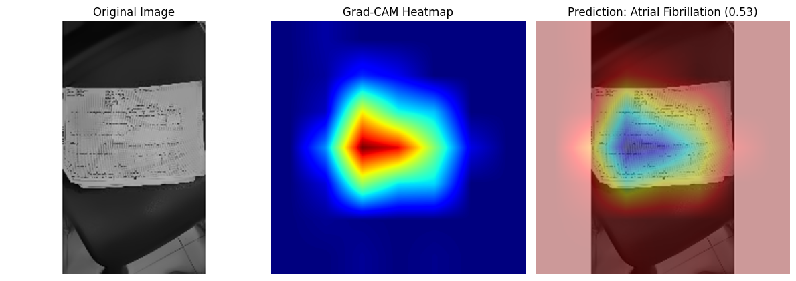

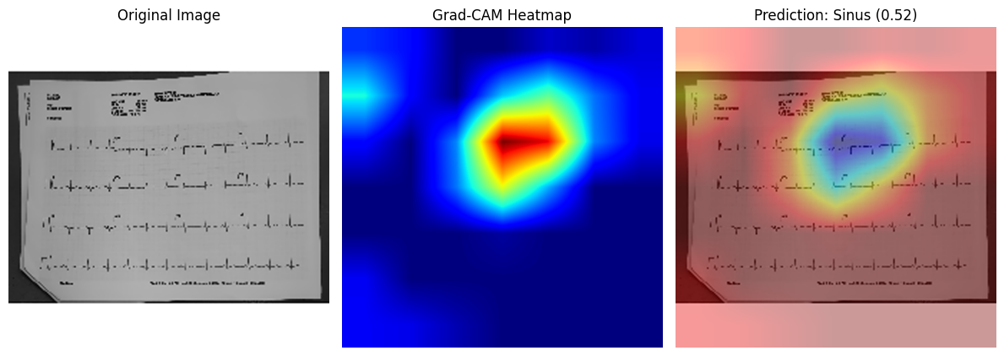

**4.7.5 Major Issue Identified**

During the initial phase of model training and evaluation, K-Fold cross-validation was implemented with the intention of assessing model performance across different subsets of the dataset. However, a critical methodological oversight occurred when the individual fold models, particularly the best-performing one, were repurposed for deployment rather than being used solely for performance evaluation. This deviation from standard practice presents a significant limitation in the study.

K-Fold cross-validation is designed to serve as an evaluation framework. It divides the dataset into *k* distinct folds, training the model on *k – 1* folds while reserving the remaining fold for validation. This process repeats *k* times, ensuring that each data point is used for both training and validation exactly once. The primary goal is to obtain a more reliable estimate of the model’s generalization performance by averaging results across all folds. However, each fold model is inherently trained on only a portion (typically 80%) of the full dataset. As such, it does not benefit from exposure to the complete training distribution, and its use for deployment leads to a suboptimal representation of the learning capacity.

By deploying a model trained on a single fold, the study inadvertently reduced the model’s ability to generalize effectively to unseen data. This approach also introduced bias, particularly if the deployed model was selected based on its favorable validation results. Since this fold was originally designated for testing rather than training, selecting it based on performance may lead to overfitting or inflated metrics that do not hold in real-world applications. Furthermore, inconsistencies may arise depending on which fold was chosen, as training subsets can vary in complexity and data distribution.

To address this limitation, a revised approach was implemented in which a final model was trained using the entire Baseline Synthetic Dataset (Dataset 1). This ensured that the model benefited from all training examples and could better capture relevant patterns for robust classification of Atrial Fibrillation and Normal Sinus Rhythm. Moving forward, it is essential that K-Fold cross-validation remains strictly a performance evaluation tool, while deployment models should always be trained on the full dataset to maximize diagnostic reliability.

**4.7.6 Initial Full Dataset Model Training**

Following the realization that K-Fold cross-validation models were inadvertently used as deployment models—despite their intended role being for performance evaluation—a corrective measure was undertaken by training a new model on the entire dataset. This model, referred to as efficeintnet_b0_model_full, was developed to ensure that the final deployment model would benefit from exposure to all available training data, thereby improving generalization and diagnostic reliability.

#### **Dataset and Configuration**

* Dataset: The same dataset used for the K-Fold cross-validation experiments, consisting of 876 ECG images, was employed in full for this training phase.
* Model Base: EfficientNet-B0 architecture, initialized with pre trained ImageNetV1 weights
* Classifier Head: Adjusted to output a two-class prediction: Atrial Fibrillation (AF) and Normal Sinus Rhythm

#### **Preprocessing and Augmentation Strategy**

To promote feature generalization and model robustness, a set of augmentations and preprocessing steps were applied:

* Resizing to 224×224 pixels
* Horizontal flipping
* Random rotation (±15°)
* Random affine transformations (including translation and scale variation)
* Color jittering (modification of brightness and contrast)
* Normalization using ImageNet mean and standard deviation

#### **Training Details**

* **Split:** 80% training, 20% validation
* **Loss Function:** CrossEntropyLoss
* **Optimizer:** Adam (learning rate = 1e-4)
* **Batch Size:** 32
* **Epochs:** Maximum of 10 with early stopping (patience = 3)
* **Evaluation Metrics:** Accuracy, F1 Score, ROC-AUC, Sensitivity, and Specificity were recorded per epoch

#### **Outcomes and Observations**

Although the efficientnet_b0_model_full approach successfully resolved the issue of improper deployment from cross-validation models, the resulting classification performance was moderate. The model showed potential but did not achieve substantial gains over previous fold-specific results. These findings highlighted the need for further improvements in both feature learning and data preprocessing to enhance model accuracy and generalizability.

**4.7.7 Retraining Full Dataset Model**

In the final retraining phase, the previously trained full dataset model, efficientnet_b0_model_full was refined using the successful training pipeline established during the Fold 3 experiments. The intent was to combine the generalizability of a model trained on all available data with the optimization strategies proven effective in earlier fold-specific training. This phase served to further enhance the model’s ability to classify Atrial Fibrillation (AF) and Normal Sinus Rhythm under real-world variability.

#### **Training Setup and Improvements**

* Model Initialization:Training resumed from the existing full-data model (efficientnet_b0_model_full), which had been trained on 100% of the dataset but exhibited moderate classification performance.
* Architecture and Fine-Tuning Strategy:  
   The model used the EfficientNet-B0 backbone. To improve ECG-specific adaptation while maintaining stable low-level representations, Blocks 4–7 were unfrozen for training. Blocks 0–3 remained frozen to retain core convolutional features from ImageNet pretraining.
* Loss Function:  
  Focal Loss (α = 0.35, γ = 2) was used to reduce the impact of easy examples and help the model focus on harder-to-classify samples, particularly those belonging to the Normal Sinus class.
* Augmentation and Preprocessing:  
   Augmentations such as rotation, brightness adjustments, shadow simulation, noise, and zoom were applied offline during the dataset preparation phase. The Dataset 3 dataset also underwent preprocessing that included square padding, denoising, erosion, and sharpening to enhance ECG clarity.

#### **Training Configuration**

* Dataset: Cleaned and preprocessed ECGs from Dataset 3
* Train/Validation Split: 80% training, 20% validation
* Optimizer: Adam (learning rate = 1e-5)
* Batch Size: 32 (train), 32 (validation)
* Epochs: Up to 15 with early stopping based on F1-score for Normal Sinus Rhythm (patience = 3)

**Evaluation Results (Validation Set)**

|  |  |  |  |  |
| --- | --- | --- | --- | --- |
| **Class** | **Precision** | **Recall** | **F1-score** | **Support** |
| **Normal Sinus** | **0.79** | **0.87** | **0.83** | **181** |
| **AF** | **0.86** | **0.78** | **0.82** | **185** |

Overall Accuracy: 0.82

Macro-Averaged F1-score: 0.82

Weighted-Averaged F1-score: 0.82

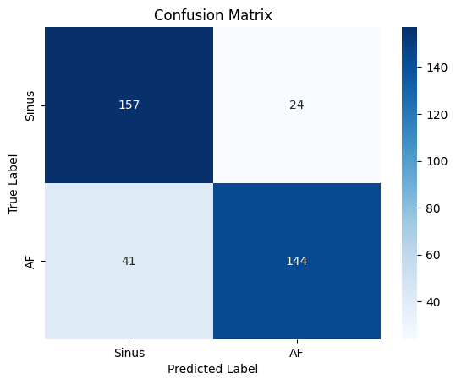

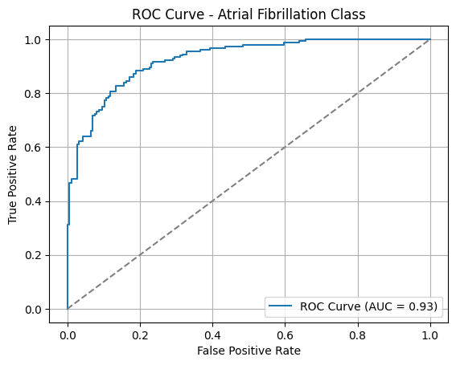

**Out of Sample Testing**

For this testing, four images that were not included in our dataset were used. These images were validated by Dr. Yumul to be AF and Normal Sinus Rhythm respectively.

AF Image 1:

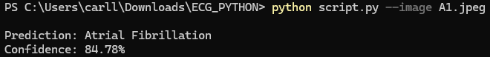

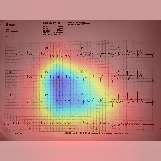

AF Image 2:

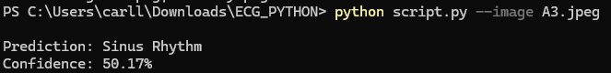

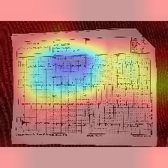

Normal Sinus Image 1:



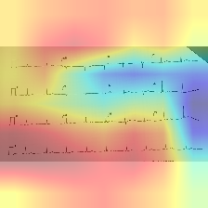

Normal Sinus Image 2:

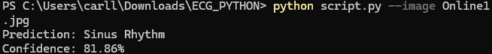

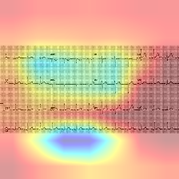

**Observation and Analysis**

The retrained efficientnet_b0_model_full, enhanced using the Fold 3 training strategy, achieved a balanced performance between Atrial Fibrillation and Normal Sinus Rhythm classification, as reflected in its F1-scores and overall accuracy. While the validation metrics—particularly an accuracy of 82% and an F1-score of 0.83 for Normal Sinus and 0.82 for AF—were slightly lower than those recorded in earlier phases, the model's behavior in out-of-sample testing revealed a significant improvement in generalization.

This outcome suggests that the model had become less reliant on patterns specific to the training data and more capable of handling variations found in real-world ECG images, such as differing image quality, orientation, and signal clarity. The use of Focal Loss contributed to better sensitivity in detecting less dominant or harder-to-classify cases, especially in the Normal Sinus class, while the selective unfreezing of Blocks 4–7 allowed the model to learn high-level ECG-specific features without discarding the general visual features captured through ImageNet pretraining.

The trade-off in slightly lower validation metrics was justified by the increased robustness and reliability of the model when evaluated on unseen data. This indicates a positive shift toward real-world applicability, which is critical for clinical deployment scenarios where model performance must remain consistent despite variability in ECG formats and acquisition conditions.

**4.7.8 Fine-Tuning Full Dataset Model**

Following the baseline retraining phase described in the previous section, the full-dataset model (efficientnet_b0_model_full) was further refined with more advanced fine-tuning strategies. This iteration aimed to enhance the model’s sensitivity and class balance without sacrificing generalizability. The improvements were guided by empirical insights from Fold 3 and implemented with careful consideration of layer freezing, learning rate control, and loss function design.

#### **Training Setup and Improvements**

**Model Initialization:**Training resumed from the previously saved model checkpoint (retrained_model_full.pth) which had already been trained on the complete Dataset 3. This approach allowed the model to retain high-level ECG representations while enabling further fine-tuning for more nuanced signal variations.

**Architecture and Fine-Tuning Strategy:**Unlike earlier phases where only Blocks 4–7 were unfrozen, this phase unfroze Blocks 3–7 of the EfficientNet-B0 backbone, while retaining the weights of Blocks 0–2 to preserve foundational image features from ImageNet. This allowed the model to better adapt to ECG-specific mid-level patterns such as waveform shapes, noise patterns, and signal variations.

**Loss Function:**Focal Loss (α = 0.35, γ = 2) was again used to emphasize learning on difficult cases, particularly Normal Sinus Rhythm samples, which tend to present more subtle patterns. This loss function proved effective in prioritizing underrepresented or noisy instances during training.

**Optimizer Strategy:** A layer-wise learning rate was implemented:

* **5e-6** for the convolutional backbone (features)
* **1e-4** for the classifier head

This controlled adjustment allowed the model to update the higher-level ECG-specific layers aggressively, while preserving general visual features in early layers.

**Early Stopping Metric:**The early stopping strategy was changed to monitor the macro-averaged F1-score, which provides a more balanced signal of performance between Normal Sinus and AF classes. This metric helped prevent the model from over-optimizing on one class.

**Training Configuration**

* Dataset: Preprocessed and augmented ECG images from Dataset 3
* Train/Validation Split: 80% training, 20% validation
* Batch Size: 32 for both training and validation
* Optimizer: Adam (with layer-specific learning rates)
* Epochs: Maximum of 15 with early stopping (patience = 3)

**Evaluation Results (Validation Set)**

|  |  |  |  |  |
| --- | --- | --- | --- | --- |
| **Class** | **Precision** | **Recall** | **F1-Score** | **Support** |
| Normal Sinus | 0.87 | 0.94 | 0.90 | 186 |
| AF | 0.93 | 0.85 | 0.89 | 180 |

Overall Accuracy: 89%

Macro-Averaged F1-score: 0.89

ROC-AUC (AF Class): 0.96

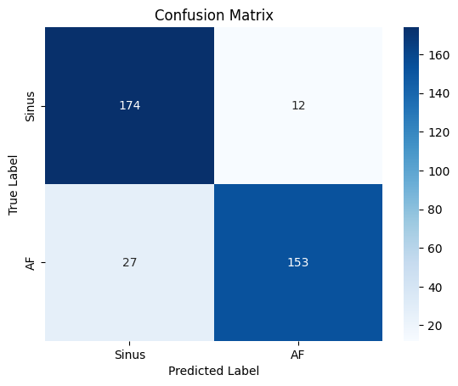

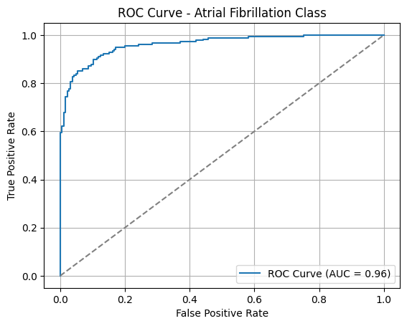

**Out of Sample Testing**

For this testing, we used the testing images from the retrained model.

AF Image 1:

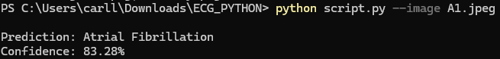

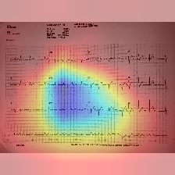

AF Image 2:



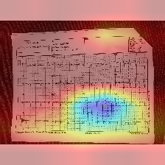

Normal Sinus Image 1:

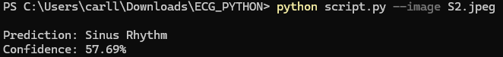

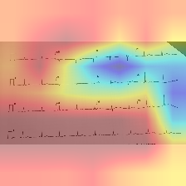

Normal Sinus Image 2:

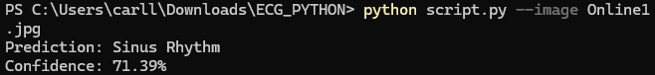

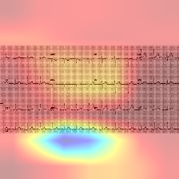

**Observation and Analysis**

The fine-tuned model demonstrated noticeable performance gains over the earlier retraining phase. The use of Focal Loss effectively improved sensitivity toward Normal Sinus Rhythm cases, while the controlled unfreezing of Blocks 3–7 allowed the model to better adapt to ECG-specific visual representations. The resulting metrics indicate a high degree of balance between precision and recall for both classes.

The confusion matrix revealed that out of 186 Normal Sinus samples, 174 were correctly classified, while 153 out of 180 AF samples were identified correctly. Most misclassifications were conservative in nature (AF predicted as Normal Sinus), which may be more acceptable in screening scenarios where false positives are safer than false negatives.

Furthermore, the ROC curve showed a strong AUC of 0.96 for the AF class, underscoring the model’s ability to maintain discriminative power across a range of thresholds. This result confirms that the model is capable of generalizing across variable ECG images with minimal degradation in predictive performance.

**4.7.9 Final Fine-Tuning with Label Smoothing**

In a final attempt to enhance both the confidence and generalization ability of the previously balanced model, an additional fine-tuning phase was performed. This stage retained the core improvements from earlier iterations while replacing Focal Loss with a calibrated form of CrossEntropyLoss using label smoothing. This strategy aimed to address observed underconfidence in the model's predictions, especially in out-of-sample scenarios.

**Training Setup and Strategy**

Model Initialization: Fine-tuning resumed from the best-performing full-dataset model, retrained_model_full_V2_corrected.pth, which had already achieved a strong balance between Atrial Fibrillation and Normal Sinus Rhythm classification.

Loss Function: Focal Loss was replaced with CrossEntropyLoss with label_smoothing=0.1, to soften overconfidence and calibrate predictions. This change encouraged better confidence distribution without altering the model's accuracy.

Architecture and Layer Strategy: As with the previous phase, Blocks 3–7 of EfficientNet-B0 were unfrozen for continued adaptation, while BatchNorm layers were frozen to preserve stable running statistics learned from ImageNet pretraining.

Learning Rate: A lower learning rate (1e-6) was used to prevent over-updating and encourage subtle refinements. Optimization was handled by Adam, and early stopping remained based on macro-averaged F1 score.

**Evaluation Results**

|  |  |  |  |  |
| --- | --- | --- | --- | --- |
| **Class** | **Precision** | **Recall** | **F1-Score** | **Support** |
| Normal Sinus | 0.91 | 0.96 | 0.93 | 179 |
| AF | 0.96 | 0.91 | 0.93 | 187 |

Overall Accuracy: 93%

Macro-Averaged F1-score: 0.93

ROC-AUC (AF Class): 0.98

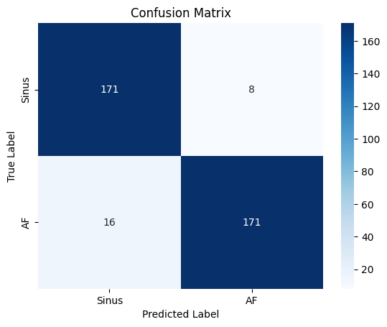

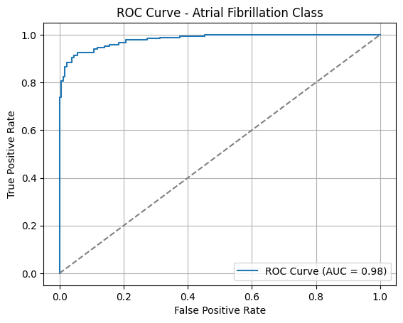

The model demonstrated both high discriminative performance and increased robustness across both classes. The confusion matrix revealed minimal misclassification: 8 Normal Sinus samples predicted as AF, and 16 AF samples predicted as Normal Sinus. The ROC curve reflected an AUC of 0.98 for Atrial Fibrillation, indicating excellent generalization and confidence.

**Out of Sample Testing**

For this testing, we used the testing images from the retrained model.

AF Image 1:



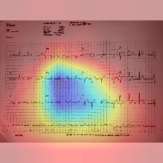

AF Image 2:



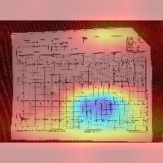

Normal Sinus Image 1:



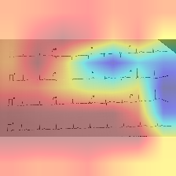

Normal Sinus Image 2:



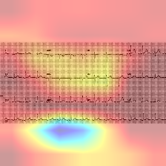

**Fine-tuned Efficient B0 deployed in AFsense website testing:**

To evaluate the practical reliability of the final model, the fine-tuned EfficientNet-B0 was (retrained_model_full_V3_finetuned.pth) deployed in the AFsense web application. The system was tested using real-world ECG image inputs captured through the web interface, simulating typical usage conditions. A total of five samples for Atrial Fibrillation (AF) and five for Normal Sinus Rhythm were evaluated under varying environmental conditions to observe the model’s prediction behavior in an uncontrolled, deployment-like setting.

**Test Conditions:**

To evaluate the real-world performance of our deployed EfficientNet-B0 model integrated into the AFsense web platform, we conducted testing under three distinct image capture conditions. The testing was personally supervised and validated by Dr. Gracita Topacio, a licensed cardiologist, to ensure clinical relevance and accuracy:

* Recommended Capture Method – This condition followed the ideal setup, where the full ECG paper was captured with sufficient lighting, at an appropriate distance (not too close or too far), ensuring clear visibility and minimal noise. This served as the baseline for optimal model performance.
* Too Close with Shadows – In this condition, images were taken at very close range, resulting in partial framing of the ECG and the presence of shadows. This setup aimed to simulate user errors during capture that may reduce diagnostic clarity.
* Too Far – Here, the ECG image was captured from a distant position, causing reduced resolution and possible background interference. This condition tested the model’s robustness when important signal details became harder to discern due to scale.

|  |  |  |
| --- | --- | --- |
| **Recommended Capture Method** | **Capture with Shadow** | **Capture far from ECG (8-15 inches away)** |
|  |  |  |

**1st Testing (April 14, 2025)**

|  |  |  |  |  |  |  |  |
| --- | --- | --- | --- | --- | --- | --- | --- |
| **Image No.** | **Test No.** | **Capture Method** | **True Label (Doctor)** | **Model Prediction** | **Match?** | **Confidence Score** | **Image Description** |
| 1 | 45 | Recommended | AF | AF | YES | 57.73% | Strong Gridmarks, small ECG waveforms |
| 46 | With Shadow | AF | SR | NO | 55.73% |
| 47 | Far from ECG (8-15 inches away) | AF | AF | YES | 56.02% |
| 2 | 49 | Recommended | AF | AF | YES | 52.20% | Moderate waveform, barely visible gridlines |
| 50 | With Shadow | AF | SR | NO | 54.67% |
| 51 | Far from ECG (8-15 inches away) | AF | AF | YES | 56.40% |
| 3 | 52 | Recommended | AF | AF | YES | 54.23% | Good waveform, Gridlines barely visible |
| 53 | With Shadow | AF | SR | NO | 56.20% |
| 54 | Far from ECG (8-15 inches away) | AF | AF | YES | 53.05% |
| 4 | 56 | Recommended | AF | AF | YES | 54.39% | Weak waveform, Gridlines barely visible |
| 57 | With Shadow | AF | SR | NO | 56.03% |
| 58 | Far from ECG (8-15 inches away) | AF | SR | NO | 50.67% |
| 5 | 59 | Recommended | AF | AF | YES | 50.17% | Good waveform, Gridlines barely visible |
| 60 | With Shadow | AF | AF | YES | 53.11% |
| 61 | Far from ECG (8-15 inches away) | AF | AF | YES | 57.04% |



|  |  |  |  |  |  |  |  |
| --- | --- | --- | --- | --- | --- | --- | --- |
| **Image No.** | **Test No.** | **Capture Method** | **True Label (Doctor)** | **Model Prediction** | **Match?** | **Confidence Score** | **Image Description** |
| 6 | 63 | Recommended | SR | SR | YES | 50.23% | Strong Gridmarks, small ECG waveforms |
| 64 | With Shadow | SR | AF | NO | 50.95% |
| 65 | Far from ECG (8-15 inches away) | SR | AF | NO | 52.72% |
| 7 | 68 | Recommended | SR | SR | YES | 50.17% | Good waveform, Gridlines barely visible |
| 69 | With Shadow | SR | SR | YES | 52.90% |
| 70 | Far from ECG (8-15 inches away) | SR | AF | NO | 55.88% |
| 8 | 72 | Recommended | SR | SR | YES | 59.53% | Moderate waveform, barely visible gridlines |
| 73 | With Shadow | SR | SR | YES | 59.35% |
| 74 | Far from ECG (8-15 inches away) | SR | AF | NO | 56.14% |
| 9 | 75 | Recommended | SR | SR | YES | 59.09% | weak waveform, Gridlines barely visible |
| 76 | With Shadow | SR | SR | YES | 55.97% |
| 77 | Far from ECG (8-15 inches away) | SR | AF | NO | 52.45% |

**2nd Testing (April 21, 2025)**

|  |  |  |  |  |  |  |  |
| --- | --- | --- | --- | --- | --- | --- | --- |
| **Image No.** | **Test No.** | **Capture Method** | **True Label (Doctor)** | **Model Prediction** | **Match?** | **Confidence Score** | **Image Description** |
| 1 | 115 | Recommended | AF | AF | YES | 51.10% | Good waveform, Gridlines barely visible. Mounted ECG, different format from training data |
| 114 | With Shadow | AF | SR | NO | 58.02% |
| 113 | Far from ECG (8-15 inches away) | AF | AF | YES | 56.18% |
| 2 | 116 | Recommended | AF | SR | NO | 57.02% | Good waveform, Gridlines barely visible. Mounted ECG, different format from training data |
| 118 | With Shadow | AF | SR | NO | 57.82% |
| 117 | Far from ECG (8-15 inches away) | AF | AF | YES | 64.37% |
| 3 | 125 | Recommended | AF | AF | YES | 56.56% | Good waveform, Gridlines barely visible. Mounted ECG, different format from training data |
| 127 | With Shadow | AF | SR | NO | 54.95% |
| 126 | Far from ECG (8-15 inches away) | AF | AF | YES | 65.94% |
| 4 | 128 | Recommended | AF | AF | YES | 58.52% | Good waveform, Gridlines barely visible. Mounted ECG, different format from training data |
| 129 | With Shadow | AF | SR | NO | 55.89% |
|  | 130 | Far from ECG (8-15 inches away) | AF | AF | YES | 63.98% |
| 5 | 152 | Recommended | AF | AF | YES | 60.51% | Good waveform, Gridlines barely visible. Mounted ECG, different format from training data. ECG has a noticeable crease. |
| 154 | With Shadow | AF | AF | YES | 50.44% |
| 153 | Far from ECG (8-15 inches away) | AF | AF | YES | 64.34% |

|  |  |  |  |  |  |  |  |
| --- | --- | --- | --- | --- | --- | --- | --- |
| **Image No.** | **Test No.** | **Capture Method** | **True Label (Doctor)** | **Model Prediction** | **Match?** | **Confidence Score** | **Image Description** |
| 6 | 155 | Recommended | AF | AF | YES | 50.20% | Good waveform, Gridlines barely visible. Mounted |
| 156 | With Shadow | AF | AF | YES | 56.87% |
| 157 | Far from ECG (8-15 inches away) | AF | AF | YES | 56.87% |
| 7 | 158 | Recommended | AF | AF | NO | 55.92% | Good waveform, Gridlines barely visible. Mounted |
| 160 | With Shadow | AF | SR | NO | 50.53% |
| 159 | Far from ECG (8-15 inches away) | AF | SR | YES | 57.43% |
| 8 | 161 | Recommended | AF | SR | NO | 56.85% | Good waveform, visible stain in the prints. Mounted ECG, different format from training data |
| 163 | With Shadow | AF | SR | NO | 56.20% |
| 162 | Far from ECG (8-15 inches away) | AF | AF | YES | 57.49% |
| 9 | 164 | Recommended | AF | AF | YES | 50.93% | Good waveform, Gridlines barely visible. Mounted ECG, different format from training data |
| 166 | With Shadow | AF | SR | NO | 53.30% |
|  | 165 | Far from ECG (8-15 inches away) | AF | SR | NO | 51.10% |
| 10 | 167 | Recommended | AF | SR | NO | 57.69% | Good waveform, Strong Gridmarks. Mounted ECG, different format from training data |
| 169 | With Shadow | AF | SR | NO | 56.74% |
| 168 | Far from ECG (8-15 inches away) | AF | SR | NO | 53.08% |

|  |  |  |  |  |  |  |  |
| --- | --- | --- | --- | --- | --- | --- | --- |
| **Image No.** | **Test No.** | **Capture Method** | **True Label (Doctor)** | **Model Prediction** | **Match?** | **Confidence Score** | **Image Description** |
| 11 | 110 | Recommended | SR | SR | YES | 57.94% | Good waveform, Strong Gridmarks. Mounted ECG, different format from training data |
| 112 | With Shadow | SR | SR | YES | 56.47% |
| 111 | Far from ECG (8-15 inches away) | SR | AF | NO | 56.28% |
| 12 | 119 | Recommended | SR | SR | YES | 63.09% | Good waveform, Gridlines barely visible. Mounted ECG, different format from training data |
| 120 | With Shadow | SR | SR | YES | 56.56% |
| 121 | Far from ECG (8-15 inches away) | SR | SR | YES | 50.99% |
| 13 | 122 | Recommended | SR | SR | YES | 52.04% | Good waveform, Gridlines barely visible. Mounted ECG, different format from training data. Mounted slightly unaligned. |
| 123 | With Shadow | SR | SR | YES | 53.10% |
| 124 | Far from ECG (8-15 inches away) | SR | AF | NO | 55.86% |
| 14 | 131 | Recommended | SR | SR | YES | 51.56% | Good waveform, Gridlines barely visible. Mounted ECG, different format from training data. ECG has a slight crease. |
| 133 | With Shadow | SR | SR | YES | 56.29% |
|  | 132 | Far from ECG (8-15 inches away) | SR | AF | NO | 52.43% |
| 15 | 134 | Recommended | SR | SR | YES | 51.90% | Good waveform, Gridlines barely visible. Mounted ECG, different format from training data |
| 136 | With Shadow | SR | SR | YES | 57.02% |
| 135 | Far from ECG (8-15 inches away) | SR | AF | NO | 70.63% |

|  |  |  |  |  |  |  |  |
| --- | --- | --- | --- | --- | --- | --- | --- |
| **Image No.** | **Test No.** | **Capture Method** | **True Label (Doctor)** | **Model Prediction** | **Match?** | **Confidence Score** | **Image Description** |
| 16 | 137 | Recommended | SR | SR | YES | 55.92% | Good waveform, mild gridlines. Mounted ECG, different format from training data |
| 139 | With Shadow | SR | SR | YES | 53.91% |
| 138 | Far from ECG (8-15 inches away) | SR | AF | NO | 50.95% |
| 17 | 140 | Recommended | SR | SR | YES | 54.77% | Good waveform, visible stain in the prints. Mounted ECG, different format from training data |
| 142 | With Shadow | SR | SR | YES | 55.69% |
| 141 | Far from ECG (8-15 inches away) | SR | AF | NO | 70.48% |
| 18 | 143 | Recommended | SR | SR | YES | 52.89% | Good waveform, Gridlines barely visible. Mounted ECG, different format from training data. ECG has a slight crease. |
| 145 | With Shadow | SR | SR | YES | 50.45% |
| 144 | Far from ECG (8-15 inches away) | SR | AF | NO | 51.36% |
| 19 | 146 | Recommended | SR | SR | YES | 57.34% | Good waveform, Gridlines barely visible. Almost same as our dataset. |
| 148 | With Shadow | SR | SR | YES | 61.50% |
|  | 147 | Far from ECG (8-15 inches away) | SR | AF | NO | 59.40% |
| 20 | 149 | Recommended | SR | SR | YES | 54.62% | Good waveform, Gridlines barely visible. Mounted ECG, differed format from training data |
| 151 | With Shadow | SR | SR | YES | 53.77% |
| 150 | Far from ECG (8-15 inches away) | SR | AF | NO | 58.37% |

**AF and Sinus Test Result:**

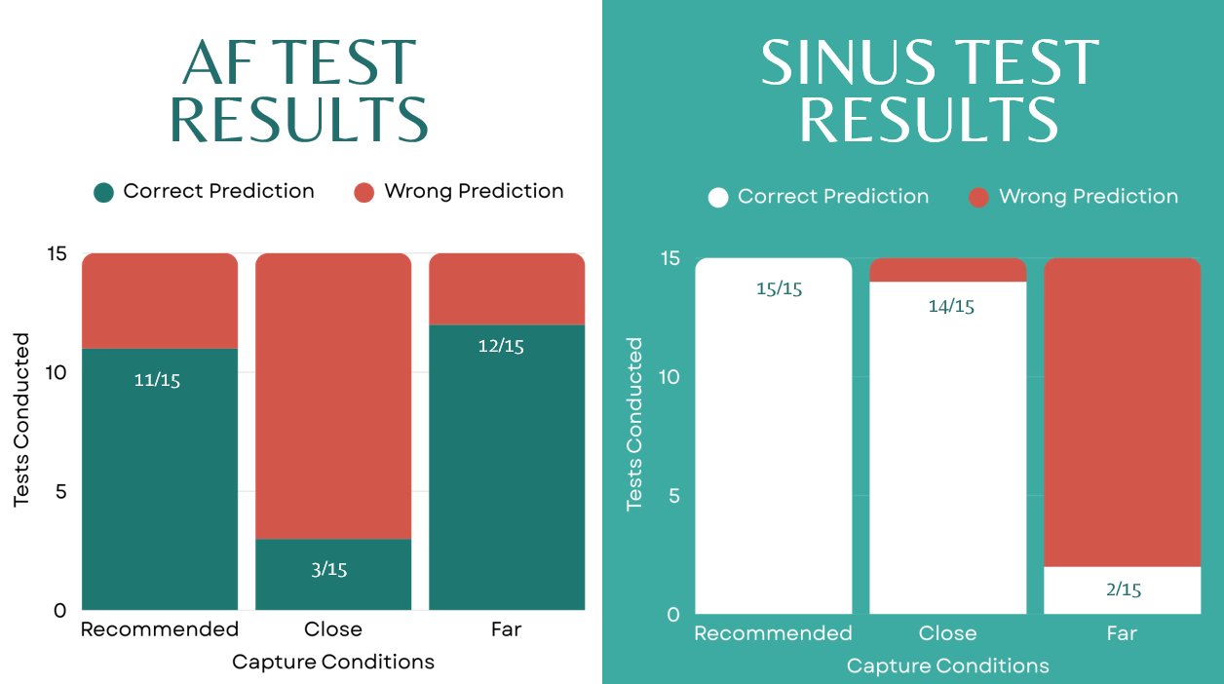

**Observations and Analysis**

The fine-tuned model, saved as retrained_model_full_V3_finetuned.pth, outperformed the prior version in both accuracy and confidence calibration within the validation set. However, it remained slightly under confident on out-of-sample ECGs—correctly classifying them but with softer probability scores. When deployed through the AFsense web application and tested on real-world ECG images (15 Atrial Fibrillation and 15 Normal Sinus cases), the EfficientNet-B0 model achieved high accuracy under recommended capture conditions, with 11 out of 15 correct predictions for AF cases and a perfect 15 out of 15 for Normal Sinus cases. The recommended setup involved capturing the full ECG paper in landscape orientation, under proper lighting, and at a moderate distance. These results affirm that the model performs most reliably when users follow the ideal capture protocol. However, performance varied under suboptimal conditions, highlighting the importance of user guidance and environment control during image acquisition. However, this level of performance may vary depending on environmental factors; the model cannot guarantee consistent accuracy across all image capture scenarios, especially when ECGs are affected by shadows, glare, or captured from a greater distance. Under such suboptimal conditions, the model displayed lower confidence scores (typically 50–60%) and occasionally favored Normal Sinus predictions, even in AF cases.

Despite this, the refined model demonstrated stronger real-world robustness and calibration. The balance between Normal Sinus and AF was preserved, and the increase in macro F1-score validated the effect of switching to label smoothing. By freezing batch normalization layers and adjusting only mid-to-deep convolutional blocks, the model adapted well without destabilizing pretrained features.

**4.8 Comparative Analysis with Existing Approaches**

Numerous studies have explored the application of deep learning for electrocardiogram (ECG) analysis, particularly in detecting Atrial Fibrillation (AF). In this study, the researchers utilized image-based convolutional neural networks (CNNs) to classify AF and Normal Sinus Rhythm (SR) from 12-lead ECG images. The approach diverges from traditional signal-based models, instead relying on 2D visual ECG inputs similar to how clinicians interpret printed ECGs. To contextualize this work, the model's methodology and performance were compared with five recent and relevant studies.

Ao and He (2023) investigated the use of VGG-based image classification models trained on printed 12-lead ECG images. Their work demonstrated that image-based deep learning can perform comparably to signal-based methods, offering a practical alternative when raw ECG signals are unavailable. Their use of data from multiple open-source datasets allowed them to test generalizability across different ECG formats, which is a shared concern in this study’s deployment context. While their architecture was simpler, the similarity lies in leveraging visual ECG data for real-world diagnostics—an approach also realized in the AFsense web platform.

Similarly, the work of Dias et al. (2021) focused on AF detection using CNNs applied to 2D images of the DII lead. Their system achieved high sensitivity (94.3%) and specificity (98.9%), demonstrating how effective visual models can be in classifying arrhythmias. However, their approach was limited to a single lead, whereas the model in this study utilized all 12 leads, offering a more comprehensive view of cardiac activity. The Dias model also emphasized PACS compatibility, while this study implemented a web-based deployment, reflecting a different form of clinical integration suited for remote or resource-limited settings.

In a different yet related study, Król-Józaga (2022) explored three forms of 2D representations—spectrograms, scalograms, and attractor reconstructions—to transform raw ECG signals into visual formats suitable for CNN training. While the study reported strong results, particularly with scalograms (F1-score: 94%), the reliance on signal-to-image conversion introduced an extra layer of preprocessing. In contrast, the model developed in this study trained directly on raw ECG images, removing the need for signal access and preprocessing transformations. This difference makes the proposed model more practical for real-world scenarios where only printed or camera-captured ECGs are available.

Lastly, The large-scale signal-based study by Ribeiro et al. (2020) is often cited for its robust deep neural network (DNN) trained on over two million ECG recordings. The architecture used residual CNN blocks and rigorous manual validation, producing one of the most accurate models for multi-label ECG diagnosis. While this scale of data collection and annotation is beyond the reach of many institutions, the Ribeiro model serves as a benchmark for performance. By comparison, the model in this study used a much smaller, clinically validated dataset but still achieved high accuracy (93%) and balanced F1-scores for AF and Normal Sinus Rhythm. This underscores the trade-off between data quantity and medical validation—a challenge that this study approached by prioritizing clinically confirmed images.

**4.9 Challenges and Limitations**

Throughout the course of developing and evaluating the atrial fibrillation (AF) detection model, the researchers encountered several challenges and limitations that affected data preparation, model training, and generalization performance. These challenges are categorized as follows:

#### **4.9.1. Dataset Limitations**

A significant constraint in this study was the limited availability of clinically validated ECG data. Although large online datasets such as PTB-XL exist, the researchers opted not to use them because the samples were not pre-validated by medical professionals. Ensuring the integrity of training data was a core priority, and asking partner cardiologists to manually validate even 200 images per class would have been extremely time-consuming and disruptive to their clinical schedules.

As a result, the model was developed using a smaller, clinically confirmed dataset collected only from clinic or hospitals, which included only 10–20 confirmed AF cases per month. This constraint led to heavy reliance on offline data augmentation to increase sample diversity, though synthetic variability could not fully replicate the real-world complexity of diverse patient ECGs.

In addition, many samples were captured through photos of ECG printouts, introducing noise such as grid lines, shadows, skew, poor lighting, and cropping. While this reflected real-world conditions, it occasionally caused the model to misinterpret distorted normal sinus rhythms as AF.

#### **4.9.2. Class Imbalance**

In the earlier models, class imbalance skewed the model’s predictions toward the more visually distinct AF class. This issue was evident in both the initial cross-validation folds and the first full-data model, where normal sinus rhythms were frequently misclassified.

To address this, the researchers introduced Focal Loss to help the model focus on harder examples and applied macro F1-score as an early stopping criterion. Later, label smoothing replaced Focal Loss during fine-tuning to encourage better confidence calibration and class balance. These interventions helped the final model achieve nearly equal F1-scores for both AF and Normal Sinus classes.

#### **4.9.3. Computational Constraints**

All training and experimentation were conducted using the Google Colab Pro tier, which operates on a token-based compute unit system. The plan used offered 100 compute units for ₱550 ($9.99 USD), and once exhausted, an additional payment was required to continue. This limitation placed a practical cap on the number of training iterations, model experiments, and validation procedures that could be performed.

While EfficientNet-B0 is lightweight compared to deeper architectures, training still became increasingly demanding as more preprocessing and augmentation steps were introduced into the pipeline. Tasks such as image resizing, normalization, denoising, sharpening, and augmentation added to the preprocessing time and consumed additional memory, especially when working with 1930 augmented ECG images.

Furthermore, experimental iterations using incorrect or unstable training pipeline configurations such as mismanaged layer freezing, early stopping not triggering, or overly aggressive augmentation settings sometimes led to prolonged runtimes, lagging sessions, or Colab freezing entirely. These issues not only consumed compute units inefficiently but also slowed down model development due to repeated re-execution and debugging.

As a result of these compute and runtime constraints, the researchers had to limit certain experiments. Careful planning, selective retraining, and the use of early stopping mechanisms became essential to avoid compute exhaustion and maintain progress within the allocated budget.

#### **4.9.4. Generalization, Confidence, and Calibration**

While the final fine-tuned model achieved high validation performance (93% accuracy, F1 = 0.93, ROC-AUC = 0.98). The model would correctly classify ECGs but often assign modest probabilities to those predictions, especially in ambiguous or noisy cases.

This underconfidence was likely influenced by the use of label smoothing, which intentionally prevents overconfident decisions, and by the model’s cautious generalization behavior. From a clinical standpoint, this trade-off was deemed acceptable: it is preferable for the model to be correct but cautious than confidently wrong in real-world deployment.

### **4.9.5. Limitations of Grad-CAM for ECG Interpretability**

While Grad-CAM was used to generate visual explanations for model predictions, it has important limitations when applied to ECG images. Grad-CAM was originally designed for natural image classification and operates by highlighting areas of high activation within the model’s convolutional layers. However, ECG waveforms are thin, low-contrast, and often overlaid with grid lines, shadows, or noise — which can distract the model’s attention.

As a result, some generated heatmaps did not accurately localize the waveform itself but instead highlighted irrelevant regions such as the background or grid. This limits the clinical interpretability of the Grad-CAM outputs, especially when evaluating whether the model focused on diagnostic waveform features like P-waves, QRS complexes, or irregular RR intervals. Although Grad-CAM can offer some insight into model behavior, it should not be considered a precise or fully reliable method for ECG explanation without further validation or refinement.

**4.9.6. No Built-In Support for Annotations or Case Tracking**

Users are unable to add notes or comments to individual ECG records, limiting the platform’s utility for longitudinal tracking, collaborative diagnosis, or contextual decision-making over time.

**4.9.7. Sensitivity to Input Quality Without Real-Time Guidance**

While the system supports ECG image uploads and camera-based capture, it lacks real-time validation tools to guide users in ensuring proper image quality. As a result, poor lighting, image blur, or incorrect framing may still occur during capture, leading to reduced usability and user confidence even before reaching the prediction stage.

**4.9.8. Influence of Lighting, Capture Angle, and Distance on Image-Based ECG Classification**

Since the model was trained to analyze ECGs in image form rather than from raw digital signals, its accuracy can be affected by how those images are captured. During testing through the AFsense web application, the model gave reliable results when users followed the recommended conditions—clear lighting, landscape orientation, and close-up framing. However, under less ideal conditions, such as when shadows were present, when the camera was too far from the ECG paper, or when the photo was taken at an angle, the model's performance noticeably dropped.

These issues sometimes led to lower confidence scores or incorrect predictions, especially when key waveform details became distorted or unclear. Because this kind of input variability is hard to avoid in real-world use, especially when users are capturing ECGs at home or in low-resource settings, it remains a limitation of the current system. A possible improvement could be to add a simple image quality check or automated cropping feature to help guide users during the upload process and ensure clearer ECG captures.

**4.10 Interpretation of Findings**

This study demonstrates the potential of deep learning, specifically the EfficientNet-B0 architecture in classifying Atrial Fibrillation (AF) and Normal Sinus Rhythm (SR) from 12-lead ECG images. Across several training phases, the model progressed from an imbalanced baseline to a more robust and clinically applicable tool, achieving high validation performance and demonstrating practical utility during real-world testing via the AFsense web platform.

#### **Key Insights:**

Early training was guided by a 5-fold cross-validation setup, used to evaluate how the model handled variations in the dataset. Fold 3 showed the most balanced performance and became the baseline for further refinement. However, a major insight and mistake was the realization that using a fold-trained model for deployment was not methodologically sound. Fold models are only trained on a subset of the dataset (typically 80%) and are intended for evaluation, not production. Using them in deployment limited the model’s exposure to the full data distribution and may have introduced hidden biases. This prompted a shift toward training on the entire dataset, allowing the model to generalize more effectively.

Another consistent issue in earlier iterations was the model’s tendency to misclassify Normal Sinus Rhythm as AF. This pattern suggested that the model struggled with the more subtle, less visually distinct features of normal ECGs. The introduction of Focal Loss helped shift attention toward these harder examples, and freezing/unfreezing specific blocks during training gave the model the flexibility to adapt without overwriting learned visual patterns.

Data quality and preprocessing proved to be just as important as the architecture itself. Models trained on unprocessed ECGs, especially those with visual clutter like gridlines, paper borders, and inconsistent lighting—often focused on irrelevant details. Once the data underwent grayscale conversion, denoising, sharpening, and padding, model accuracy and stability improved. These preprocessing techniques helped the model learn from actual waveform shapes rather than noisy visual artifacts.

Label smoothing was introduced in the final fine-tuning stage to improve prediction calibration. This adjustment allowed the model to make decisions more cautiously, preventing overconfident but incorrect classifications. The trade-off was slightly lower confidence scores during testing, but predictions became more balanced and generalizable, especially important in clinical contexts where cautious correctness is preferred over confident errors.

#### **Real-World Integration and Observed Limitations**

The final model (retrained_model_full_V3_finetuned.pth) was tested in a deployed setting through the AFsense web application using a total of 30 real-world ECG images (15 Atrial Fibrillation and 15 Normal Sinus cases). Under proper capture conditions: clear lighting, landscape orientation, and close-range framing, the model demonstrated high reliability, correctly classifying 11 out of 15 AF cases and achieving a perfect 15 out of 15 accuracy for Normal Sinus cases. However, under more challenging conditions such as shadowed close-range images or distant captures, performance dropped considerably. The model tended to favor Normal Sinus predictions in ambiguous scenarios, especially when signal clarity or resolution was compromised, highlighting its sensitivity to image quality and the need for user adherence to the recommended capture method.

This variation in performance highlights the importance of controlled capture environments and possibly adding automated quality checks in the user interface. It also emphasizes that while the model is robust and performs well under realistic use, it is not immune to noise or inconsistency in how ECGs are captured.

**4.11 Summary of Findings**

The study successfully developed a deep learning model using the EfficientNet-B0 architecture to detect Atrial Fibrillation and Normal Sinus Rhythm from 12-lead ECG images. Across multiple phases of training and evaluation, the model demonstrated both high classification performance and practical deployment readiness.

Initial experimentation using K-Fold cross-validation helped identify Fold 3 as the most stable configuration. However, it was later recognized that deploying a fold-specific model trained on only a subset of the data limited generalization. This led to a shift in methodology—training on the full dataset to maximize exposure to waveform variability and improve diagnostic consistency.

Retraining on noisy and unprocessed ECG images proved that the model could learn from real-world imperfections but also revealed challenges in sinus rhythm detection and a tendency to overpredict AF. To address this, the dataset was cleaned and preprocessed, resulting in significantly improved performance and class balance. Further refinements, including Focal Loss, selective layer unfreezing, and label smoothing, helped the model prioritize harder examples, reduce bias, and make more calibrated predictions.

The final model (retrained_model_full_V3_finetuned.pth) achieved 93% accuracy, balanced F1-scores across both classes, and an AUC of 0.98 for AF on the validation set. When tested through the AFsense web application using real-world ECG captures, the model demonstrated high accuracy under ideal conditions, correctly classifying all Normal Sinus cases (15/15) and most Atrial Fibrillation cases (11/15). These ideal conditions included clear lighting, landscape orientation, and close-range framing. However, performance declined under suboptimal conditions, particularly with shadowed or distant captures, resulting in lower confidence scores and several misclassifications, with the model frequently defaulting to Normal Sinus predictions in uncertain scenarios. These findings emphasize the importance of proper image acquisition for maintaining diagnostic reliability in real-world deployments.

**CHAPTER 5**

**CONCLUSION AND RECOMMENDATIONS**

### **5.1 Conclusion**

This study set out to explore whether deep learning, specifically through the EfficientNet-B0 architecture, could effectively classify Atrial Fibrillation (AF) and Normal Sinus Rhythm (SR) using 12-lead ECG images. The primary goal was to design a reliable diagnostic model capable of operating through a web platform, with real-world ECG images as inputs. These images were sourced solely from the clinic of Dr. Gracita Topacio in Manila and were validated by a cardiologist to ensure diagnostic accuracy.

Across multiple training phases, the model evolved from an imbalanced baseline into a clinically usable tool. Initially, k-fold cross-validation was employed to evaluate model robustness, with Fold 3 emerging as the most balanced performer. However, it became evident that using a fold-trained model for deployment limited generalization due to its exposure to only a subset of the dataset. This prompted a critical methodological shift, training on the entire dataset to allow broader learning and stronger real-world performance.

The final model, trained on a cleaned and augmented dataset (Dataset 3) and fine-tuned using label smoothing, achieved strong validation metrics: 93% accuracy, balanced F1-scores of 0.93, and an AUC of 0.98. Techniques such as Focal Loss and block-wise unfreezing of EfficientNet layers significantly improved model performance, particularly in detecting Normal Sinus Rhythm, which had previously been a challenge. Although preprocessing steps like denoising, sharpening, and padding contributed positively, the overall preprocessing pipeline still lacked full robustness, especially when handling extreme lighting conditions or significant noise variations present in real-world ECG images.

To operationalize the model, a dedicated web platform, AFsense, was developed and deployed using the LEMP stack on a DigitalOcean virtual private server. The system was built with Laravel, which handled user management, image uploads, and secure backend communication with Python-based inference scripts. Users could register, log in with OTP verification, capture ECG photos using their device camera, and receive instant model predictions along with a Grad-CAM heatmap for transparency. Doctors and patients alike benefited from an organized dashboard, archiving options, and detailed PDF/Excel reports for clinical use. Admins were given extended access for managing users and monitoring usage.

All Python inference scripts were executed via Laravel’s server-side command handling, with results securely transmitted back to the frontend. Strict security protocols were implemented, including CSRF protection, encrypted communication via HTTPS, environment file access control, SQL injection prevention, and data encryption at rest using Laravel’s built-in security features.

Real-time testing through the web app using actual ECG photographs demonstrated the model’s effectiveness under ideal capture conditions. Out of 30 test cases, 15 for Atrial Fibrillation and 15 for Normal Sinus Rhythm, the model correctly classified all 15 Sinus cases and 11 out of 15 AF cases when images were well-lit, clearly framed, and captured at an appropriate angle and distance. However, both prediction confidence and accuracy declined in suboptimal scenarios, including shadowed, overly close, distant, or misaligned captures, revealing practical limitations in uncontrolled environments. These results highlight the system’s strong performance under proper usage while underscoring the importance of clear user instructions for consistent outcomes.

Each research objective was successfully addressed:

* **Objective 1:** A valid, cardiologist-verified dataset was compiled from a clinical source.
* **Objective 2:** A deep learning model was trained and refined to classify 12-lead ECG images with significant diagnostic performance.
* **Objective 3:** The model was successfully deployed through a functioning, accessible web application (AFsense.com).
* **Objective 4:** Clinical testing via the web app demonstrated the model’s utility, while also highlighting challenges under varying image capture conditions.

This study confirms that deep learning applied to ECG images when properly trained and validated can serve as a foundation for accessible and automated AF diagnosis. While the model is not immune to external variability such as lighting or framing, and the preprocessing pipeline still has room for improvement, the outcomes offer a strong starting point for building more intelligent, inclusive, and deployable diagnostic tools in clinical and remote healthcare settings.

### **5.2 Recommendations**

In light of the findings and limitations presented in this study, the following recommendations are proposed to enhance the robustness, generalizability, and clinical utility of future ECG-based diagnostic systems:

**5.2.1 Process Lead II Separately for Signal-Specific Training**

According to cardiologist Dr. Alvin Yumul, Lead II often provides the clearest view of atrial activity, particularly the P-wave and overall rhythm regularity. Future researchers are encouraged to explore models trained specifically on Lead II images, as this may enhance the model’s ability to detect atrial fibrillation and improve clinical interpretability in real-world diagnostic settings.

**5.2.2 Enhance the Web Application with Image Quality Validation or Guidance Prompts**

To improve the reliability of predictions in practical deployments, the web platform should incorporate real-time image validation. Features such as lighting condition detection, alignment guidance, and clarity feedback can help users capture better-quality ECG images and reduce misclassification caused by suboptimal inputs.

**5.2.3 Explore Online Datasets and Collaborate with Additional Clinics for Dataset Expansion**

Expanding the training dataset by integrating samples from public repositories and collaborating with other medical institutions can improve generalization and reduce potential biases. A larger, more diverse dataset would allow the model to learn from a broader range of ECG presentations and environmental capture conditions.

**5.2.4 Investigate Transfer Learning Using Stronger Backbone Architectures and Dynamic Input Handling**

While EfficientNet-B0 provided a strong baseline in this study, future researchers are encouraged to explore more advanced architectures such as EfficientNetV2, Vision Transformers (ViT), or hybrid CNN-attention models. These architectures offer improved representational capacity and often support larger input resolutions, which may help preserve finer ECG waveform details—especially in high-resolution or noisy image captures.

Additionally, experimenting with adaptive pooling mechanisms or architectures that allow flexible input dimensions (e.g., spatial pyramid pooling, global average pooling) may reduce information loss from resizing and allow models to better accommodate ECGs of varying layout and size. This could improve generalizability and enhance feature extraction across different capture scenarios.

**5.2.5 Mobile-First Deployment and Offline Inference**

To broaden accessibility in underserved or remote areas, future implementations should consider optimizing the model for mobile-first deployment with offline inference capabilities. This includes reducing model size for efficient edge deployment and enabling local image capture and processing without requiring continuous internet access. Such enhancements would support point-of-care diagnostics, particularly in rural settings where connectivity is limited but timely ECG evaluation is critical.

**5.2.6 Utilize Prediction Feedback Logs for Continuous Evaluation**

Since user responses to the model’s predictions are already recorded in the database, future studies should analyze these logs systematically. This will help monitor real-world performance, uncover trends in incorrect classifications, and inform data-driven strategies for model retraining or fine-tuning, thereby ensuring continued accuracy and clinical relevance over time.

**5.2.7 Add Model Version Display and Confidence Tooltips**

To increase transparency and assist clinicians in interpreting results, the system should display the version of the model used during each prediction. Additionally, integrating tooltips or simple legends to explain confidence scores can help users better understand the model’s certainty, especially in borderline or ambiguous cases.

**5.2.8 Implement Annotation Support for ECG Records**

Allowing users, particularly healthcare professionals, to add brief annotations or diagnostic flags (e.g., “requires follow-up” or “ambiguous trace”) to ECG records would improve the clinical value of archived entries. These annotations can support more effective case tracking, retrospective analysis, and patient care coordination.

**5.2.9 Optimize Software Flow for Clarity and Efficiency**

To enhance user interaction and reduce task friction, future versions of the platform should streamline key workflows—such as image capture, upload, and result viewing—into a more cohesive and guided sequence. Implementing progress indicators, step-by-step tooltips, or visual cues (e.g., “Next Step” buttons) can help users understand what to expect at each stage, reducing confusion and improving task completion, particularly for non-technical users.

**5.2.10 Conduct Broader Usability Testing Across Diverse User Groups**

While this study validated the system with a licensed cardiologist, future research should involve usability testing with a more diverse range of users, including general practitioners, nurses, and clinic support staff. Feedback from varied clinical roles can reveal interface improvements, accessibility needs, and potential barriers, ultimately leading to a more inclusive and user-friendly diagnostic platform.

**References**

*[1]Bianca Brundel, X. A. (2022). Atrial Fibrillation. Nature Reviews Disease Primers 8, 21. Chan Yuan, Y. Y. (2016). Automated atrial fibrillation detection based on deep learning network. IEEE International Conference on Information and Automation (ICIA). Nikita Rafie, A. K. (2021). ECG Interpretation: Clinical Relevance, Challenges, and Advances. Hearts, 505-513.*

*[2]Yong-Soo baek, S.-C. L.-H. (2021). A new deep learning algorithm of 12-lead electrocardiogram for identifying atrial fibrillation during sinus rhythm. Scientific Reports 11, 12818.*

*[3]Ping, Y., Chen, C., Wu, L., Wang, Y., & Shu, M. (2020). Automatic detection of atrial fibrillation based on CNN-LSTM and shortcut connection. Healthcare, 8(2), 139.* [*https://doi.org/10.3390/healthcare8020139*](https://doi.org/10.3390/healthcare8020139)

*[4]Murat, F., Sadak, F., Yildirim, O., Talo, M., Murat, E., Karabatak, M., Demir, Y., Tan, R., & Acharya, U. R. (2021). Review of Deep Learning-Based Atrial Fibrillation Detection Studies. International Journal of Environmental Research and Public Health/International Journal of Environmental Research and Public Health, 18(21), 11302.* [*https://doi.org/10.3390/ijerph182111302*](https://doi.org/10.3390/ijerph182111302)

*[5]Khurshid, S., Friedman, S., Reeder, C., Di Achille, P., Diamant, N., Singh, P., Harrington, L. X., Wang, X., Al-Alusi, M. A., Sarma, G., Foulkes, A. S., Ellinor, P. T., Anderson, C. D., Ho, J. E., Philippakis, A. A., Batra, P., & Lubitz, S. A. (2022). ECG-Based deep* *learning and clinical risk factors to predict atrial fibrillation. Circulation, 145(2), 122–133.* [*https://doi.org/10.1161/circulationaha.121.057480*](https://doi.org/10.1161/circulationaha.121.057480)

*[6]Khriji, L., Fradi, M., Machhout, M., & Hossen, A. (2020). Deep Learning-Based Approach for Atrial Fibrillation Detection. In Lecture notes in computer science (pp. 100–113).* [*https://doi.org/10.1007/978-3-030-51517-1_9*](https://doi.org/10.1007/978-3-030-51517-1_9)

*[7]Tutuko, B., Darmawahyuni, A., Nurmaini, S., Rachmatullah, M. N., Firdaus, F., Sutarno, S., Passarella, R., Sapitri, A. I., Islami, A., Ramansyah, M. W., & Hadi, M. I. A. (2023). Empowering AI-Diagnosis: Deep learning abilities for accurate atrial fibrillation classification. International Journal of Online and Biomedical Engineering (iJOE), 19(17), 134–151.* [*https://doi.org/10.3991/ijoe.v19i17.42499*](https://doi.org/10.3991/ijoe.v19i17.42499)

*[8]Chen, J., Zhang, L., & Zhao, S. (2021). Deep learning for multi-class classification of ECG signals: Combining CNN and LSTM. Journal of Biomedical Signal Processing, 60(3), 102-112.* [*https://doi.org/10.1016/j.bspc.2021.102112*](https://doi.org/10.1016/j.bspc.2021.102112)

*[9]Ma, X., Zhang, Q., & Li, Y. (2022). Hybrid CNN-LSTM model for automatic classification of atrial fibrillation signals. IEEE Transactions on Biomedical Engineering, 69(7), 2321-2330.* [*https://doi.org/10.1109/TBME.2021.3132890*](https://doi.org/10.1109/TBME.2021.3132890)

*[10]Nguyen, T., Lee, S., & Park, J. (2020). Combining SVM and CNN for ECG classification: Application to PhysioNet data. Computers in Biology and Medicine, 124(6), 103-114.* [*https://doi.org/10.1016/j.compbiomed.2020.103586*](https://doi.org/10.1016/j.compbiomed.2020.103586)

*[11]Petmezas, G., Iliopoulos, I., & Loukides, I. (2021). CNN and LSTM for accurate ECG classification of arrhythmias. Biological Psychology, 159, 107-118.* [*https://doi.org/10.1016/j.biopsycho.2021.107092*](https://doi.org/10.1016/j.biopsycho.2021.107092)

*[12]Serhal, S., Boudjema, L., & Mourad, A. (2022). Continuous wavelet transform and 2D CNN for ECG signal classification. Pattern Recognition, 119, 108-120.* [*https://doi.org/10.1016/j.patcog.2021.108521*](https://doi.org/10.1016/j.patcog.2021.108521)

*[13]Aldughayfiq, B., Ashfaq, F., Jhanjhi, N. Z., & Humayun, M. (2023). A Deep Learning Approach for Atrial Fibrillation Classification Using Multi-Feature Time Series Data from ECG and PPG. Diagnostics, 13(14), 2442.* [*https://doi.org/10.3390/diagnostics13142442*](https://doi.org/10.3390/diagnostics13142442)

*[14]Makhijani, C. (2024, January 5). Machine Learning Model Deployment as a Web App using Streamlit. Medium.* [*https://charumakhijani.medium.com/machine-learning-model-deployment-asa-web-app-using-streamlit-4e542d0adf15*](https://charumakhijani.medium.com/machine-learning-model-deployment-asa-web-app-using-streamlit-4e542d0adf15)

*[15]Ali, M. (2023, September 9). Easily deploy machine learning models from the comfort of your Notebook. Medium.* [*https://moez-62905.medium.com/easily-deploy-machine-learning-modelsfrom-the-comfort-of-your-notebook-9068a88f4cf5*](https://moez-62905.medium.com/easily-deploy-machine-learning-modelsfrom-the-comfort-of-your-notebook-9068a88f4cf5)

*[16]Baj, G., Gandin, I., Scagnetto, A., Bortolussi, L., Cappelletto, C., Di Lenarda, A., & Barbati, G. (2023). Comparison of discrimination and calibration performance of ECG-based machine learning models for prediction of new-onset atrial fibrillation. BMC Medical Research Methodology, 23(1).* [*https://doi.org/10.1186/s12874-023-01989-3*](https://doi.org/10.1186/s12874-023-01989-3)

*[17]Tutuko, B., Nurmaini, S., Tondas, A. E., Rachmatullah, M. N., Darmawahyuni, A., Esafri, R., Firdaus, F., & Sapitri, A. I. (2021). AFibNet: an implementation of atrial fibrillation detection with convolutional neural network. BMC Medical Informatics and Decision Making, 21(1).* [*https://doi.org/10.1186/s12911-021-01571-1*](https://doi.org/10.1186/s12911-021-01571-1)

*[18]Ribeiro, E., Soares, Q. B., Dias, F. M., Krieger, J. E., & Gutierrez, M. A. (2023, January 1). Can deep learning models differentiate atrial fibrillation from atrial flutter?. medRxiv.* [*https://www.medrxiv.org/content/10.1101/2023.08.08.23293815v1.full*](https://www.medrxiv.org/content/10.1101/2023.08.08.23293815v1.full)

*[19]Olier, I., Ortega-Martorell, S., Pieroni, M., & Lip, G. Y. H. (2021). How machine learning is impacting research in atrial fibrillation: implications for risk prediction and future management. Cardiovascular Research, 117(7), 1700–1717.* [*https://doi.org/10.1093/cvr/cvab169*](https://doi.org/10.1093/cvr/cvab169)

*[20]Thalor, Dr. M., Pathak, Dr. M., Shinde, Dr. A., Dhumale, Dr. R., Chavan, Dr. A., & Srivas, Dr. S. (2023, March 6). Web Based Cardiac Arrhythmia Classification System Using ECG Data Analysis and Machine Learning. International Journal of Intelligent Systems and Applications in engineering.* [*https://ijisae.org/index.php/IJISAE*](https://ijisae.org/index.php/IJISAE)

*[21]Serhal, H. A., Abdallah, N., Marion, J. M., Chauvet, P., Oueidat, M., & Humeau-Heurtier, A. (2022). Overview on prediction, detection, and classification of atrial fibrillation using wavelets and AI on ECG. Computers in Biology and Medicine, 142, 105168.* [*https://doi.org/10.1016/j.compbiomed.2021.105168*](https://doi.org/10.1016/j.compbiomed.2021.105168)

*[22]Smith, S. W., Rapin, J., Li, J., Fleureau, Y., Fennell, W., Walsh, B. M., Rosier, A., Fiorina, L., & Gardella, C. (2019). A deep neural network for 12-lead electrocardiogram interpretation outperforms a conventional algorithm, and its physician overread, in the diagnosis of atrial fibrillation. IJC Heart & Vasculature, 25, 100423.* [*https://doi.org/10.1016/j.ijcha.2019.100423*](https://doi.org/10.1016/j.ijcha.2019.100423)

*[23]Ding, E. Y., Marcus, G. M., & McManus, D. D. (2020). Emerging Technologies for Identifying Atrial Fibrillation. Circulation Research, 127(1), 128–142.* [*https://doi.org/10.1161/circresaha.119.316342*](https://doi.org/10.1161/circresaha.119.316342)

*[24]Stoyanov, T. (2022). Web-Based Software Tool for Electrocardiogram Annotation. In Lecture notes in networks and systems (pp. 322–331).* [*https://doi.org/10.1007/978-3-030-96638-6_34*](https://doi.org/10.1007/978-3-030-96638-6_34)

*[25]Challenges in Learning ECG Interpretation Among Medical Students: A Small Group-Based Solution - American College of Cardiology. (2021, November 11). American College of Cardiology.* [*https://www.acc.org/Membership/Sections-and-Councils/Medical-Students/SectionUpdates/2021/11/11/13/23/Challenges-in-Learning-ECG-Interpretation-Among-MedicalStudents*](https://www.acc.org/Membership/Sections-and-Councils/Medical-Students/SectionUpdates/2021/11/11/13/23/Challenges-in-Learning-ECG-Interpretation-Among-MedicalStudents)

*[26]Król-Józaga, B. (2022). Atrial fibrillation detection using convolutional neural networks on 2- dimensional representation of ECG signal. Biomedical Signal Processing and Control, 74, 103470.* [*https://doi.org/10.1016/j.bspc.2021.103470*](https://doi.org/10.1016/j.bspc.2021.103470)

*[27]Ao, R., & He, G. (2023). Image based deep learning in 12-lead ECG diagnosis. Frontiers in Artificial Intelligence, 5.* [*https://doi.org/10.3389/frai.2022.1087370*](https://doi.org/10.3389/frai.2022.1087370)

*[28]Hughes, J. W., Olgin, J. E., Avram, R., Abreau, S. A., Sittler, T., Radia, K., Hsia, H., Walters, T., Lee, B., Gonzalez, J. E., & Tison, G. H. (2021). Performance of a convolutional neural network and explainability technique for 12-Lead electrocardiogram interpretation. JAMA Cardiology, 6(11), 1285.* [*https://doi.org/10.1001/jamacardio.2021.2746*](https://doi.org/10.1001/jamacardio.2021.2746)

*[29]Zhang, D., Yang, S., Yuan, X., & Zhang, P. (2021). Interpretable deep learning for automatic diagnosis of 12-lead electrocardiogram. iScience, 24(4), 102373.* [*https://doi.org/10.1016/j.isci.2021.102373*](https://doi.org/10.1016/j.isci.2021.102373)

*[30]Ribeiro, A. H., Ribeiro, M. H., Paixão, G. M. M., Oliveira, D. M., Gomes, P. R., Canazart, J. A., Ferreira, M. P. S., Andersson, C. R., Macfarlane, P. W., Meira, W., Schön, T. B., & Ribeiro, A. L. P. (2020). Automatic diagnosis of the 12-lead ECG using a deep neural network. Nature Communications, 11(1).* [*https://doi.org/10.1038/s41467-020-15432-4*](https://doi.org/10.1038/s41467-020-15432-4)

*[31]Tricog Health. (2024, July 27). 12 Lead ECG vs Single Lead ECG: The Superior Choice. Tricog Health.* [*https://www.tricog.com/12-lead-ecg-vs-single-lead-ecg/*](https://www.tricog.com/12-lead-ecg-vs-single-lead-ecg/)

*[32]F. M. Dias et al., "2D Image-Based Atrial Fibrillation Classification," 2021 Computing inCardiology (CinC), Brno, Czech Republic, 2021, pp. 1-4, doi: 10.23919/CinC53138.2021.9662735.*

*[33]Patwari, A., Dash, S., Tripathy, R. K., Panda, G., & Pachori, R. B. (2024). Ramanujan filter bankdomain deep CNN for detection of atrial fibrillation using 12-lead ECG. In Elsevier eBooks (pp. 35–47).* [*https://doi.org/10.1016/b978-0-44-314141-6.00008-6*](https://doi.org/10.1016/b978-0-44-314141-6.00008-6)

*[34]Atrial fibrillation. (n.d.). Heart and Stroke Foundation of Canada.* [*https://www.heartandstroke.ca/heart-disease/conditions/atrial-fibrillation*](https://www.heartandstroke.ca/heart-disease/conditions/atrial-fibrillation)

*[35]Diagnosis | NHLBI, NIH. (2022, November 30). NHLBI, NIH.* [*https://www.nhlbi.nih.gov/health/atrial-fibrillation/diagnosis*](https://www.nhlbi.nih.gov/health/atrial-fibrillation/diagnosis)

*[36]Kapoor, A., & Reddy, S. (2020). Atrial fibrillation: A review of pathophysiology, clinical manifestations, and management. Indian Heart Journal, 72(3), 207-216.*

*[37]Lippi, G., Franchini, M., & Plebani, M. (2020). Errors in clinical laboratory testing: Causes, detection, and prevention. Clinical Chemistry and Laboratory Medicine, 58(1), 11-22.*

*[38]Piccirillo, J. F., Stein, J. L., & Kanters, J. K. (2014). Noise and artifacts in electrocardiography: A review of signal processing techniques for their removal. Biomedical Engineering Online, 13(1), 6.*

*[39]Hannun, A. Y., Rajpurkar, P., Haghpanahi, M., Tison, G. H., Bourn, C., Turakhia, M. P., & Ng, A. Y. (2019). Cardiologist-level arrhythmia detection and classification in ambulatory electrocardiograms using a deep neural network. Nature Medicine, 25(1), 65-69.*

**APPENDIX A**

Budget Plan

|  |  |  |
| --- | --- | --- |
| **Item** | **Quantity** | **Price in PHP** |
| **Software, Services, and IDE** | **7** | **PHP 5000.00** |
| **Server and Hosting** | **2** | **PHP 500/ month** |
| **Google Colab** | **1** | **PHP 571/ month + 571 for 100 Compute units**  **= PHP 1142** |

**APPENDIX B**

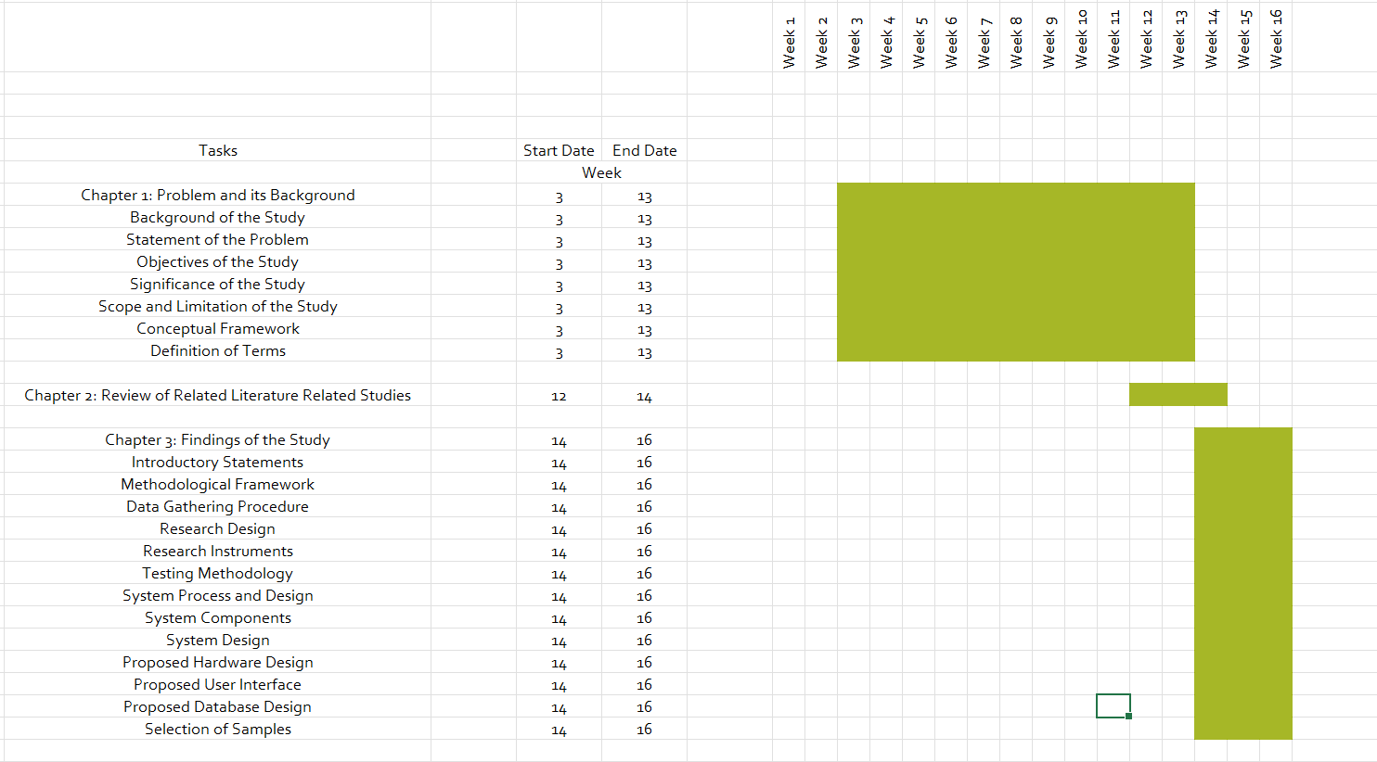Gantt Chart

**APPENDIX C**

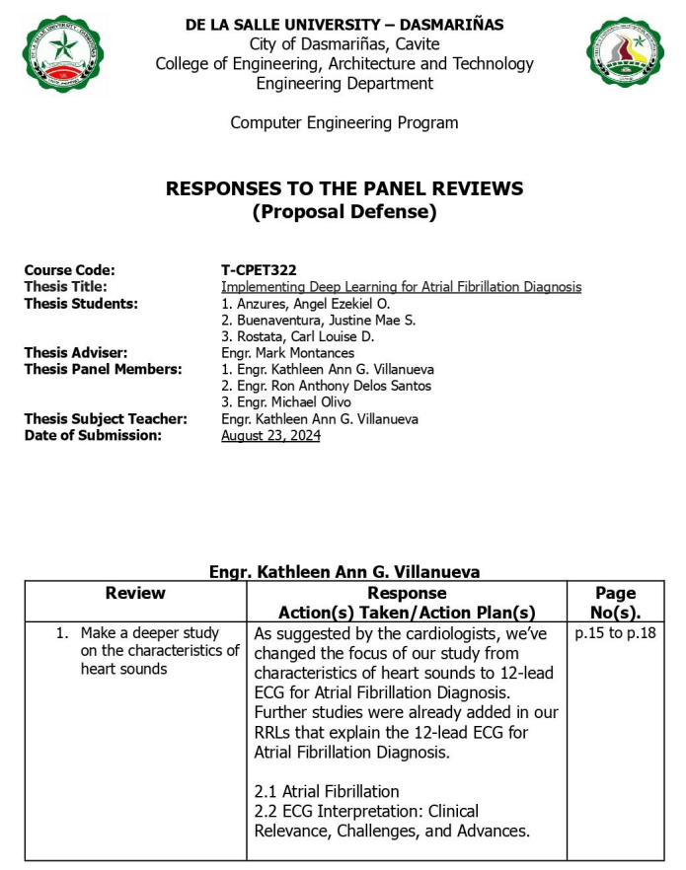

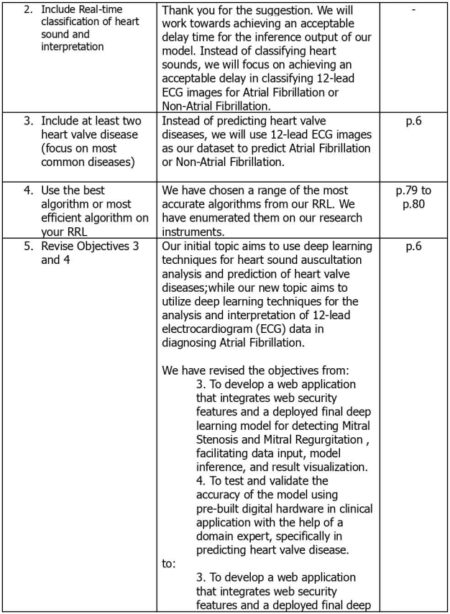

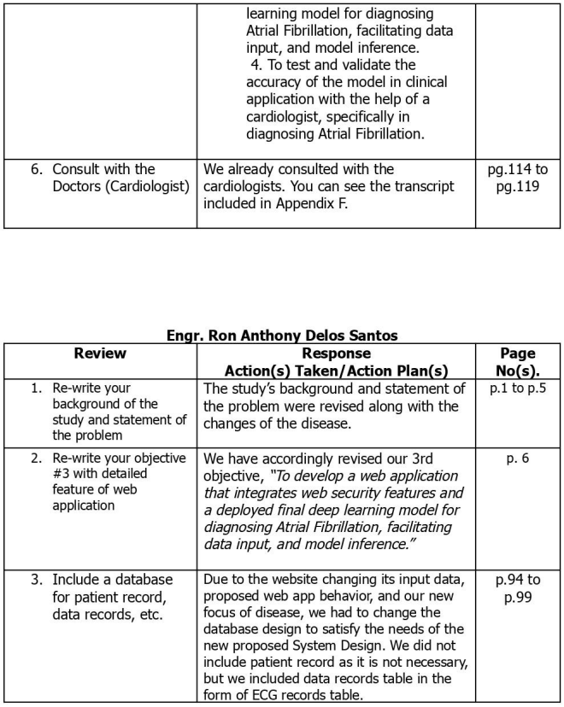

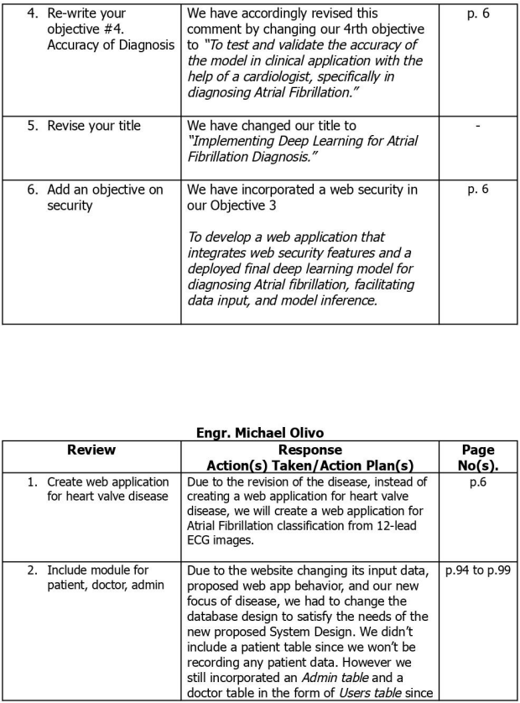

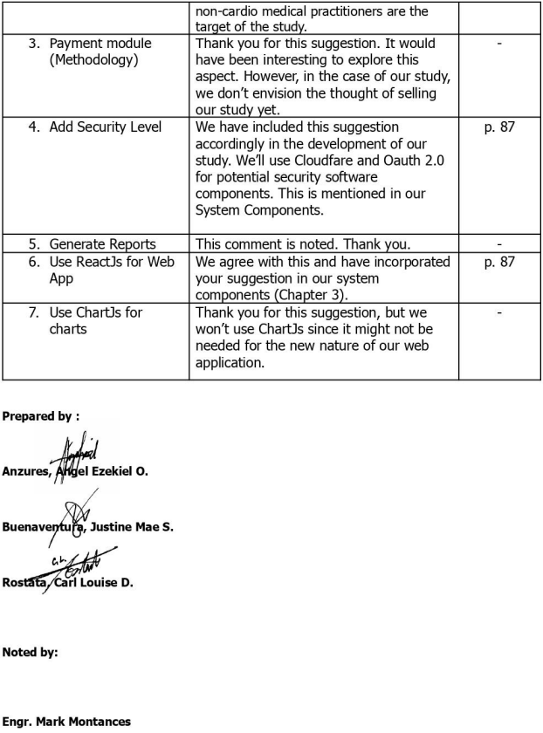

**APPENDIX D**

Transcript

**Researcher:** What is the valve/s of the heart that commonly has heart valve diseases in the Philippines?

***Dr. Topacio:*** The most common heart valve disease in patients is in the mitral valve. In the Philippines, since we are a third world country, the most common cause of heart disease is rheumatic heart or an infection, the most affected is the mitral valve.

**Researcher:** Since there are a lot of diseases affecting the valves, is it better to predict specific diseases within the valves or should we predict what valve has a disease?

***Dr. Topacio:*** You don’t predict what valve the disease originates, since if you say that the disease is a mitral condition, you already know where it is. You should predict the specific disease within the valve. Maybe, it is better to focus only on the mitral valve.

**Researcher:** What specific disease can we predict from the mitral valve?

***Dr. Topacio:*** There are a lot of diseases within the mitral valve. It can be Mitral valve stenosis, regurgitation, prolapse, etc. As mentioned earlier, you may predict Mitral Stenosis or Mitral Regurgitation as diseases in the mitral valve. Because those two is either the opening of the valve is too narrow (Stenosis) or the valve is wide, and the valve doesn’t coaptate, thus it has a gap then the blood flows back, and the atrium also expands (Regurgitation). Mitral stenosis and regurgitation have their own distinct sound.

**Researcher:** How accurate should the model be to tell that it is effective in predicting heart valve diseases?

***Dr. Topacio:*** You need to ask a statistician for that. Statisticians determine that aspect of the research, because for example, for a study to reach a statistical significance, you need a statistician.

**Researcher:** Is it possible to acquire datasets that can be used to train our model from healthcare institutions, possibly from Manila Med?

***Dr. Topacio:*** That’s challenging, in manila med, we have teaching materials of the sound which comprises of the typical sound of the diseases. I can help you if that’s all you need. However, if you need a lot of data, I’ll ask other cardiologists/institutions, but as far as I know, we don’t have that.

**Researcher:** How can we find participants for our research testing?

***Dr. Topacio:*** Our possible approach to this could be asking heart stations or high-precision laboratories if they will allow to provide patients. You can ask for the 2d echo of patients that previously were diagnosed with mitral valve stenosis or regurgitation, then find them through their name, contact, and address. Rather than screening the general population. Write a letter to of request for the information of patients. Include your objective and methodology. It is better to ask them because they have a database of patients.

**Researcher:** Is it possible to have a partnership with you in our study?

***Dr. Topacio:*** Yes, I am open for partnership as long as I am a co-author.

***Dr. Topacio called Dr. Yumul through the phone:***

After explaining the situation, Dr. Yumul suggested Aortic Valve since it is the most common. The researchers were offered sound clips of heart sounds by Dr. Yumul, but they were only one sound clip per heart disease, used for educational purposes. The research needed a lot of sound data to train the model.

***Dr. Yumul:*** If you need a lot of data for variability of the same disease, you’ll need to gather data from actual patients.

**Researcher:** Do you have records actual sound data of patients?

***Dr. Yumul and Dr. Topacio:*** We have none.

***Dr. Yumul:*** There are also a lot of heart disease possibilities and severities with actual patients, so it’s not guaranteed to only find Mitral Stenosis or Regurgitation. Start simple.

**Researcher:** If we want to test the accuracy of the model with actual patients, will the lack of variability from the training data affect its accuracy?

***Dr. Yumul:*** Where do you expect to find many patients? In Heart Centers, there are Valve clinics. However, they only expect 30 patients per day, and you’ll need a data that will be your main reference.

***Dr. Yumul:*** It is possible to find data in heart centers, but it will take you a long time. If you must collect heart sound data from actual patients, you’ll need a licensed practitioner to do it for you. Since there are proper ways to use stethoscopes on patients and you are not licensed to do it yourself with actual patients. You will need a partner Doctor that has a lot of patients with heart valve diseases.

***The Call Dropped.***

**Researcher:** We feel hesitant if it’s still feasible since the collection of datasets will be difficult.

***Dr. Topacio:*** Yes, it will be difficult for you since only heart centers have dedicated facilities for valvular diseases, but it will be difficult to gain access to a heart center. There’s also the issue with legalities since you are not licensed doctors. Reconsider your topic.

***Dr. Topacio:*** The research topic has low feasibility due to the lack of data available and potential legality issues from using actual patients for dataset collection. This topic will be very difficult.

**Researchers:** Are there other possible topics to tackle related to heart that will be more feasible?

***Dr. Topacio:*** Heart diseases are complicated, but I will try to call Dr. Yumul again if he has topic ideas that will be more feasible. This will be difficult since you are not Doctors.

**Researcher:** If we seek a partnership with a doctor, will it be possible?

***Dr. Topacio:*** That will be possible since you will only take care of the technical aspect while the Doctor will be on the medical aspect.

**Researcher:** Can we not find patients here in ManilaMed for our dataset collection?

***Dr. Topacio:*** As I said before, when it comes to valvular heart disease, we don’t usually have patients with only valve diseases. It is only in heart centers.

***Dr. Yumul called through the phone:***

***Dr. Yumul:*** This is just an idea, but why not just predict Atrial Fibrillation and Non-AF from the model through images. Are you familiar with Google Lens’ Google Translate? Where you only point the camera to a text, and it will automatically translate for you? This idea will be like that. However, since you’re only undergrads, keep it simple. Just predict AF and Non-AF.

**Researcher:** What will be the image that we will analyze, if that’s the idea?

***Dr. Yumul:*** You will analyze ECG graphs; the data is readily available. You also won’t need legalities since you won’t be needing any patients or personal information. You will only need the graphs of their ECG.

**Researcher:** What is the problem that this research topic will solve, and what is its significance?

***Dr. Yumul:*** Most of the health practitioners that are not cardiologists doesn’t know how to properly read output graphs of ECGs. So, they consult cardiologists to interpret the graphs. The more advanced ECG machines generate their own predictions, but we can’t say that they are reliable enough since most of them are not that accurate. This topic is significant to non-cardio practitioners that can’t interpret ECG graphs for example nurses, new doctors, medical students, trainees, etc. This is also significant since the medications of patients will vary significantly if they Atrial Fibrillation or not. If they have AF, they will be prescribed blood thinners, depending on the severity of the condition. Otherwise, if they don’t have AF, they won’t receive any additional medications. Diagnosing AF in patients is significant to plot the next actions to take for the patient.

**Researcher:** What will be your expected output if ever we push through with this research topic, do you prefer to have a dedicated device for this?

***Dr. Yumul:*** It is more convenient if it is deployed in mobile much like Google Lens. The one when you only point the camera then you will automatically generate readings. I don’t think that having a dedicated device (dedicated hardware) will be convenient since it will be more difficult for older medical practitioners to operate. If it’s in a phone, then it’s real time, it’s better.

**Researcher:** What will be your terms and conditions for being co-authors?

***Dr. Yumul:*** You decide, as long as we are included in the synthesis and methods.

**Researcher:** Is it possible to take photos of the ECG graphs of your patient records with AF and Non-AF for our dataset collection?

***Dr. Topacio:*** Yes, since you won’t be recording personal information from patients.